POPULATION ESTIMATION, HIV KNOWLEDGE, ATTITUDES AND PRACTICES STUDY AND HOTSPOTS MAPPING AMONG MOST AT RISK POPULATIONS IN THE
EAST CENTRAL REGION OF UGANDA

Final Report

March 2012




Population Estimates, HIV Knowledge,
Attitudes and Practices Study, Hotspots
Mapping among Most at Risk Populations in
East Central Region of Uganda



Disclaimer

This report is made possible by the generous support of the American people through the support of the Office of Health, United States Agency for International Development (USAID) USAID/Uganda, John Snow Institute (JSI) and STAR EC Project.
The contents are the responsibility of the authors and do not necessarily reflect the views of USAID or the United States Government.

Recommended Citation
M.Muyonga,N.Mulumba ,P. Oshabe,G.Kayita,S. Kironde,D.Businge,M.Bandunga (2012) “Population Estimates, HIV Knowledge, Attitudes and Practices Study, Hotspot mapping among Most at Risk Populations in East Central Region of Uganda “.Kampala :STAR-EC JSI/USAID

TABLE OF CONTENTS

List of Acronyms/Abbreviations iv
Acknowledgement iv
List of Investigators iv
Executive Summary iv
CHAPTER ONE 4
Introduction 4
1.0 National HIV Situation 4
1.1 Most at Risk Populations 4
1.2 Background to the Study Project 4
1.3 Major Objectives of STAR-EC 4
1.4 Rationale of the Baseline Survey among MARPs 4
1.5 Purpose and Objectives 4
1.5.1 Specific Objectives of the Study. 4
1.5.2 Research Questions 4
CHAPTER TWO 4
Methodology 4
2.0 Methodology 4
2.1 Overview of the Study Design 4
2.2 Geographic Area 4
2.3 Study Population 4
2.3.1 Formative Research to Improve on Definitions of MARPs 4
2.4 Determining the Quantitative Sample for the Study 4
2.5 Sampling Design and Selection 4
2.5.1 Sampling for Fisher Folks 4
2.5.2 Sampling for Female Sex workers 4
2.5.3 Sampling of other MARPs Categories 4
2.6 Eligibility Criteria 4
2.7 Selection of the Qualitative Study Participants 4
2.8 Data Collection Procedures and Methods 4
2.8.1 Overview of data collection Methods and Instruments 4
Size Estimation MARP Specific Methods 4
2.9 Data Analysis 4
2.10 Anticipated Risks and Ethical Considerations 4
2.11 Benefits and Incentives 4
Study Limitations 4
2.13 Reporting and Dissemination 4
CHAPTER THREE 4
Presentation of Findings and Maps 4
3.0 Key Findings on Background Characteristics 4
3.1 Introduction 4
3.2 Response Rates 4
3.3 Age Distribution 4
3.4 Marital Status 4
3.5 Education 4
3.6 Variance between Birth and Current Location 4
3.7 Mobility 4
3.8 Media Characteristics 4
3.9 Common Messages on the Main Channel 4
CHAPTER FOUR 4
HIV Related Knowledge and Attitudes 4
4.1 Introduction 4
4.2 Knowledge of Prevention Methods 4
4.3 Comprehensive HIV Knowledge 4
4.4 Beliefs and Misconceptions 4
4.5 Accepting Attitudes to People Living with HIV&AIDS. 4
4.7 Tuberculosis Knowledge 4
Table 4.14: Tuberculosis Knowledge 4
CHAPTER FIVE 4
HIV Related Sexual Behaviours 4
5.3 Primary Abstinence 4
5.4 Secondary Abstinence among Youth 4
5.5 Multiple Concurrent Sexual Relationships and Life Time Partnerships 4
5.6 Higher Risk Sex 4
Table 5.5: Higher Risk Sex in last year and condom use is such sex 4
5.7 Commercial Sex Work Male Respondents 4
Table 5.6: Paid sex in last year and condom use at last paid sex 4
CHAPTER SIX 4
Sexually Transmitted Infections Prevalence 4
6.1 Introduction 4
CHAPTER SEVEN 4
HIV Counselling and Testing and Male Circumcision 4
7.1 Introduction 4
7.2 Male Circumcision 4
7.3 Self Reporting HIV prevalence 4
CHAPTER EIGHT 4
Population Estimates, Vulnerability, Mapping of MARPs and HIV Service Status 4
8.1.2 Key Findings on sex workers 4
8.1.3 Characteristics of MARPs, Size Estimation and Vulnerability 4
8.1.4 Characteristics of female sex workers 4
Geographical Location and Size Estimation 4
8.1.4 Estimated Number of Female sex workers by KIs and FGDs 4
8.1.5 Current Age of Sex workers 4
8.1.6 Nationality and Ethnicity 4
8.1.7 Clients 4
8.1.8 Dressing Code and Identity and Time of Work 4
8.1.9 Amount Paid for Services 4
8.1.10 Operational Sites and Vulnerability Levels 4
8.1.11 Factors leading to Engagement in Commercial sex work 4
8.1.12 Suggestions 4
8.2 Key findings related to plantation workers 4
8.2.1 Introduction 4
8.2.2 Size Estimation and Characteristics of Plantation workers 4
8.2.3 Geographical Location 4
8.2.4 Nationality and Ethnicity 4
8.2.5 Vulnerability 4
8.2.6 Age and Sex 4
8.2.7 Risky Behaviors and the Influencing factors 4
8.2.8 HIV Response 4
8.2.9 HIV Response Gaps 4
8.2.10 Suggestions 4
8.3 Key findings related to Uniformed Personnel 4
8.3.1 Introduction 4
8.3.2 Age 4
8.3.3 Vulnerability of Uniformed Personnel 4
8.3.4 Factors Influencing Risk Behaviours 4
8.4 Key Findings related to “Boda-boda”motor Cyclists 4
8.4.1 Introduction 4
“Boda -boda” motor Cyclists Characteristics 4
8.4.2 Geographical Location 4
8.4.3 Size Estimation 4
8.4.4 Organization and Leadership 4
8.4.5 Vulnerabilities of “boda-boda” motor-cyclists 4
8.4.6 Factors Influencing Risk Behaviours among “Boda- boda” Motor Cyclists 4
8.4.7 Knowledge and Perceptions among “Boda- Boda” Motor cyclists 4
8.4.8 HIV Service Accessibility and Current Prevention Needs 4
8.5 Key findings related to fisher folks 4
8.5.1 Introduction 4
8.5.2 Estimated Number and their Characteristics 4
8.5.3 Age 4
8.5.4 Vulnerabilities 4
8.5.5 Emerging MARPs and the Prevention Needs 4
8.5.6 Factors Influencing Risk Behaviours among Fisher folks 4
8.5.7 Knowledge and Perceptions among Fisher folks 4
8.5.8 HIV Response in among fisher folks 4
8.5.9 HIV Response Gaps and Needs 4
8.6 Key findings Truckers and Their Assistants 4
8.6.1 Introduction 4
8.6.2 Size Estimation among Truckers and their Assistants 4
8.6.3 Geographical Location 4
8.6.4 Nationality 4
8.6.5 Risk Behaviors and influencing Factors 4
8.6.6 HIV Response 4
8.6.7 HIV Response Gaps 4
8.6.8 Current Source of Health Information among Truckers 4
8.6.9 Preferred Source of Health Information 4
8.6.10 Suggestions 4
8.7 General Key Findings 4
8.7.1 Other Problems in the Community 4
8.7.2 HIV Magnitude and Manifestation 4
8.7.3 Factors Influencing Risky Behaviours 4
8.7.4 Emerging High Risk Groups 4
8.7.5 Critical areas with Require Additional Knowledge Dissemination. 4
8.7.6 Current and Preferred Source of Health information 4
HIV Response 4
8.7.7 HIV response Gap 4
8.7.8 Suggestions 4
CHAPTER NINE 4
Conclusions and Recommendations 4
9.1 Introduction 4
9.2 Overview of the conclusions 4
9.3 MARPs Population Estimation, Location, Vulnerability and other characteristics. 4
9.4 Female Sex Workers 4
9.5 Plantation workers 4
9.6 Uniformed Personnel 4
9.7 “Boda-Boda” motor cyclists 4
9.8 Fisher Folks 4
9.9 Truckers and their assistants 4
9.10 Emerging Most At Risk Populations and Prevention Needs 4
9.11 Prevention Needs 4
9.12 Knowledge Attitudes and Beliefs among the Selected MARPs 4
9.13 HIV and AIDs related Sexual Behaviour 4
9.14 Service Accessibility 4
9.15 Recommendations 4
Annexes 4
Annex 4 - Consent Statements 4

MAP SHOWING STUDY AREA

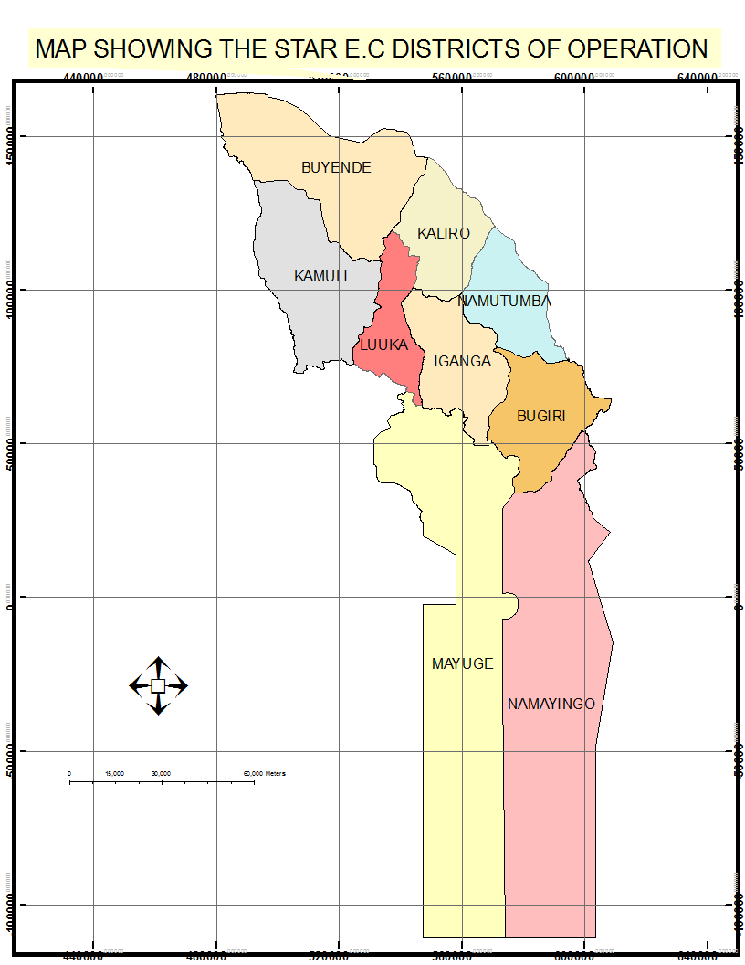

List of Acronyms/Abbreviations
AIDS Acquired Immune Deficiency Syndrome
AIS AIDS Indicator Survey
ANC Ante – Natal Clinic
ART Anti-retroviral Therapy
ARVs Anti-retroviral drugs
BCC Behavior Change Communication
BMU Beach Management Unit
CSW Commercial Sex Worker
CSWs Commercial Sex Workers
DHO District Health Officer
EID Early Infant Diagnosis
EMTCT Elimination of Mother to Child Transimission of HIV
FSW Female Sex Workers
FGD Focus Group Discussions
GPA Global Programme on AIDS
H/C Health Centre
HCT HIV Counseling and Testing
HIV Human Immuno-deficiency Virus
HSD Health Sub District
IEC Information Education and Communication
KAP Knowledge, Attitudes, Practices
MOH Ministry of Health
MTCT Mother to Child Transmission
OIs Opportunistic Infections
PACE Program for Accessible health Communication and Education
PMTCT Prevention from Mother to Child Transmission of HIV
PLHIV People Living with HIV
SAIL Sugar &Allied Industries Limited
STAR-EC Strengthening TB and AIDS Response in East Central Uganda
STDs Sexually Transmitted Diseases
STD/ACP Sexually Transmitted Diseases/AIDS Control Program
STIs Sexually Transmitted Infections.
VCT Voluntary Counseling and Testing for HIV
VHT Village Health Team
UHSBS Uganda HIV/AIDS Sero Behavioural Survey
URA Uganda Revenue Authority
URHB Uganda Reproductive Health Bureau
USAID United States Agency for International Development
WHO World Health Organization

Acknowledgement

On behalf of STAR EC, my own behalf and the consulting team I wish to express my sincere gratitude to all the key stakeholders who provided their valuable inputs into the process of survey design, planning and eventual implementation.

Special mention is made of the District Health team of the nine study districts, the management of : Tilda Rice Scheme ,Mayuge Sugar Plantation and SAIL, fisheries officers of all the nine districts ,regional prisons and police officers, the District Police officers , the local leaders of the different groups of study ,the Beach management committees and local leaders for your kind inputs.

In addition we do appreciate the role played by the research assistants, supervisors and study respondents whose interaction enabled us to generate the valuable data.

Focus Development Associates team for diligently spearheading the entire study process.

Last but not least is STAR EC, USAID and JSI team as represented by Mr Denis Businge for providing the technical and financial support for this very useful study.

Dr. Samson Kironde
Chief of Party,
STAR-EC

List of Investigators

Principal Investigator:
Mr. Michael Muyonga

Co –Investigators

- Noordin Mulumba
- Dr Godfrey Kayita
- Patrick Nsamba Oshabe
- Moses Banduga
- Samson Kironde
- Denis Businge

Executive Summary

Most At Risk Populations (MARPs) practice risky sexual behaviors that make them more vulnerable to HIV infection than the general population. This study intended to generate strategic information that will facilitate STAR-EC, Ministry of Health and her partners to design HIV prevention interventions for MARP that are evidence-based and population centered.
The study involved collecting qualitative and quantitative information on six selected MARPs (Female Sex Workers, (FSWs), Fisher folks, “Boda- boda” motor cyclists, Plantation workers, Truckers and Uniformed personnel), population sizes, congregation centers and their knowledge, attitudes and practices.
Triangulation approach was utilized in collection of both qualitative and quantitative data. Investigations involved use of Key Informant (KI )interviews, FGDs, individual survey, enumeration matrices, observations and mapping.
Computerized aided data analysis was used in processing GIS and quantitative data sets while thematic analysis was used for qualitative information processing.
Population estimates for each MARP were generated by using different methods but adjusting enumerated sizes for under reporting for FSW, “Boda- boda” motor cyclists and Fisher Folks. Plantations, truckers and uniformed personnel sizes were taken as accurate with no adjustments from institutional records. The truckers estimate did also not have under reporting adjustments.

SUMMARY OF FINDINGS
Knowledge and Attitudes
The overall Comprehensive HIV knowledge for all the six MARPs was 37.5% and it was slightly higher among the uniformed personnel at 46.5% and lowest among fisher folk at 27.7%.Comparatively this is higher than that in the general population in the study region which was noted to be 22%. Knowledge on modes of HIV transmission was 75.6% for all the six MARPs with misconceptions common in about 60%. Accepting attitudes for People Living with HIV (PLHIV) were low as only 32% of the MARPs had positive attitudes. These were highest among uniformed personnel (46%) and lowest among FSW (22.6%).

HIV & AIDs related Sexual Behaviours
The median age of sexual debut was lowest among FSW (15 years) and higher among uniformed personnel (18 years). Abstinence was rare among the MARPs. Specifically, for those aged 15-24 years, only 12% of plantation workers,6.5% of fisher folks (and 3.7% of truckers indicated that they abstained in the last 12 months .About 60% of the “boda-boda” motor cyclists and truckers had had sex with more than one sexual partner in the last 12 months with about 50% engaged in higher risk sex while about 35% of the fishing communities and plantation workers also reported higher risk sex .Overall 47.8% of the study population were engaged in sex with more than one sexual partner in the last 12 months and 14.7% of the men paid for sex in the last 12 months.
Sexually Transmitted Infections Prevalence
Prevalence of STIs was highest among FSW (37%) and Boda- boda motor cyclists (26 %).Implying a percentage reporting to have had at least on episode of Sexually Transmitted Infections (STIs) in the last 12 months. In other MARPs, about 17% of plantation workers and 17.8% of uniformed personnel reported suffering from an STI. About 80% of the FSWs, 71.2% of “boda- boda” motor cyclists, 65% of fisher folks, about 60% of truckers and plantation workers reported seeking treatment or advice for STIs. Twenty three percent of the study population reported to have had an STD in the last 12 months among whom 68% sought treatment or advice.
HIV Counselling and Testing and Male Circumcision
Among uniformed personnel 90% have ever tested for HIV and 80% of FSW had ever taken an HIV test in life. Seventy percent of the FSW, 35% of plantation workers and 46.8% of “Boda-boda” motor cyclists had taken an HIV test in the last 12 months. The aggregated uptake for HCT was 76.1% to have ever taken an HIV test while 53.7% had taken a test in the last 12 months. This HIV Counselling and Testing (HCT) uptake is higher than the general population in the study region whose uptake in the last 12 months was reported to be 46.9 %(LQAs report 2011).
The proportion of respondents who had been circumcised was high at 61.4% for the entire male study population. It was highest among the truckers (79.6%) followed by the “boda -boda” motor cyclists (67.5%) and fisher folks (62%). Among the fisher folk, about 16% indicated to have got circumcised in less than a year ago (15.8%) implying they may have responded to current initiatives. This wasn’t evident in other groups who got circumcised at either birth or five and more years ago. The main reason stated for circumcision was reduction of HIV infections. This compares to an uptake of 35.8% of males circumcised in the general population with only 9.2% circumcised within the last 12 months.

POPULATION SIZE ESTIMATES CATEGORISATION AND CHARACTERISTICS OF MARPS
Female sex workers
FSWs were mainly located in urban areas and fishing landing sites. Categorised in three main profiles as bar based, lodge based and those disguisedly employed. There were approximately 489 lodge based of whom 66% were operating in fishing communities, 232 bar based and not employed by the social facility they operated from while 776 were disguised as bar or lodge attendants while Street based sex-workers were limited in the region.
Unprotected sex was more common among the bar and street based categories and lowest among lodge based sex workers. Sexual intercourse cost between 3000($1.3) - 5,000/= ($2.1) Uganda shillings for a short period of less than five minutes while between 15,000/=(6.3) to 50,000($20.1) depending on length or overnight. Clients were mainly truckers, “Boda- boda” motor cyclists and businessmen in main land hotspots and townships while fishermen were the common clients at landing sites. Majority of sex workers were relatively young between 15 years and 40 years of age. They report poverty, lack of employment, and means of supplementing income as key influencing factors in joining commercial sex. Overall, it was estimated that there were 1497 FSWs in the study region.
Plantation workers
Three operational plantations were identified namely; Tilda Rice Plantation, Sugar and Allied Industries limited (SAIL)and Mayuge Sugar Plantation with a total population of 2201 staffs ( Tilda had 1140, SAIL had 61 and Mayuge SP had 1,000) of ages between 20-50 years. Alcohol consumption and staying away from spouses were the major influences to risky sexual behaviours coupled with no written HIV work place-policies at the three plantations which made interventions difficult.
Uniformed Personnel
The uniformed personnel covered in this study included the police, prisons and army estimated at 2000 in the study region. The police, army and prisons staffs were enumerated from records at regional police and prisons structures. The results show a population of 1,075 police staffs and 275 prisons staffs. The army were estimated to be 650 staffs or combatants at “Magamaga” barracks. The risky behaviours like multiple sexual relations and unprotected sex were common and these were influenced by sharing accommodation, enticement for women staff, night duty and alcohol consumption. The rescue of accident victims without protective gear especially among the traffic police was also associated with risk of HIV infection.
“Boda-boda” Motor cyclists
The “boda-boda” population operated in mainly urban and semi urban areas and they were estimated to be about 12,680 ‘Boda boda’ motor cyclists among which 28% were stationed at the district headquarters with a young energetic population mainly aged between 15 and 35 years. Idleness, intimacy with their clients especially school girls, female sex workers and married women who tend to take advantage of free lifts, alcohol consumption were main influencing factors to risky behaviours in this particular group.
Fisher Folks
Fisher folks were mainly located at landing sites on Lake Victoria, Kyoga and River Nile distributed in six districts namely: Bugiri, Kamuli, Kaliro Buyende, Mayuge and Namayingo districts. Their population was estimated at about 63,640 people mainly males and highly mobile. Sharing of women, multiple sexual partnerships and unprotected sex was common. These risky behaviours were attributed to alcohol consumption, redundancy during day time with disposable income and limited access to condoms.
Truckers and their assistants
Truckers and their assistants were estimated on daily basis to be about 321 men of different nationalities (Somali,Kenyans,Burundians and Ugandans) staying over night at 4 hotspots of Naluwerere, Busowa, Idudi and Bulanga. Long periods away from marital homes, peer pressure, alcohol consumption, drug abuse were the factors that contributed to multiple sexual relationships and limited condom use .
Emerging MARPs and the prevention needs
A deliberate effort was made to establish existence of any other groups which seem to have more than average HIV risk and their prevention needs. In response the study participants identified the mobile business men who came to transact business on market days and stay overnight, young girls especially students, opium smokers, taxi drivers and the polygamous couples. The prevention needs identified included education on the female condoms, SMC, HIV discordance and consequences of teenage pregnancy.
Conclusions and Recommendations
The study population demonstrated characteristics which put them at higher risk of HIV infection and would therefore require tailored interventions in both HIV prevention and introduce comprehensive HIV care for those in need.
The following recommendations were made:
- Scale –up Safe Male Circumcision for the Male MARPs Categories.
- Establish MARPs Led HIV Community Education Services.
- Implement Income Generation Activities for MARPs for selected groups.
- Develop and Implement a Behavioural Change Communication strategy for MARPs.
- Promotion of Life Skills among MARPs.
- Scale-Up Peer Education Program.
- Improvement of Accommodation for the uniformed personnel
- Scale-Up HIV & STD services delivery through innovative service models.
- Parent Child Communication Initiatives.
- Establish MARPs Tailored Stigma reduction Initiatives.
- Support the development and implementation of work HIV policies at Plantations in the study region.

CHAPTER ONE

Introduction

1.0 National HIV Situation
The HIV&AIDS epidemic in Uganda has continued to be a serious public health problem contributing to the high morbidity and mortality; it has negatively impacted on development of the country. Currently the HIV prevalence in the general population is estimated at 6.7% with about 1.2 million living with HIV infection (Ministry of Health Uganda AIDS Indicator Preliminary Report 2012)
Since early 1986, the national response under the leadership of the Uganda AIDS Commission has been implementing HIV interventions for prevention and control of the epidemic. Despite these interventions there are indications of an increased number of new infections estimated at 132,500 adults and children per year (Ministry of Health epidemiological Surveillance Report 2010).
The national response recognizes the need for generation of strategic information to inform the design of interventions. Therefore second generation surveillance approaches have been utilized to generate behavioral and Sero behavioral data. The studies conducted include the AIDS Indicator Survey (AIS) in 2004-05 and the national AIS done in 2010-11.
The others covering the sub-populations include: The Crane Study 2009 which covered Female Sex Workers, “Boda-boda” motor cyclists, the MOH knowledge, attitudes, behaviors and practices (KABP) surveys and as well HIV sero Behavioral among fishing communities and female sex workers.
In the last study among female sex workers (STD/ACP MOH 2003) and the 2009 Crane Study, HIV prevalence was 47.2% and 33% respectively about 7 times that estimated in the general population at 6.4% (Uganda HIV/AIDS Sero-Behavioural Survey 2004-05).

1.1 Most at Risk Populations
The national response recognizes the Most At Risk Populations (MARPs) as one of the key priority target groups for HIV prevention and control. MARPs have been taken as a target group because of the more than average risk they have for HIV infection.
Studies conducted previously among special groups such as Female Sex Workers and fishing communities have revealed that there is universal awareness on HIV/AIDS which is not matched by behavioral change. Among FSWs in Kampala district, HIV prevalence increased from 28.2% in 2001 to 47.2 % in 2003. The 2003 study also revealed that; only 29.8% of the FSW perceived themselves to be at high risk of HIV infection, 59.6% of FSWs reported to ever have had an STD in the 12 months preceding the survey a significant increase from 33.7% in 2001.

The Crane Study 2008/09 revealed an HIV prevalence of 33% among FSW,18% among partners of sex workers,13% amongst men who have sex with men and 7.4% among ‘boda boda’ motor cyclists. Other studies by MOH among fishing communities in Mukono and Wakiso show an HIV prevalence of 15.5% and 17.2% respectively.

1.2 Background to the Study Project
The Strengthening TB and HIV&AIDS Responses in East Central Uganda (STAR-EC) Program is being implemented in nine districts of Uganda which are inhabited by over three million people (9 % of the Ugandan population). This region is bordered by the Lakes Victoria and Kyoga in the south and north respectively, a location that allows for both commercial and subsistence fishing. Islands, beaches and landing sites are key features of six of the districts (including Bugiri, Kaliro, Buyende, Namayingo, Kamuli and Mayuge). The East Central mainland is characterized by some densely forested areas, pastoral belts, as well as commercial centers along the northern transport corridor that stretches from the Kenya-Uganda border at Malaba and Busia through Bugiri and Iganga to Kampala.
The Uganda Demographic and Health Survey 2006 showed that the East Central region has one of the highest total fertility rates in the country, averaging 7.5 births per female¹. Additionally, this region had an estimated HIV prevalence of 6.5%², which translates into approximately 73,000 Persons Living with HIV (PLHIV), the majority of whom did not know their HIV status or had never accessed the treatment and care needed to maintain good health. Other drivers of the HIV epidemic in the East Central region include multiple concurrent and cross-generational sexual relationships due to a high level of polygamy; significant transactional sexual activity especially in those districts situated along the northern transport corridor; a high number of residents involved in the high HIV risk occupation of commercial fishing; migrant plantation workers; and the presence of a large number of uniformed personnel at the armed forces barracks and prisons in the region. This situation was exacerbated by the low HTC service coverage which ranged from 0.5% - 8.8% in the region and ART service coverage that ranged from 2.5 - 10.4%³.
According to the Service Provision Assessment Survey 2007, 24% of health facilities in the East Central region offered TB diagnostic services and 83% of these had all components needed to conduct TB sputum tests (microscope, glass slides and ZN reagents). Only 28% of the facilities had TB treatment and follow-up services. District Reports (Oct. – Dec. 2008) to Zonal TB and Leprosy Supervisors indicated a low TB case detection rate within the region (average 35%) and treatment success rate average of 66%. Efforts aimed at providing TB/HIV services in the region are hampered by the general weakness of the primary healthcare and logistics systems. Operational health facilities often have inadequate staffing, equipment and infrastructure necessary to provide a comprehensive range of needed services.
It is against this background that STAR-EC’s interventions aim at expanding access to and utilization of the comprehensive package of TB and HIV&AIDS services by building upon existing networks, expanding geographical coverage and populations served through strengthening district specific responses and expanding the role of civil society organizations and communities in planning, implementing and monitoring activities.

1.3 Major Objectives of STAR-EC
STAR-EC has five major objectives that include
- Increasing access to, coverage of, and utilization of quality comprehensive HIV&AIDS and TB prevention, care and treatment services within district health facilities and their respective communities;
- Strengthening decentralized HIV&AIDS and TB service delivery systems with emphasis on HCs IV and III and community outreach;
- Improving quality and efficiency of HIV&AIDS service delivery within health facilities and civil society organizations;
- Strengthening networks and referral systems to improve access to, coverage of and utilization of HIV&AIDS and TB services; and
- Intensifying demand generation activities for HIV&AIDS and TB prevention, care and treatment services.

1.4 Rationale of the Baseline Survey among MARPs
MARPs practice risky sexual behaviors like concurrent multiple sexual relations, cross generational sex, low utilization of condoms, alcohol and drug abuse that make them more vulnerable to HIV infection than the general population. However, there is insufficient HIV prevention and population based information on these specific sub-populations to guide the development of effective interventions.
Information that was generated in this study will help STAR EC, partners and the government to design better evidence based HIV interventions especially for the East Central region.

1.5 Purpose and Objectives
The purpose of this study was to generate strategic information that will facilitate STAR-EC and partners to design HIV prevention interventions for MARPs that are evidence-based and population centered.

1.5.1 Specific Objectives of the Study.
These were:
- Characterize and categorize selected MARPs by geographical locations, type and estimated population to facilitate development of focused and contextual interventions.
- Provide understanding into the Knowledge, Attitude and Practices (KAP) of various MARPs on HIV &AIDS and their perceived vulnerability to facilitate development of an effective behavior change and communication strategy for MARPs (a strategy that will convey risk reduction messages, address appropriate target groups/sub-populations, culturally and socially appropriate and conveyed in multiple local languages).
- Obtain baseline data on reportable indicators to effectively track progress on HIV interventions for MARPs in the region.

- Obtain data that will enable STAR-EC contribute to the National HIV Prevention Strategy and Action Plan (2011-15) .
- Design appropriate capacity building strategies that increase knowledge, skills and ability of community structures, local government structures, households and MARPs themselves to access and sustain local response to HIV prevention among MARPs.
- Make recommendations pertaining to which MARPs category and sites may need faster attention based on ranking of the observed situation.

1.5.2 Research Questions
- What is the estimated population of selected MARPs by geographical location, sex, age and population type? What is the nature and level of their vulnerability?
- Are there any new emerging (evolving) type of MARPs other than the ones listed and if so what are their unique HIV prevention needs?
- What drives MARPs into commercial and other risky sexual activity in target communities? What factors are associated with the vulnerability of MARPs in the East Central region?
- How do MARPs behave and what influences their behaviours? What do they know, believe, and think about HIV, its causes, impact and prevention?
- To what extent are MARPs accessing the needed HIV prevention services in the target region? What are their unique HIV prevention needs?

CHAPTER TWO

Methodology

2.0 Methodology
The section provides details on how the study was implemented and data were managed.

2.1 Overview of the Study Design
The study was a descriptive sub population-based study on HIV& AIDS related Knowledge, Attitudes Behaviors and Practices focusing on Most At Risk Populations (MARPs). It was cross-sectional in design based on a statistically representative sample for the different categories of MARPs in East-Central Region of Uganda. It employed both quantitative and qualitative methods to collect information from the field which will be used to inform programming for MARPs.

2.2 Geographic Area
This study was conducted in nine districts where STAR-EC operates namely; Bugiri, Buyende, Iganga, Kamuli, Kaliro, Luuka, Mayuge, Namayingo, and Namutumba. It was conducted in areas where MARPs are situated and these include fish landing sites, road side hotspots, plantations and urban areas.

2.3 Study Population
The primary respondents of this study were individuals who were identified as Most At Risk Populations (MARPs). According to UNAIDS MARPs or Key populations at higher risk of HIV exposure’ refers to those populations most likely to be exposed to HIV or to transmit it and this is country specific based on the epidemiological and social context. It also states that there is a strong link between various kinds of mobility and heightened risk of HIV exposure, depending on the reason for mobility or simply these are sub-populations who are at more than average risk of HIV infection.
For the purpose of this study these groups included the following categories;
- Female Sex Workers (FSWs),
- Fisher folks,
- Plantation workers,
- Truckers and assistants,
- ‘Boda-boda’ motorcyclists,
- Uniformed personnel,
Whereas the incarcerated populations are recognized as a MARP administratively it was difficult to include this group in the study within the settings of the study area and country at large and as such excluded.
The secondary respondents (Key Informants) were:
- District local government and other local leaders;
- Health/other social service providers;
- Managers or proprietors of key social facilities; and
- Other individuals that interact with the identified MARPs at various levels.

2.3.1 Formative Research to Improve on Definitions of MARPs
Formative research was used to improve the study team’s understanding of the population of interest and to determine the best ways to reach the population.
Formative research for size estimation included talking to members of the population at higher risk of HIV infection , talking to persons who provide services to that population, persons who reside or work in areas where the population congregates, observing the population and reading existing literature on the population.
The formative research helped in learning: whether the population are visible, which sub-groups of the population are not visible, where the population regularly meet, where the population receives services, time of day the population is approachable for data collection, how the population networks, who the gatekeepers are to the population, how they react and interact with public officials such as survey implementers.
Geographic mapping described the universe of places where the population congregates and provided a rough estimate of the population size and characteristics of the locations where the population congregates.
In summary, formative research helped in defining and describing the population of interest, it helped in understanding the factors which influence their behaviour, and determined the best way to reach the population. Geographic mapping provided the physical description and the characteristics of the area where the study team worked.

2.4 Determining the Quantitative Sample for the Study
This study was designed to generate data that can be used to establish whether there is improvement on the impact of a number of interventions made by the STAR EC program. The following assumptions were considered in order to generate an optimal sample size for the study:
- The main variable of the quantitative part of survey was “condom use at last higher risk sex in past 12 months prior the study time”. It was selected because of its importance to the study population and in addition it is easy to monitor after some interventions have been made. The indicator assumed a value of 55.8%, obtained from the Uganda HIV/AIDS Sero-Behavioral Survey (2005).
- It was assumed that an increment of 0.15 points (15%) will happen after some interventions have been made. This figure was selected because it is realistic in terms of what the program can achieve in 5 years and yet it yields an optimal sample size that is manageable.
- Confidence level of 95% was taken and a power of 80% to allow comparison with similar studies done in the country.
- Response rate was 91.8% and the design effect was 1.157 (Uganda HIV/AIDS Sero-Behavioral Survey 2005), to be in line with similar studies.
The following statistical formula by Joseph Amon et al (Behavioral Surveillance Surveys, 2000), was used to determine the sample size.
²
n = D [Z_{1-} {2(P(1-P))} + Z_{1-β} { p₁(1-p₁) + p₂(1-p₂)} ]
(p₂-p₁)²
Where;
n = required sample size
D = design effect or factor by which cluster sample
should be multiplied in order to obtain survey
results with same precision as those of a Simple
Random Sample.
Z_{1-} = the z-score at the desired level of significance
Z_{1-} = 1.96 at 95% confidence level and considering a two sided test (since there can be either an increase or decrease)
Z_{1- β} = the z-score at the desired level of power
Z_{1- β} = 0.84 at power of 80%.
p₁ = the estimated proportion of the main variable at the time of first survey; p₁=0.558 (refer to assumption i)
p₂ = the target proportion at some future date; p₂=0.708
p₂ ₋ p₁ = magnitude of change anticipated; p₂-p₁=0.15
P = (p₁+ p₂)/2
Thus a sample size equivalent to 186 individuals was obtained. However due to the fact that the response rate was assumed to be around 92% (refer to assumption iv), the calculated sample size of 186 was multiplied by a factor of 1.0896 (that is 100/91.8) to cater for non response. This means that the optimum sample size required for each category of MARPs was 203 individuals. Hence for the 6 categories of MARPs; FSWs, Fishing communities, Plantation workers, Truckers, “Boda-Boda" motorcyclists and Uniformed personnel; it necessitated to multiply 203 by 6 to generate the sample size for the entire survey. Hence a total of 1,218 respondents were targeted for the entire survey.

2.5 Sampling Design and Selection
In the quantitative part of the study, stratified sampling was used, whereby each category of the MARPs was a stratum. This was intended to ensure that certain significant attributes of the different categories of MARPs are not lost as would be the case if the whole study population is taken as one.

2.5.1 Sampling for Fisher Folks
The fisher folks are found in six out of the nine study districts namely: Namayingo, Mayuge, Bugiri, Buyende, Kaliro and Kamuli. Fisher folks are found on landing sites. A landing site has both individuals that earn their livelihoods directly from fisheries related activities (like fishermen, fishmongers, and boat makers) and those who do not directly earn from fishing (for example shop attendants, food vendors, transporters, bar owners and bar attendants). The individuals that earn directly from fishing activities are registered in an organization called beach management unit (BMU), whereas those who do not earn from fishing directly are not members of BMU.
The cost of constructing/updating a sampling frame that has all individuals in all landing sites is very high. Consequently it was not possible to use simple random sampling (SRS) under fishing communities, since it requires use of a sampling frame; instead multi-stage sampling was employed when selecting units into the sample. The primary sampling Units (PSUs) were the landing sites (clusters) and the secondary sampling units (SSUs) were the individuals. In the selection process the clusters were taken as landing sites instead of the BMUs because if the later are used as the sample population, the unregistered BMU members who are part and parcel of the fishing community would be left out. The non-BMU members may not be engaged in direct fisheries activities, but they interact with BMU members and thus they have similar dynamism in relation to HIV transmission.
In order to obtain an adequate minimum sample size of 203 individuals, a total of 19 landing sites were selected and from each an average of 11 members were selected. The two figures 19 and 11 above were determined on the principle that in cluster sampling it is more efficient to have a larger number of smaller clusters than to have a smaller number of large clusters. In other words if a few big clusters are selected it will lead to higher intra cluster correlation (since there is a high likelihood for neighbouring units to be positively correlated) and this will yield poor estimates. The solution to this would be to have as many small clusters as possible but caution had to be taken because the bigger the number of clusters the higher the costs. An equilibrium therefore had to be sought of not having too few clusters and at the same time not having too many clusters; and the optimum position taken was to have 19 clusters of size 11 each. The 19 landing sites were selected from a total of 93 landing sites (Ministry of Agriculture, Animal Husbandry and Fisheries) that exist in the region, using systematic sampling. The procedure involved computing a sampling interval and determination of random start. The use of sampling interval enabled a landing site with more Fisher Folks to have a higher chance of being included in the sample compared with one that has less Fisher Folks, thereby making the sample more representative of the target population (list of selected landing sites is attached in annex II).
Through multistage sampling, the cost of constructing a sampling frame reduced since instead of listing all individuals in all the 93 clusters, it necessitated to list individuals in only 19 clusters. The sampling frames of the selected 19 landing sites were constructed/updated to ensure that all eligible respondents in these clusters were listed, such that they could be assigned an equal chance to participate in the survey. The sampling frames were updated in collaboration with the BMUs’ leadership, fishing department and the village council leadership. In practice, a BMU can overlap with one or more village/local council one (LC1). A number of LC1s had lists of households and yet the sampling procedure required lists of individuals as opposed to lists of households. In order to solve that problem, for each of the 19 selected landing sites the following procedure was followed: 1) all the BMU members were listed, 2) all the heads of households located in the LC 1 zone(s) where the landing site is located were listed and 3) the heads of the households were requested to list all the resident household members who fall within the age bracket 15-59 years. Since the LC1 chairpersons may not necessarily know everyone residing in their zone and their ages, the household heads or any adult member of the household available assisted in the listing of the eligible members in their households which minimized gross age misreporting at the listing stage. Further, the BMU list was married with the list of individual members of the households to form one list of individuals aged 15-59 years. While doing this, caution was taken to ensure that there was no duplication in the listing. This procedure generated a sampling frame of individuals for each of the 19 selected landing sites. The updated sampling frames included the BMU members and the non-BMU members. Using simple random sampling (SRS) technique, 11 individuals were selected from each of the updated sampling frames, to participate in the survey for the fishing community stratum.

2.5.2 Sampling for Female Sex workers
In the case of FSWs, it should be noted that commercial sex work is illegal in the country and therefore one cannot easily generate a sampling frame of registered FSWs. In the absence of sampling frame, SRS cannot be used. The investigators were therefore compelled to apply a non-random sampling method called snowballing to include participants for the study from the FSWs domain. Initial sets of sex workers helped to identify other sex workers. In order to ensure that a district with more FSWs has more representation in the sample, probability proportionate to size (PPS) technique was employed. During the pre-visits which were made to districts prior the actual implementation of the survey, some estimates on number of FSWs were collected for use in the PPS technique and the number of FSWs to participate in the survey were determined (refer to annex III).

2.5.3 Sampling of other MARPs Categories
In each of the remaining four strata (plantation workers, truckers, ‘boda-boda’ motorcyclists and uniformed personnel), simple random sampling (SRS) was employed to select individuals to participate in the study. This is because SRS is statistically believed to be the most scientific method of selecting a representative sample. A sampling frame was constructed for each of the four strata. These lists were obtained from local authorities where these groups were located and they were updated to ensure that all members that left the place were deleted and new entrants included. The updated lists in the different districts (in the study area) were merged to form one sampling frame for each stratum. That is, for the nine districts a total of three sampling frames were generated. On the other hand the system for truckers was different as the sampling frames were generated on the day of the interview at the key sites after which simple random sampling was applied.
It should however be noted that the sampling design described above has implication on presentation of survey results. It allowed results to be presented regionally for each of the six study MARPs and not per district. This was intended to cut on the costs since if the results were to be presented per district it would necessitate a bigger sample size hence increasing the costs.

2.6 Eligibility Criteria
Eligibility in this survey has been defined as all men and women aged 15-59 years who are categorized under the MARPs categories outlined above. The age-group 15-59 years was selected on account that it is mainly the sexually active age-group and thus it would yield reliable HIV/AIDS information since the main mode of HIV transmission in Uganda, is heterosexual. Another reason for selection of that age group was that similar studies that have been conducted in the area of HIV&AIDS had used the same age-group, and thus using it in this study would allow comparison with other studies that have been conducted in the area of HIV and AIDS.

2.7 Selection of the Qualitative Study Participants
These were purposively selected to cover individuals with rich knowledge on issues of MARPs. They were at the district and community levels. These included HIV programmers in the public and private sectors; local leaders, proprietors of social facilities and leaders of identified MARPs.

2.8 Data Collection Procedures and Methods
Degree holding Research Assistants with social science training bias were recruited to collect data. The Research Assistants were oriented in a workshop to introduce them to the study protocol, study instruments and techniques of data collection. The Research assistants participated in the translation and back translation of study Instruments from English to Luganda and other local languages. This was because the study population was multicultural and Luganda was commonly used. In addition Luganda has previously been used successfully in studies like the AIDS Indicator Surveys in the same region. Depending on performance during training supervisors were selected to check the quality of the data collection done by the Research Assistants.
The survey team did not limit itself to a single method for estimating the size of a sub-population, nor limit itself to a few data sources. A triangulated approach to data collection was adopted because multiple methods make for checks and balances, and cross validation. It is also true that studies conducted with limited time frame benefit from different methods which produce estimates in the same overall range and are most likely to inspire more confidence than a single estimate produced by a single method. In addition we recognized the fact that different MARPs required different estimation approaches and therefore more modifications after the pre-visits and pre-testing were effected. For instance, the review of institutional records and interface with human resource officers provided a better estimate for uniformed personnel and plantation workers than use of individual interview estimates.

2.8.1 Overview of data collection Methods and Instruments
Pretesting
All the instruments of data collection were pre-tested before production of the final tools. The pre-testing was made in Bugembe town ship outside the study area. After the survey the tools were refined and produced in sufficient quantities for data collection.
a) The Structured Questionnaire
The structured questionnaire was the major data collection instrument for Knowledge, Attitudes and Practices part in the study. It investigated MARPs specific background characteristics, knowledge and practices related to STD/HIV/AIDS, experiences and organization of a given group, and access to essential services for that group.
After pre-testing and reproducing the questionnaire in sufficient quantities, the Research Assistants were deployed in pairs in the different districts of the East Central region. The Research Assistants worked with MARPs leaders, local leaders and proprietors of social outlets, managers of plantations, entertainment places to collect names or telephone numbers of persons who had been identified as study respondents. These were then contacted physically or through telephone to seek their participation. Upon consent, the study participants were met at agreed places for questionnaire administration.
Research Assistants conducted interviews by reading out the questions while seated face to face with respondents and immediately wrote down the responses in the spaces provided on the questionnaire. After the interview, Research Assistants would seek clarifications on contradictory responses and thank the respondents for participation.
b) Focus Group Discussions (FGD) and Social Mapping
Table 2.1 FGDs Conducted

Category of FGD Participants | Number covered | Number of participants
Female Sex Workers | 04 | 36
Fishing folks | 04 | 36
Plantation | 02 | 17
Truckers | 02 | 16
“Boda-Boda”-motor cyclists | 04 | 36
Uniformed personnel | 02 | 18

In these meetings the study participants were asked to provide information on the estimated number of MARPs and their characteristics and lifestyles to determine the levels of vulnerability. Operational definitions of MARPs were provided to these groups to guide the discussion process.

c) Key informant Interviews
Table 2.2 KIs Conducted

Category of Key informants | Number covered | Number of participants
Local Leaders | 10 | 10
Health workers | 05 | 05
MARPs Leaders | 12 | 12
NGO representatives | 02 | 02
Owners/Managers of recreational outlets | 04 | 04

Key informants (KI) were chosen from knowledgeable persons in the community, local council leaders, local governments, Faith Based Organizations (FBO) and Non-Governmental Organizations’(NGOs) . Key local leaders and owners/managers of social service outlets like bars and film show sites were interviewed to give the estimated number of Most at Risk Populations including sex workers who operate in their areas and common characteristics. An average was computed for the figures from key informants. This information was compared with that generated from FGDs.
KI interviews were conducted in two stages. In the preliminary phase, the field team conducted excursions to the hot spots in the districts. Local Council leaders and most-at-risk group mobilizers were approached and briefed about the study. After consenting, they were interviewed in private places. In the second phase, KIs were individually approached, briefed about the study and requested to participate. After consenting, face-to-face interviews were conducted. Prior to each interview session, permission to use a recorder was sought. Probing was made to clarify any vague answers.
e) Enumeration of Trucks and truckers
The trucker population at each hot-spot was estimated by carrying out a census of parked trucks each evening between 7pm-11.30pm over a period of four days at each of the hotspots in Naluwerere, Busoowa, Idudi and Bulanga. This was done in roadside hotspots in the project districts. The observation was done over a period of four days and on this basis the estimates of the number of truckers and their assistants as one of the MARPs was made. On the basis of the generated figures an estimate was generated for the entire project area.

f) The Social Health Mapping Guides
The Mapping Guide was used in capturing coordinates and geographical locations of key hotspots, MARPs congregation places, and to show areas where most-at-risk groups reside, work, and obtain STD/HIV and social support services.
g) Desk Review
Deliberate effort was made to review any studies conducted on MARPs. Specifically these included among others: The STAR EC project reports, the LQAs study findings, the Crane Study, MOH HIV/AIDS Epidemiological Surveillance Report 2010 and the EALP HIV Sero Behavioral Survey in four plantations of the Lake Victoria Basin of Uganda.
h) Health Services Inventory
The survey captured information on HIV services at selected sites and other capacities possessed by these facilities. The matrix captured information on the disease profile on the MARPs, particularly STIs, the main clientele and the ability to cater for their health care needs. This information was backed up with information from literature review of LQAs and Ministry of Health reports since not all facilities were visited.

Size Estimation MARP Specific Methods
2.8.2 Female Sex Workers (FSW)
Overview
Data collection on FSW was informed by results from the formative research and leads from KIs and study guides. This helped to define their locations and operations. These guides were instrumental in providing clues on how to locate and access the FSW. It was observed that the majority of FSW congregate around social outlets like: bars, dancing halls and lodges in the region. The data collection instruments used included sex workers enumeration matrix, bar/lodging questionnaire, KI/FGD guides and individual questionnaires.
2.8.2.1 Size Estimation Approach for FSW
A method mix was employed to improve on the validity of the estimates especially at hotspots and towns. Comparison was made for estimates from the different methods and an average was taken as the best estimate for the FSWs. In some instances mainly data from the enumeration matrix and bars questionnaires were utilised and an assumption was taken of coverage of 85% of the social facilities.
This percentage was arrived at after discussions with local leaders and guides who estimated that about an average 85% of the social facilities had been visited by the survey team. The intention was to take care of those social outlets like bars and lodges which were not visited by the survey team though not scientifically generated.
Therefore to estimate for each of groups in the different urban areas/small towns/trading observed in the region the mean/sum was multiplied by 115%. Whereas individual data collection was done in areas with concentration of FSW like hotspots and key landing sites the small towns had FSWs disguised as either bar or lodge attendants.
2.8.3 Fisher Folks
Overview
During the formative phase, it was observed that collecting data from 60% of the BMUs and projecting for the rest of the fisher folks could be taken as a reliable approach to estimate these populations. Therefore a fisher folk enumeration matrix, was used to collect data from BMU leadership structures using BMU registers as the reference point. Most BMUs however did not have updated registers and others had registers with only a few people registered citing fear for law enforcement officers or Uganda Revenue Authority(URA). In such circumstances the size estimation team interviewed BMU members to estimate the numbers of key categories found at landing sites. For example the number of operational boats used for fishing would help in establishing the number of fishermen. The numbers of processors were established by knowing the number of Omena/Mukene boats etc.
In Bugiri data were collected from two out of four BMUs, in Namayingo data were collected from forty two out of fifty BMUs, in Mayuge data were collected from eleven out of thirty two BMUs Buyende three out of seven and in Kaliro two out of nine BMUs. During data collection the team targeted visiting big (as perceived by guides in terms of economic activities and settlement) BMUs.
2.8.3.1 Size Estimation Approach:
An assumption of 5% under-reporting was made for the areas covered and the figures adjusted accordingly. The adjusted total was used to generate average numbers per category (totals divided by number of BMUs visited). The average was then used to determine the big and small BMU. Big BMUs were those that had their number of “Barias” the Swahili word for fishermen above the generated average and small BMUs were those that had their number of “Barias” less than the generated average. An average of both BIG and SMALL BMUs was generated which was used to compute the district level estimates.
2.8.4 Trucker Drivers
Overview
In the formative assessment it was observed that to get the best estimate of truckers and their assistants, enumeration of trucks was the best approach. The key truck stop-overs were established and enumeration was done between 8.30-11.30p.m for a period of four days each of the key stop-overs namely: Naluwerere, Idudi, Busoowa and Bulanga. The enumeration team captured the 'head'/in-front number plate of all parked trucks. Trucks that were still on the road side (not yet parked) were not captured to avoid counting those that stop for a few minutes and continue with their journeys. Data were cross checked on a daily basis to avoid capturing the same truck twice between the different stop-overs in the same day.

2.8.4.1 Size Estimation approach
It was discovered that each truck carries between two to three occupants, a driver and 2 “tonne- boys” or one “tonne-boy”. To get the average number of trucks the total number of enumerated trucks were divided by the number of enumeration days per stopover.
To get the size estimate per stop-over per night, the average number of trucks over the truck enumeration period was multiplied by 2.5 on the basis that every truck usually has an average of 2.5 people.
2.8.5 ‘Boda Boda’ Motorcyclists
Data on ‘Boda-boda’ motorcyclist’s population were collected from the ‘Boda-Boda’ Association records. For associations that had no up-to-date or no records at all, data were collected from stage chairpersons and or secretaries. In order to capture populations of individual cyclists that are not registered, stage verifications either by phone or actual visiting by the study team was done. An assumption of 5% under reporting was made and therefore the estimate was generated by multiplying by 105% by the figure got from the leaders’ records.
2.8.6 Uniformed Personnel
The population information for the police and prisons was obtained from the regional police and prisons officers. However for the army this was got indirectly from FGDs and key informant interviews at “Magamaga” army barracks. Data provided by personnel officers were not subjected to any adjustments because of the fact that nomination rolls for staffs have minimal chances of errors and omissions.
2.8.7 Plantation workers
Data on plantations were collected from human resource personnel of the respective plantations and factories. These data were not adjusted for underreporting since they were from their respective institutional records.

2.9 Data Analysis
a) Quantitative Data Analysis
A data management unit was established where the completed questionnaires were registered and checked against the mailing list to verify that all the questionnaires sent from the field were received at the center.
Data processing involved editing of the questionnaires and coding of open-ended responses. Data were entered into the computer using the Epidemiological Information (Epi-Info) software package (version 3.5.1). In order to ensure that data entered are of good quality, double data entry technique was used. Double data entry technique is a data entry quality control method that is employed when data records are entered sequentially by two different sets of data entrants in order to facilitate verification. The data manager compares the data entered by one set of data entrants with those entered by the second set. While this method of quality control clearly is not proof against systematic errors or operators' misread entries, it is very useful in catching and correcting random strokes keyed in by mistake which occur even with experienced data entry operators.
Before data could be analyzed, they were cleaned through checking of range, structure and internal consistency of the data entered. Data were analyzed using both Epi-Info (version 3.5.1) and Statistical Package for Social Scientists (SPSS version 16.0). Descriptive analysis was employed to generate data related to means, medians, proportions, modes and cross tabulations for selected variables.
Questionnaire data were analyzed in phases following standard descriptive statistical guidelines. In the first phase, the responses on each question were distributed using univariate analysis. Continuous variables were analyzed using means and their standard deviations. In the second phase, some categorical variables were cross-tabulated using bivariate percentage analysis. Graphs were used to display the variations in distribution of responses.
b) Qualitative Data Analysis
Thematic analysis was utilized for qualitative data. Key emerging issues were summarized according to the key themes and statements were identified for the different thematic areas. The field observations were captured to enhance the analysis process.
c) Social Health Mapping Data Analysis
Data collected through social maps were used to obtain precise coordinates for hotspots, health and social service centers as well as commercial MARPs areas. The data were entered into health map computer software and used to draw maps for the districts.
The data were analyzed through classification of locations with similar values and creation of surfaces that illustrated the distribution of MARPs and related social/health service facilities. Data on distribution of MARPs and social health services were analyzed in phases.
- In the first phase, coordinates of all locations were downloaded to a computer, cleaned and coded using the Map-source Software V. 6.
- In phase two, data were edited using MS Excel and imported in Arc-GIS 9.2.
- In phase three, the geographic coordinate system of GCS_Arc_1960 were used to generate digital formatted (JPEG and PDF) district maps that illustrated the locations and variations in the density of commercial sex work, health and other social service in the districts.

2.10 Anticipated Risks and Ethical Considerations
The team ensured adherence to ethical standards when collecting data on MARPs especially those considered to be vulnerable populations. Collecting and storing of data on people and their risky behaviors may place excess risk of harm to these populations due to stigmatization, economic loss or legal liability.
Therefore the study team did the following:
- Gave target populations special protection, including privacy during data collection and confidentiality of the information afterwards. Respect for privacy protected respondents and created an atmosphere of confidentiality that enhanced the completeness of reporting.
- Upheld the ethical principal of “beneficence”, or do no harm, at a minimum this included:
  - Referring individuals to available services and information
- Prepared the Research Assistants to give the following:
- Basic information about HIV & AIDS whenever respondents asked for it after the interviews.
- Basic counseling whenever deemed convenient to the respondent after the interviews to avoid contamination of the results.
- Informed consent was sought from respondents before any information was collected from them.

2.11 Benefits and Incentives
The study generated data which will inform the refinement of HIV interventions for MARPs in the eastern Uganda region and the country at large. This would lead to improvement in services. The study team did not provide direct monetary incentives to participants however the local guides- MARPs leader indentified in the study area were provided a daily allowance of UGX 20,000/=($8.3).

Study Limitations
The MARPs are a hidden population so studies targeting them largely have no reliable sampling frames.
Size Estimation methods for MARPs are not fully tested universally.

2.13 Reporting and Dissemination
After data analysis, a report was compiled covering all the key study elements. The report will be disseminated to stakeholders at the national level and regional levels.

CHAPTER THREE

Presentation of Findings and Maps

3.0 Key Findings on Background Characteristics
- Overall response rate was 97.6% and for each of the selected MARPs it was over 90% for each of the groups.
- The majority of the fisher folk and uniformed personnel respondents were male.
- Amongst the FSWs the majority were aged between 15 years to 34 years.
- Only 8.5% of the FSW respondents were married and 43% had either separated or divorced.
- Most of the respondents had education attainment of up to primary level apart from the uniformed personnel and plantation workers who had secondary level attainment.
- About forty percent of plantation workers and “Boda- boda” motor cyclists had never spent a night out of their homes in the last 12 months while only 1.5% of the female sex-workers had never spent a night out of their homes in a similar period.
- The radio was the main source of information on HIV followed by health workers.
- The main messages from these channels were: Condom use and limiting sex to one safe sexual partner.

3.1 Introduction
This section presents information on the key characteristics of the respondents which would be related to the other variables. Information is provided on the overall response rates and the individual response rates of the different MARPs. Information is given on the age distribution, education, marital status, mobility and media characteristics of the study population.

3.2 Response Rates
The response rates cover the extent to which the expected sample was covered among the different MARPs covered in the study. The overall response was 97.6% and the individual MARP response rates were generally high ranging from 94.1% among the truckers to 100% among plantation workers and ‘Boda –boda’ motorcyclists and the details are in the Table below:

Table 3.1: Showing Response Rates for the selected MARPs

Item | Female Sex Workers | Fisher Folks | Plantation Workers | Truckers | ‘Boda-boda’ Motorcyclists | Uniformed Personnel | Total
1. Number of respondents with fully completed  questionnaire (A) | 198 | 191 | 202 | 190 | 203 | 199 | 1183
2. Number of selected respondents with partially completed questionnaire (B) | 1 | 0 | 1 | 1 | 0 | 3 | 6
3. Moved Away/Absent for extended period (C) | 4 | 12 | 0 | 12 | 0 | 1 | 29
4.Number of respondents interviewed (D=A+B) | 199 | 191 | 203 | 191 | 203 | 202 | 1189
5. Number of respondents selected  (E = C + D) | 203 | 203 | 203 | 203 | 203 | 203 | 1218
6. Percentage Response Rate (R= D/E x 100 %) | 98.0 | 94.1 | 100 | 94.1 | 100 | 99.5 | 97.6

3.3 Age Distribution
The study population distribution varied from MARP to MARP for instance among the uniformed personnel there were non who were within the age range of 15 -19 years while among the FSWs the majority were within the a range of 15 -34 years. This distribution is reflected in the figures 3.1-3.6 below. The majority of the respondents were males for fisher folks, plantation workers and uniformed personnel while for some categories like “Boda-boda” motor cyclists and truckers these were predominantly for the males while FSW is for the females.

Figure 3.1: Percent Distribution of the De facto Survey Population by Five-Year Age
Groups, According to Sex – Fishing Folk
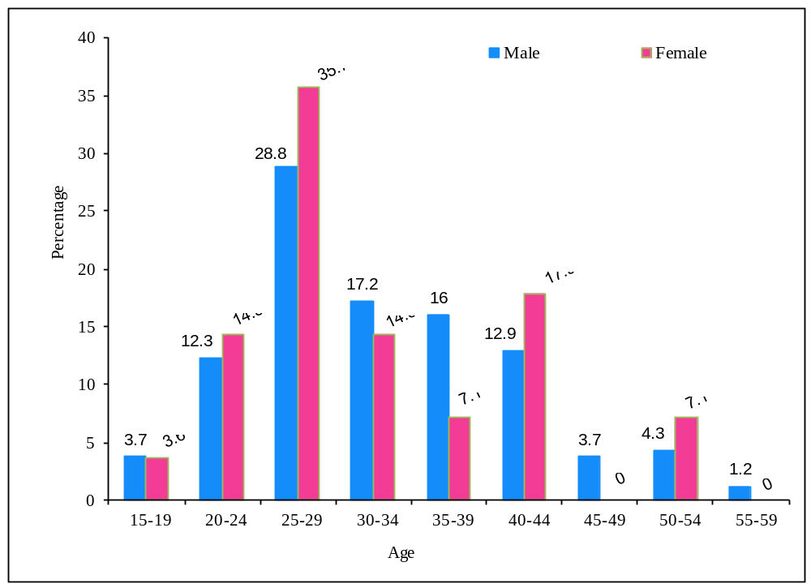

Figure 3.2: Percent Distribution of the De facto Survey Population by Five-Year Age
Groups, According to Sex – Plantation Workers

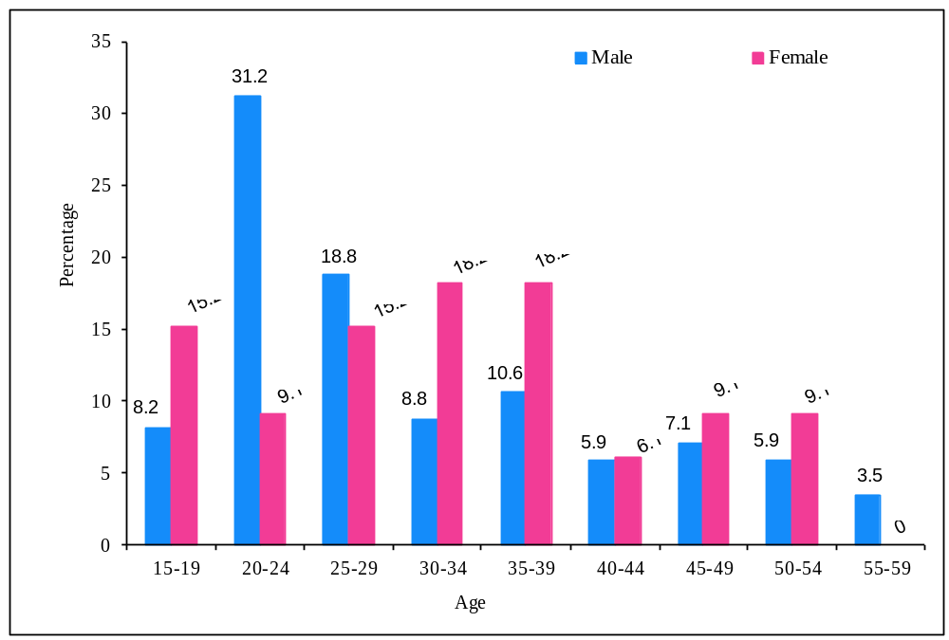

Figure 3.3: Percent Distribution of the De facto Survey Population by Five-Year Age
Groups, According to Sex – Uniformed Personnel

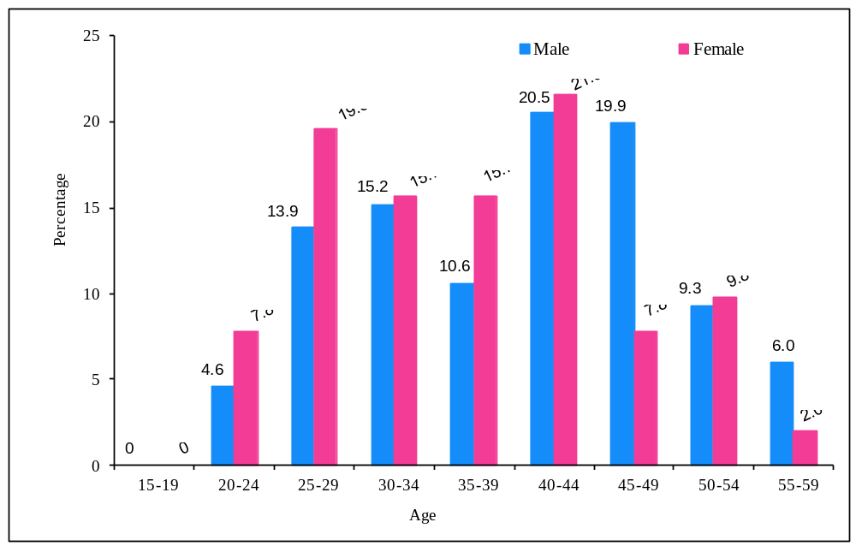

Figure 3.4: Percent Distribution of the De facto Survey Population by Five-Year Age
Groups– Female Sex Workers

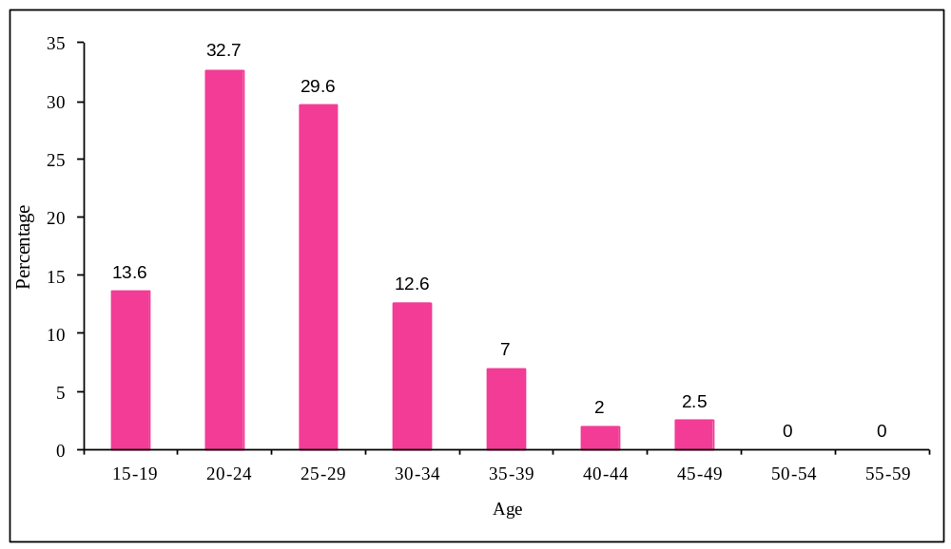

Figure 3.5: Percent Distribution of the De facto Survey Population by Five-Year Age
Groups – Truckers
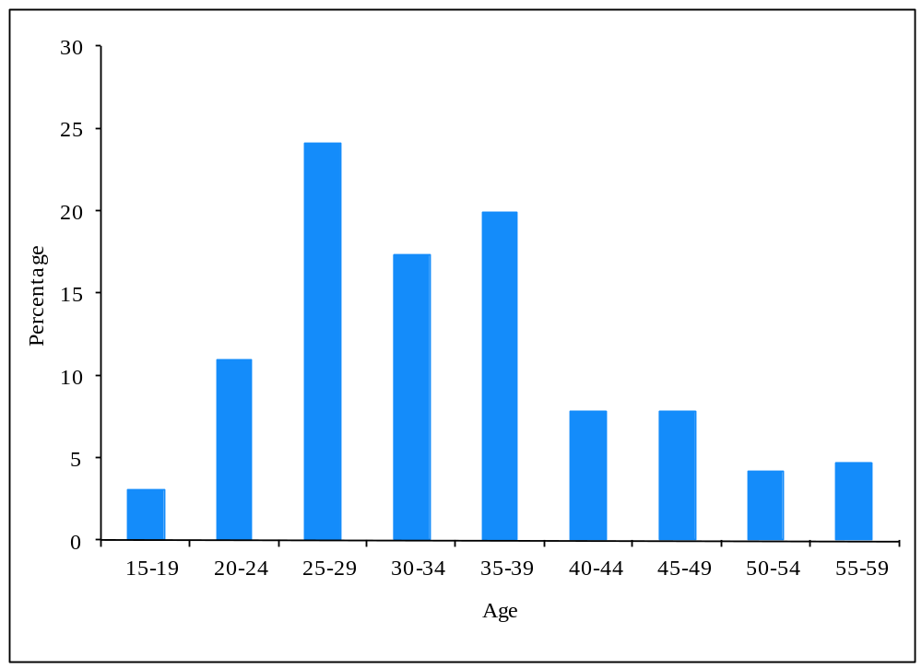
Figure 3.6: Percent Distribution of the De facto Survey Population by Five-Year Age
Groups – “Boda-Boda" motorcyclists

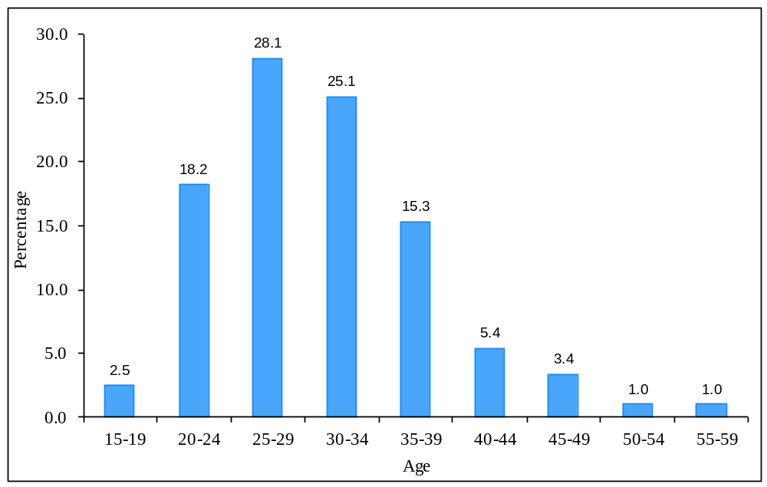

3.4 Marital Status
The majority of respondents were married ranging between 56.7% among plantation workers and over 70% for fisher folks, uniformed personnel, truckers and “Boda-Boda” motor cyclists. However, only 8.5% of the FSWs reported to be married and 43.25% to have either separated or divorced while 5% were widowed.

3.5 Education
The bulk of the respondents had attained education at least up to primary level especially among the fishing communities, FSWs and “Boda-boda” motorcyclists. However, among the uniformed personnel and plantations the majority had attained at least secondary level Education.

3.6 Variance between Birth and Current Location
The respondents were asked whether their current location of residence had been their place of residence since birth. It was noted that 44.3% of “ Boda- boda” motor cyclists have been in their respective areas since birth while the sex workers it was 16.6%;fisher- folks (24.6%);Plantation workers(31.5%) and uniformed personnel(6.4%).

3.7 Mobility
Mobility is associated to increased risk of HIV infection and the respondents were asked whether they have ever slept out over night in the last 12 months and how often this was done. It was noted that above 40% of the plantation workers and “Boda-boda” motorcyclists had never slept out over-night in the last 12 months. Surprisingly 19.9% of the truckers reported not to have slept out in the last 12months given the nature of their work. On the other hand as expected only 1.5% of the FSWs reported that they had never slept away from their homes in the last 12 months. As expected it was common for FSWs to stay out.

3.8 Media Characteristics
The respondents were asked to state their main source of information on health. In response it was noted that the radio and health workers were the main channels through which the different respondents received information on HIV. The respondents were allowed to make more than one response. The respondents were asked t o provide more than one response.

Table 3.2: Main channels of communication for HIV information

 | Main channels of communication for HIV/AIDS information and education.
 | Main Channels of Communication |  | Percentage of respondents receiving AIDS information and education from the channel **
 | Radio |  | 79.0
 | Health Workers |  | 45.5
 | Friends |  | 15.6
 | Teachers |  | 18.8
 | Newspapers/Magazines |  | 16.1
 | Television |  | 26.9
 | Family |  | 6.6
 | Peers |  | 5.6
 | Political Leaders |  | 1.4
 | Community Notices |  | 3.6
 | Religious Leaders |  | 2.3
 | Drama |  | 3.7
 | Posters |  | 2.2
 | Billboards |  | 1.0
 | Film |  | 3.4
 | Brochures |  | 1.0
 | Traditional Leaders |  | 0.8
 | Internet |  | 0.8
 | Number of respondents |  | 1189
 | ** A respondent was allowed to cite as many channels as he/she could

Figure 3.7: Top Six Sources of HIV/AIDS Information (n = 1,189)
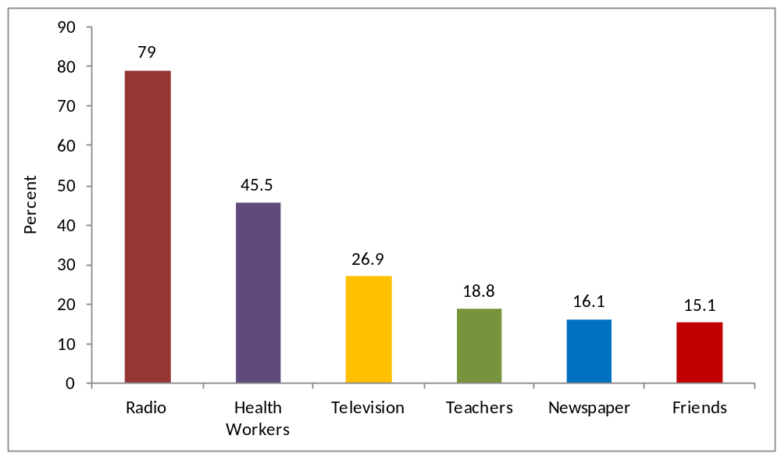

3.9 Common Messages on the Main Channel
The respondents were asked to state the most important message learnt from the main source of information and it was noted that condom use and limiting sex to one faithful partner were the messages most cited to have been learnt by the study population the details of which are stated in Table 3.3 and figure 3.8: below:

Figure 3.8: Top Five Messages Obtained from Most Important Source of AIDS Information (n = 1,189)
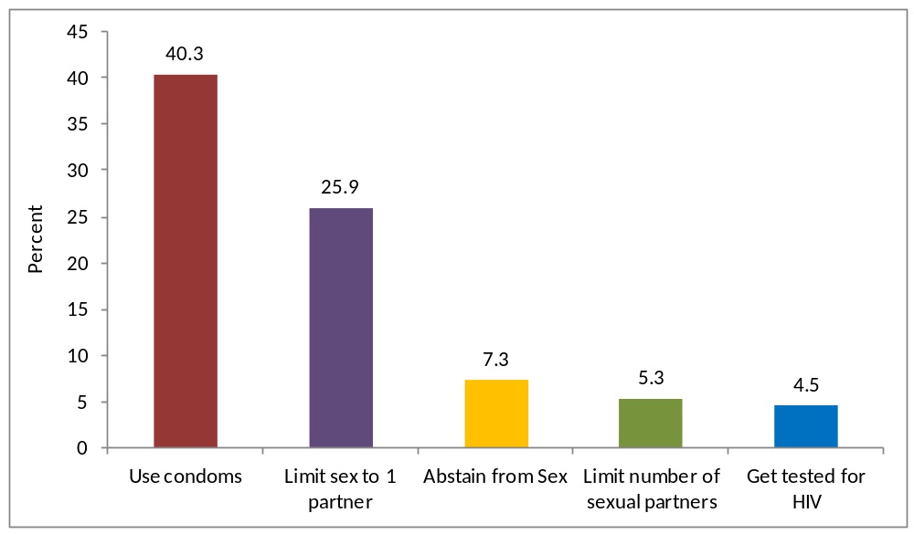

Table 3.3: The Four Main Messages on HIV Information

 | Most important message learned from main source of AIDS information.
 | Message learned from the main source of AIDS information |  | Percentage of respondents citing the message as the most important one they have learned
 | Limit Sex to one Partner/Stay Faithful to one Partner |  | 25.9
 | Use condoms |  | 40.3
 | Abstain from sex |  | 7.3
 | Get tested for AIDS (HIV) |  | 4.5
 | Limit Number of Sexual Partners |  | 5.3
 | AIDS is a killer |  | 3.7
 | Avoid Injections |  | 0.2
 | Anyone can get AIDS |  | 0.6
 | Don't take chances |  | 0.9
 | Avoid sex with prostitutes |  | 1.1
 | Avoid Discrimination against Persons Living with AIDS |  | 0.7
 | Follow the ABC's |  | 2.9
 | Anti-Retroviral drugs available prevent Mother to Child transmission |  | 0.9
 | Avoid Blood Transfusions |  | 0.3
 | Avoid sex with person who has many partners |  | 1.3
 | Avoid sex with homosexuals |  | 0.2
 | Avoid sex with drug users |  | 0.2
 | Others |  | 1.5
 | Number of respondents |  | 1189

CHAPTER FOUR

HIV Related Knowledge and Attitudes

4.0 Key Findings related to Knowledge and Attitudes

- The aggregated comprehensive knowledge for all the groups was 37.5% and it was slightly higher among the uniformed personnel with 46.5% and lowest among fisher folks with 27.7%. This compares with 22% in the general population in the study region.
- Knowledge of methods of HIV prevention was 75.6% for all the six MARPs. It was highest plantation workers (80.8%) and FSW (78.4%).
- Knowledge of the source of condoms was almost universal among some groups like “boda-boda” motor cyclists (98.5%), uniformed personnel (93.1%) and FSWs (93%). Overall, the knowledge of condom sources was 90% for all groups.
- Knowledge about cure Tuberculosis (TB) was high it was highest among the uniformed personnel (88.6%) and truckers (82.2%).It was lowest among “boda-boda”motor cyclists(759%). Overall, knowledge on cure was 81% for all the study groups.
- Misconceptions were common as 56.6% of the study population still had misconceptions on HIV.
- Accepting attitudes for PLHIV was low among the MARPs as less than 50% of the MARPs had positive attitudes. These were higher among uniformed personnel(46%) and lowest among FSW(22.6%).

4.1 Introduction
This section presents findings related to knowledge of the respondents on how HIV infection can be avoided, the comprehensive HIV knowledge, misconceptions/beliefs, and accepting attitudes for all the six groups at higher risk of HIV infection identified in the study. These are presented in consistence with the UNAIDS and national indicators related to HIV knowledge.

4.2 Knowledge of Prevention Methods
Knowledge indicator 1 measures the proportion of the population aged 15-49 years who know that you can avoid HIV infection by using a condom and limiting sex to one uninfected sexual partner. It is assumed having preventive knowledge enhances the use of protection during sexual intercourse and taking the appropriate behavioral change. Specifically, 75.6% of all the MARPs had knowledge of the three methods of preventing HIV infection namely: Abstinence, Being Faithful to one safe sexual partner and using condoms. Knowledge on limiting sex to one uninfected partner was highest among the respective respondents. The differences in knowledge did not change a lot with the education, religion, marital status and mobility. The details are presented in the figures and tables below:

Figure 4.1: Percent Citing Condom Use As a Prevention Method Against HIV by MARP Category

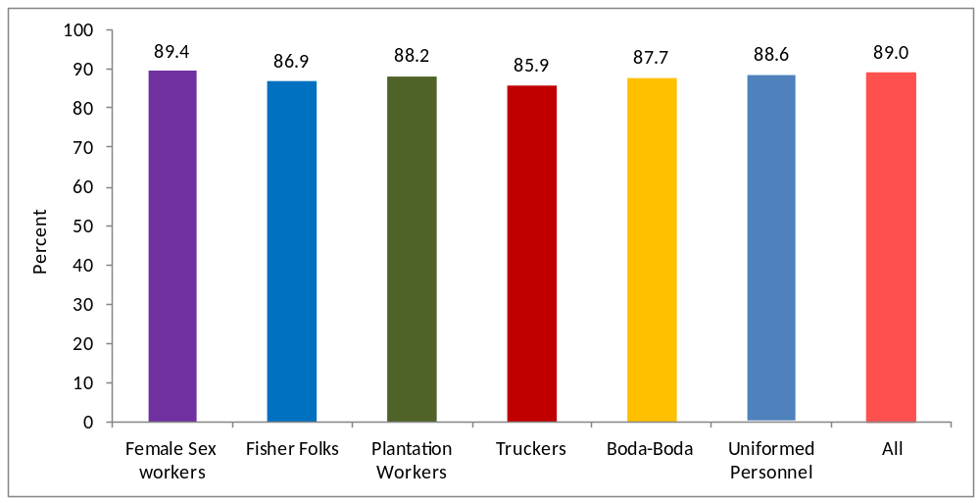

Figure 4.2: Percent Citing Limiting Sex to One Uninfected Partner As a Prevention Method Against HIV by MARP Category

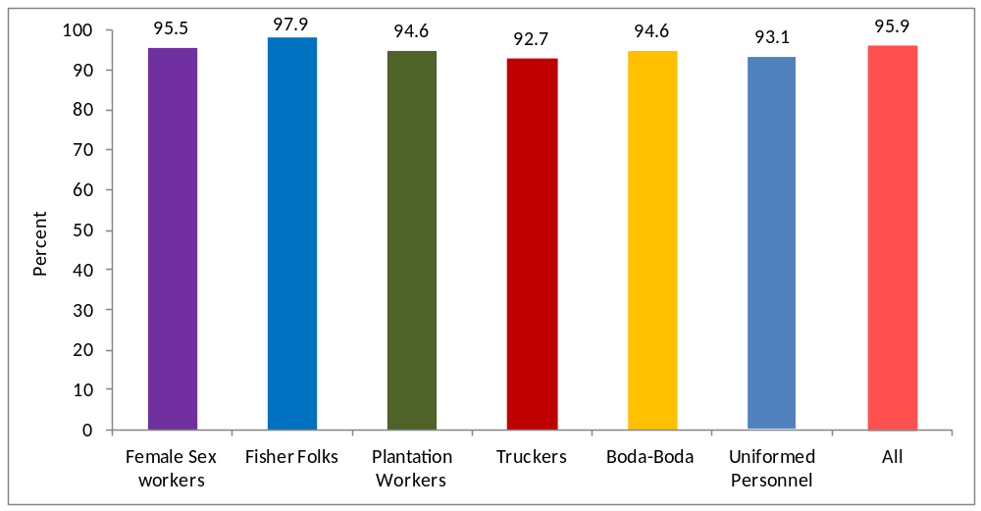

Figure 4.3: Percent Citing Abstaining From Sexual Intercourse As a Prevention Method Against HIV by MARP Category

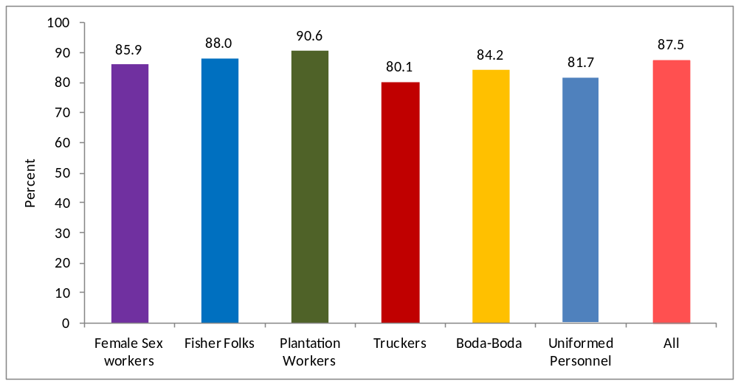

Figure 4.4: Percent Citing All The Three Prevention Methods Against HIV (Abstinence, Being faithful and Condom Use) by MARP Category

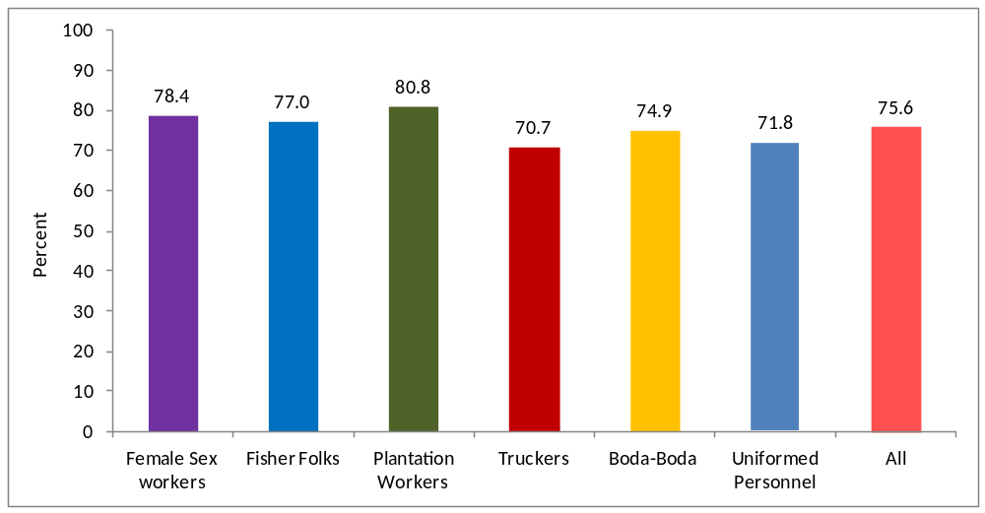

Table: 4.1: Knowledge of HIV prevention methods: Female Sex Workers (FSWs)

Knowledge of HIV prevention methods – Female Sex Workers (FSWs)
 |  |  | Knowledge of HIV prevention by:
Background characteristic |  |  | Using condoms |  | Limiting sex to one uninfected partner |  | Using condoms, and limiting sex to one uninfected partner¹ |  |  |  | Abstaining from sexual intercourse |  |  |  | Number of FSWs
Age
15-19 |  |  | (88.9) |  | (96.3) |  | (88.9) |  |  |  | (85.2) |  |  |  | 27
20-24 |  |  | 84.6 |  | 96.9 |  | 81.5 |  |  |  | 83.1 |  |  |  | 65
25-29 |  |  | 89.8 |  | 94.9 |  | 88.1 |  |  |  | 89.8 |  |  |  | 59
30-34 |  |  | (96.0) |  | (92.0) |  | (88.0) |  |  |  | (84.0) |  |  |  | 25
35-39 |  |  | * |  | * |  | * |  |  |  | * |  |  |  | 14
40-59 |  |  | * |  | * |  | * |  |  |  | * |  |  |  | 9
Marital status
Never married |  |  | 88.1 |  | 93.2 |  | 83.1 |  |  |  | 86.4 |  |  |  | 59
Married/ Living together |  |  | 90.5 |  | 97.6 |  | 88.1 |  |  |  | 76.2 |  |  |  | 42
Others ( Divorced,  Separated, Widowed etc) |  |  | 89.8 |  | 95.9 |  | 87.8 |  |  |  | 89.8 |  |  |  | 98
Education
Primary/Post Primary |  |  | 87.0 |  | 94.4 |  | 83.3 |  |  |  | 85.2 |  |  |  | 108
Secondary |  |  | 93.1 |  | 97.2 |  | 90.3 |  |  |  | 88.9 |  |  |  | 72
College/University |  |  | * |  | * |  | * |  |  |  | * |  |  |  | 2
Others |  |  | * |  | * |  | * |  |  |  | * |  |  |  | 17
Religion
Roman Catholic |  |  | 92.6 |  | 92.6 |  | 87.0 |  |  |  | 85.2 |  |  |  | 54
Protestant |  |  | 90.2 |  | 96.7 |  | 88.5 |  |  |  | 91.8 |  |  |  | 61
Born Again |  |  | * |  | * |  | * |  |  |  | * |  |  |  | 7
Muslim |  |  | 88.2 |  | 96.1 |  | 85.5 |  |  |  | 81.6 |  |  |  | 76
Others |  |  | * |  | * |  | * |  |  |  | * |  |  |  | 1
Distance to former place of residence
Born in that area |  |  | 90.9 |  | 90.9 |  | 84.8 |  |  |  | 84.8 |  |  |  | 33
Less than 29 Km |  |  | 86.8 |  | 100 |  | 86.8 |  |  |  | 76.3 |  |  |  | 38
30 - 100 Km |  |  | 90.6 |  | 93.8 |  | 85.9 |  |  |  | 92.2 |  |  |  | 64
100 Km and above |  |  | 89.8 |  | 96.6 |  | 88.1 |  |  |  | 84.7 |  |  |  | 59
Not Stated |  |  | * |  | * |  | * |  |  |  | * |  |  |  | 5
Frequency of travel in last 12 months
Never slept away |  |  | 87.5 |  | 91.3 |  | 82.5 |  |  |  | 81.3 |  |  |  | 80
1 - 5 trips |  |  | 89.9 |  | 97.5 |  | 87.3 |  |  |  | 87.3 |  |  |  | 79
Above 5 trips |  |  | 91.9 |  | 100 |  | 91.9 |  |  |  | 91.9 |  |  |  | 37
Not Stated |  |  | * |  | * |  | * |  |  |  | * |  |  |  | 3
Total |  |  | 89.4 |  | 95.5 |  | 86.1 |  |  |  | 85.9 |  |  |  | 199
¹Corresponds to UNAIDS Knowledge Indicator 1 "Knowledge of HIV prevention methods".
Note: Figures in parentheses are based on 20-29 cases while an asterisk indicates that a figure is based on less than 25 cases and has been suppressed.
Table 4.2 : Knowledge of HIV prevention methods – Fisher Folks
 |  |  | Knowledge of HIV prevention by:
Background characteristic |  |  | Using condoms |  | Limiting sex to one uninfected partner |  | Using condoms, and limiting sex to one uninfected partner¹ |  |  | Abstaining from sexual intercourse |  |  |  | Number of Fisher Folks
Age
15-19 |  |  | * |  | * |  | * |  |  | * |  |  |  | 7
20-24 |  |  | (91.7) |  | (95.8) |  | (87.5) |  |  | (91.7) |  |  |  | 24
25-29 |  |  | 87.7 |  | 96.5 |  | 86.0 |  |  | 87.7 |  |  |  | 57
30-34 |  |  | 90.6 |  | 96.9 |  | 90.6 |  |  | 87.5 |  |  |  | 32
35-39 |  |  | (82.1) |  | (100) |  | (82.1) |  |  | (82.1) |  |  |  | 28
40-59 |  |  | 81.4 |  | 100 |  | 81.4 |  |  | 90.7 |  |  |  | 43
Marital status
Never married |  |  | * |  | * |  | * |  |  | * |  |  |  | 16
Married/ Living together |  |  | 89.1 |  | 98.7 |  | 88.5 |  |  | 87.2 |  |  |  | 156
Others ( Divorced,  Separated, Widowed etc) |  |  | * |  | * |  | * |  |  | * |  |  |  | 19
Education
Primary/Post Primary |  |  | 88.2 |  | 97.6 |  | 87.4 |  |  | 89.0 |  |  |  | 127
Secondary |  |  | 86.8 |  | 100 |  | 86.8 |  |  | 86.8 |  |  |  | 38
College/University |  |  | * |  | * |  | * |  |  | * |  |  |  | 2
Others |  |  | (83.3) |  | (100) |  | (83.3) |  |  | (83.3) |  |  |  | 24
Religion
Roman Catholic |  |  | 84.7 |  | 96.6 |  | 83.1 |  |  | 89.8 |  |  |  | 59
Protestant |  |  | 91.7 |  | 98.3 |  | 91.7 |  |  | 86.7 |  |  |  | 60
Born Again |  |  | (95.2) |  | (95.2) |  | (90.5) |  |  | 85.7 |  |  |  | 21
Muslim |  |  | 81.3 |  | 100 |  | 81.3 |  |  | 87.5 |  |  |  | 48
Others |  |  | * |  | * |  | * |  |  | * |  |  |  | 3
Distance to former place of residence
Born in that area |  |  | 91.5 |  | 95.7 |  | 87.1 |  |  | 95.7 |  |  |  | 47
Less than 29 Km |  |  | (78.6) |  | (100) |  | (78.6) |  |  | 92.9 |  |  |  | 28
30 - 100 Km |  |  | 91.4 |  | 98.3 |  | 91.4 |  |  | 84.5 |  |  |  | 58
100 Km and above |  |  | 82.7 |  | 98.1 |  | 82.7 |  |  | 82.7 |  |  |  | 52
Not Stated |  |  | * |  | * |  | * |  |  | * |  |  |  | 6
Frequency of travel in last 12 months
Never slept away |  |  | 84.9 |  | 97.3 |  | 83.6 |  |  | 84.9 |  |  |  | 73
1 - 5 trips |  |  | 87.7 |  | 98.6 |  | 87.7 |  |  | 94.5 |  |  |  | 73
Above 5 trips |  |  | 88.9 |  | 97.8 |  | 86.7 |  |  | 82.2 |  |  |  | 45
Not Stated |  |  | * |  | * |  | * |  |  | * |  |  |  | 0
Total |  |  | 86.9 |  | 97.9 |  | 85.9 |  |  | 88.0 |  |  |  | 191
¹Corresponds to UNAIDS Knowledge Indicator 1 "Knowledge of HIV prevention methods".
Note: Figures in parentheses are based on 20-29 cases while an asterisk indicates that a figure is based on less than 20 cases and has been suppressed.
Table 4.3 : Knowledge of HIV prevention methods – Plantation Workers
 |  |  | Knowledge of HIV prevention by:
Background characteristic |  |  | Using condoms |  | Limiting sex to one uninfected partner |  | Using condoms, and limiting sex to one uninfected partner¹ |  |  | Abstaining from sexual intercourse
Age
15-19 |  |  | * |  | * |  | * |  |  | *
20-24 |  |  | 87.5 |  | 98.2 |  | 87.5 |  |  | 87.5
25-29 |  |  | 91.9 |  | 97.3 |  | 89.2 |  |  | 94.6
30-34 |  |  | (100) |  | (95.2) |  | (95.2) |  |  | (90.5)
35-39 |  |  | (87.5) |  | (95.8) |  | (87.5) |  |  | (91.7)
40-59 |  |  | 76.1 |  | 89.1 |  | 73.9 |  |  | 91.3
Marital status
Never married |  |  | 93.3 |  | 95.0 |  | 90.0 |  |  | 90.0
Married/ Living together |  |  | 89.3 |  | 95.0 |  | 86.8 |  |  | 90.9
Others ( Divorced,  Separated, Widowed etc) |  |  | (68.2) |  | (90.9) |  | (68.2) |  |  | (90.9)
Education
Primary/Post Primary |  |  | 87.5 |  | 95.0 |  | 85.0 |  |  | 91.3
Secondary |  |  | 91.2 |  | 95.6 |  | 87.9 |  |  | 91.2
College/University |  |  | * |  | * |  | * |  |  | *
Others |  |  | * |  | * |  | * |  |  | *
Religion
Roman Catholic |  |  | 91.4 |  | 96.6 |  | 89.7 |  |  | 87.9
Protestant |  |  | 91.8 |  | 95.1 |  | 90.2 |  |  | 93.4
Born Again |  |  | 76.5 |  | 88.2 |  | 70.6 |  |  | 88.2
Muslim |  |  | 91.1 |  | 95.6 |  | 88.9 |  |  | 91.1
Others |  |  | * |  | * |  | * |  |  | *
Distance to former place of residence
Born in that area |  |  | 92.2 |  | 92.2 |  | 89.1 |  |  | 93.8
Less than 29 Km |  |  | 90.2 |  | 97.6 |  | 87.8 |  |  | 90.2
30 - 100 Km |  |  | 85.1 |  | 95.5 |  | 83.6 |  |  | 94.0
100 Km and above |  |  | (84.6) |  | 92.3 |  | 80.8 |  |  | 76.9
Not Stated |  |  | * |  | * |  | * |  |  | *
Frequency of travel in last 12 months
Never slept away |  |  | 88.5 |  | 92.0 |  | 83.9 |  |  | 93.1
1 - 5 trips |  |  | 83.6 |  | 96.4 |  | 81.8 |  |  | 89.1
Above 5 trips |  |  | 93.9 |  | 100 |  | 93.9 |  |  | 90.9
Not Stated |  |  | (89.3) |  | (92.9) |  | (89.3) |  |  | 85.7
Total |  |  | 88.2 |  | 94.6 |  | 85.7 |  |  | 90.6
Table 4.4 : Knowledge of HIV prevention methods – Truckers
 |  |  |  | Knowledge of HIV prevention by:
Background characteristic |  |  |  | Using condoms |  | Limiting sex to one uninfected partner |  |  | Using condoms, and limiting sex to one uninfected partner¹ | Abstaining from sexual intercourse |  |  | Number of Truckers
Age
15-19 |  |  |  | * |  | * |  |  | * | * |  |  | 6
20-24 |  |  |  | (85.7) |  | (90.5) |  |  | (81.0) | (81.0) |  |  | 21
25-29 |  |  |  | 87.0 |  | 91.3 |  |  | 82.6 | 80.4 |  |  | 46
30-34 |  |  |  | 84.8 |  | 90.9 |  |  | 81.8 | 75.8 |  |  | 33
35-39 |  |  |  | 89.5 |  | 94.7 |  |  | 86.8 | 73.7 |  |  | 38
40-59 |  |  |  | 85.1 |  | 97.9 |  |  | 85.1 | 89.4 |  |  | 47
Marital status
Never married |  |  |  | (100) |  | (92.9) |  |  | (92.9) | (82.1) |  |  | 28
Married/ Living together |  |  |  | 85.4 |  | 94.0 |  |  | 83.4 | 80.1 |  |  | 151
Others (Divorced,  Separated, Widowed etc) |  |  |  | * |  | * |  |  | * | * |  |  | 12
Education
Primary/Post Primary |  |  |  | 77.8 |  | 90.1 |  |  | 74.1 | 77.8 |  |  | 81
Secondary |  |  |  | 92.2 |  | 96.7 |  |  | 91.1 | 83.3 |  |  | 90
College/University |  |  |  | * |  | * |  |  | * | * |  |  | 15
Others |  |  |  | * |  | * |  |  | * | * |  |  | 5
Religion
Roman Catholic |  |  |  | 88.2 |  | 96.1 |  |  | 88.2 | 80.4 |  |  | 51
Protestant |  |  |  | 91.2 |  | 93.0 |  |  | 86.0 | 86.0 |  |  | 57
Born Again |  |  |  | * |  | * |  |  | * | * |  |  | 8
Muslim |  |  |  | 80.9 |  | 91.2 |  |  | 77.9 | 79.4 |  |  | 68
Others |  |  |  | * |  | * |  |  | * | * |  |  | 7
Distance to former place of residence
Born in that area |  |  |  | 83.3 |  | 95.0 |  |  | 83.3 | 81.7 |  |  | 60
Less than 29 Km |  |  |  | * |  | * |  |  | * | * |  |  | 14
30 - 100 Km |  |  |  | 91.2 |  | 91.2 |  |  | 85.3 | 79.4 |  |  | 34
100 Km and above |  |  |  | 87.0 |  | 91.3 |  |  | 82.6 | 81.2 |  |  | 69
Not Stated |  |  |  | * |  | * |  |  | * | * |  |  | 14
Frequency of travel in last 12 months
Never slept away |  |  |  | 84.2 |  | 97.4 |  |  | 84.2 | 86.8 |  |  | 38
1 - 5 trips |  |  |  | 86.7 |  | 93.3 |  |  | 83.3 | 73.3 |  |  | 30
Above 5 trips |  |  |  | 85.5 |  | 90.6 |  |  | 82.1 | 79.5 |  |  | 117
Not Stated |  |  |  | * |  | * |  |  | * | * |  |  | 6
Total |  |  |  | 85.9 |  | 92.7 |  |  | 83.2 | 80.1 |  |  | 191
¹Corresponds to UNAIDS Knowledge Indicator 1 "Knowledge of HIV prevention methods".
Note: Figures in parentheses are based on 20-29 cases while an asterisk indicates that a figure is based on less than 20 cases and has been suppressed.

Table 4.5 : Knowledge of HIV prevention methods – “Boda-Boda “motor cyclists
 |  | Knowledge of HIV prevention by:
Background characteristic |  | Using condoms | Limiting sex to one uninfected partner | Using condoms, and limiting sex to one uninfected partner¹ | Abstaining from sexual intercourse | Number of Boda-Boda motor Cyclist
Age
15-19 |  | * | * | * | * | 5
20-24 |  | 91.9 | 86.5 | 81.1 | 78.4 | 37
25-29 |  | 86.0 | 96.5 | 86.0 | 87.7 | 57
30-34 |  | 88.2 | 96.1 | 86.3 | 76.5 | 51
35-39 |  | 87.1 | 96.8 | 83.9 | 87.1 | 31
40-59 |  | (81.8) | (95.5) | (77.3) | (95.5) | 22
Marital status
Never married |  | * | * | * | * | 15
Married/ Living together |  | 86.3 | 94.5 | 83.0 | 83.5 | 182
Others( Divorced,  Separated, Widowed etc) |  | * | * | * | * | 6
Education
Primary/Post Primary |  | 86.0 | 94.1 | 82.4 | 83.1 | 136
Secondary |  | 91.1 | 96.4 | 89.3 | 87.5 | 56
College/University |  | * | * | * | * | 1
Others |  | * | * | * | * | 10
Religion
Roman Catholic |  | 90.9 | 97.0 | 87.9 | 81.8 | 33
Protestant |  | 87.5 | 93.8 | 83.3 | 87.5 | 48
Born Again |  | * | * | * | * | 11
Muslim |  | 88.9 | 95.4 | 86.1 | 84.3 | 108
Others |  | * | * | * | * | 3
Distance to former place of residence
Born in that area |  | 90.0 | 97.8 | 88.9 | 85.6 | 90
Less than 29 Km |  | 83.8 | 90.5 | 78.4 | 86.5 | 74
30 - 100 Km |  | (92.3) | (92.3) | (84.6) | (73.1) | 26
100 Km and above |  | * | * | * | * | 12
Not Stated |  | * | * | * | * | 1
Frequency of travel in last 12 months
Never slept away |  | 86.0 | 93.5 | 81.7 | 86.0 | 93
1 - 5 trips |  | 92.2 | 96.9 | 89.1 | 84.4 | 64
Above 5 trips |  | 85.7 | 95.2 | 83.3 | 83.3 | 42
Not Stated |  | * | * | * | * | 4
Total |  | 87.7 | 94.6 | 84.2 | 84.2 | 203
¹Corresponds to UNAIDS Knowledge Indicator 1 "Knowledge of HIV prevention methods".
Note: Figures in parentheses are based on 20-29 cases while an asterisk indicates that a figure is based on less than 20 cases and has been suppressed.

Table 4.6: Knowledge of HIV prevention methods – Uniformed Personnel
 |  | Knowledge of HIV prevention by:
Background characteristic |  | Using condoms | Limiting sex to one uninfected partner | Using condoms, and limiting sex to one uninfected partner¹ | Abstaining from sexual intercourse | Number of Uniformed Personnel
Age
15-19 |  | * | * | * | * | 0
20-24 |  | * | * | * | * | 11
25-29 |  | 93.5 | 100 | 93.5 | 83.9 | 31
30-34 |  | 77.4 | 93.5 | 77.4 | 87.1 | 31
35-39 |  | (95.8) | (91.7) | (87.5) | (91.7) | 24
40-59 |  | 89.5 | 90.5 | 84.8 | 80.0 | 105
Marital status
Never married |  | * | * | * | * | 9
Married/ Living together |  | 88.1 | 93.2 | 84.7 | 82.4 | 176
Others ( Divorced,  Separated, Widowed etc) |  | * | * | * | * | 17
Education
Primary/Post Primary |  | 91.4 | 91.4 | 85.7 | 77.1 | 35
Secondary |  | 87.1 | 92.1 | 83.6 | 82.1 | 140
College/University |  | (92.3) | (100) | (92.3) |  | 26
Others |  | * | * | * | * | 1
Religion
Roman Catholic |  | 91.2 | 91.2 | 85.3 | 88.2 | 68
Protestant |  | 92.0 | 94.3 | 88.6 | 80.7 | 88
Born Again |  | * | * | * | * | 16
Muslim |  | (76.0) | (92.0) | (76.0) | (76.0) | 25
Others |  | * | * | * | * | 5
Distance to former place of residence
Born in that area |  | * | * | * | * | 13
Less than 29 Km |  | 86.1 | 91.7 | 80.6 | 80.6 | 36
30 - 100 Km |  | 91.2 | 94.1 | 89.7 | 80.9 | 68
100 Km and above |  | 87.0 | 94.8 | 83.1 | 83.1 | 77
Not Stated |  | * | * | * | * | 8
Frequency of travel in last 12 months
Never slept away |  | 90.8 | 96.9 | 90.8 | 81.5 | 65
1 - 5 trips |  | 90.9 | 92.4 | 86.4 | 83.3 | 66
Above 5 trips |  | 84.8 | 90.9 | 78.8 | 80.3 | 66
Not Stated |  | * | * | * | * | 5
Total |  | 88.6 | 93.1 | 85.1 | 81.7 | 202
¹Corresponds to UNAIDS Knowledge Indicator 1 "Knowledge of HIV prevention methods".
Note: Figures in parentheses are based on 20-29 cases while an asterisk indicates that a figure is based on less than 20 cases and has been suppressed.

4.3 Comprehensive HIV Knowledge
Comprehensive knowledge indicator refers to the percentage of respondents who say that people can reduce the risk of getting the HIV virus by using a condom every time they have sex and by having sex with just one partner who is not infected and who has no other partners, who say that people cannot get the AIDS virus from mosquito bites or from sharing food with a person who has AIDS, and who say that a healthy-looking person can have the AIDS virus. This information was collected for all MARPs under this study. It was noted that for all the groups the comprehensive knowledge was 37.5% and it was highest among the uniformed personnel where it was 46.5% and lowest among the fisher folks(27.7%) and “boda-boda “motor cyclists (30.5%).Among all the groups comprehensive knowledge increased with level of education apart from the uniformed personnel where it reduced with the level of education. Overall, there were no big differences in relation to religion apart from the scenario of FSWs where comprehensive knowledge was 25.9% among the Roman Catholics compared to 41% among the Protestants. Generally comprehensive knowledge was higher in the study population compared to the general population which was 22% (STAR –EC LQAs Report 2011) in the study region. The details are presented in the figures 4.6 below:

Figure 4.6: Comprehensive HIV knowledge by MARPs

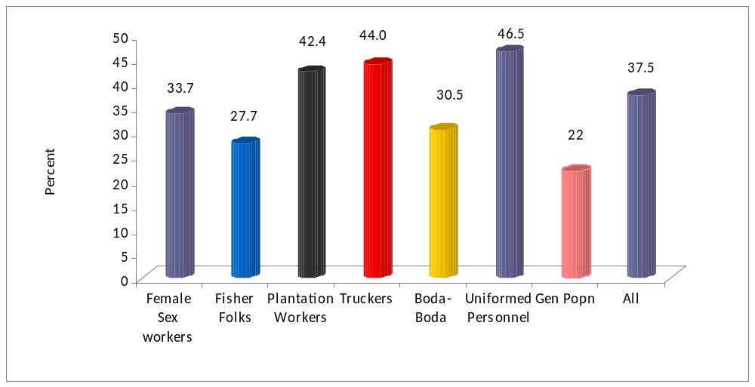

4.4 Beliefs and Misconceptions
Misconceptions and wrong beliefs related to HIV are known to contribute to risky behaviours among the targeted populations. The study population provided a response to prompted questions on whether a healthy looking person can have the HIV virus, whether a mosquito bite can transmit HIV, whether AIDS cannot be transmitted with super natural powers and if a person can be infected by sharing instruments with someone who has AIDS&HIV. The interest of this area is to determine the percentage of respondents who reject the two common misconceptions and say that the healthy looking person can have the HIV virus.
It was observed that misconceptions are still prevalent. Specifically only 30.9% of the fisher folks,36.5% of “boda-boda “motor cyclists and 36.7% of the FSWs were able to reject two most common misconceptions that is HIV transmission through mosquito bites and sharing utensils and saying a health looking person can have the AIDS virus. About 50% of truckers and uniformed personnel had no incorrect beliefs about AIDS and said that a healthy looking person can have the AIDS virus. On the other hand some misconceptions were still common as only 48.7% of the fisher folks and 47.8% the “Boda-boda”motor cyclists knew that the mosquito cannot transmit the HIV virus. On the other hand about 80% of all the study groups were aware that a healthy looking person could have the HIV virus.The implication of misconceptions on HIV transmission through mosquitoes which is more prevalent among the fisher folks and “Boda- Boda” motorcyclists may affect risk perception among these categories as they would believe that they are already infected through these means. Only 43.4% of all the study MARPs rejected all the three misconceptions (Mosquito bites, witch craft and sharing utensils).This level of rejection of the three misconceptions is lower than that observed in the general population which was 51.8% (STAR –EC LQAs Report 2011)This is shown in figure 4.7 below:

Figure 4.7: Proportion of Respondents Who Reject All the 3 Major Misconceptions about AIDS (Mosquito Bites, Witchcraft, Sharing Utensils)
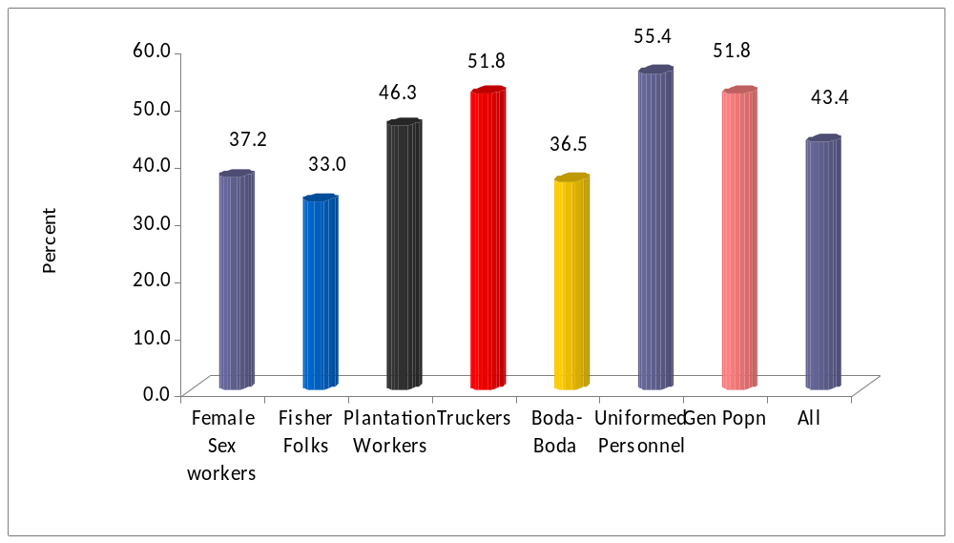

Figure 4.8 : Proportion of Respondents Who Have No Incorrect Beliefs About AIDS

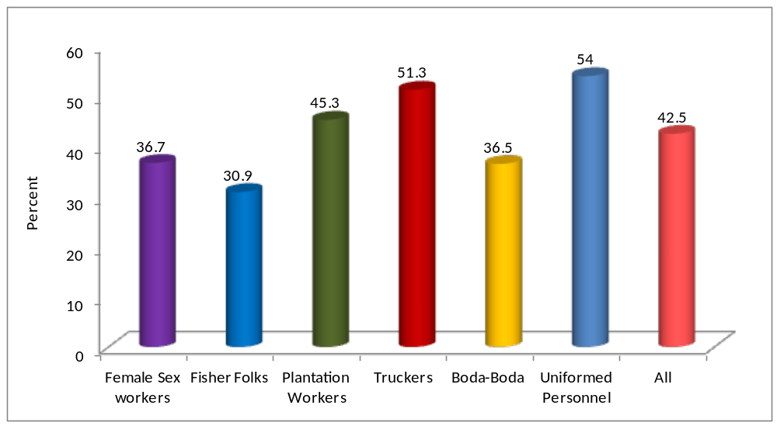

4.5 Accepting Attitudes to People Living with HIV&AIDS.
As a means of measuring the level of stigma and discrimination the respondents were asked four questions: whether they would be willing to care for a family member with HIV at home; would buy fresh vegetables or fish from a vendor who has HIV; believe HIV positive teacher should be allowed to continue teaching and whether they are supportive of disclosing of HIV status of a family member.
The uniformed personnel had better accepting attitudes towards people living with HIV compared to the rest of the groups that is 46% of the uniformed personnel were supportive of all the four elements of supporting people living with HIV. The least supportive were the FSWs (22.6%) followed by“Boda-boda” motor cyclists (27.1%), plantation workers(30.5%),truckers(31.9%) and fisher folks (32.5%).The accepting attitudes among the MARPs were generally low for all groups (31.8%)and therefore a gap which needs to be addressed. The accepting attitudes appear comparatively higher in the study population as only 19% of the females and 29% of the males had all the four accepting attitudes in the general population nationally ( UHSBS 2004-05). On the hand for all the four indicators of misconceptions, among fisher folks in the lake Victoria basin the result shows that 40% of women and 45% of men express positive attitudes on all four indicators(HIV Sero-Behavioural Survey among fishing communities in lake Victoria Basin 2010).

Figure 4.9: Proportion of Respondents who Express Accepting Attitudes on All 4 Measures by MARP Category
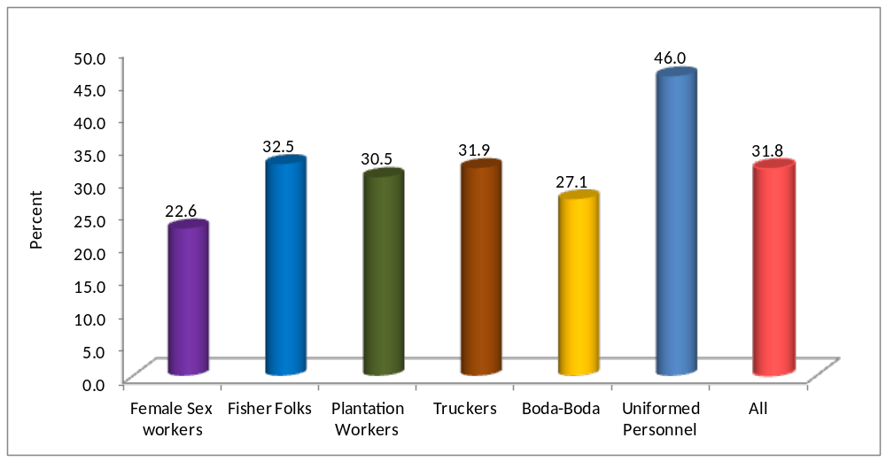

Table 4.7: Accepting Attitudes Toward Those Living With HIV – Female Sex Workers
Among respondents who have heard of HIV/AIDS, percentage expressing accepting attitudes toward people with HIV, by selected background characteristics
 |  |  |  |  | Percentage of respondents who : |  |  |  |  |  |  |  |  |  |  |  |  |  |  |  | Percentage expressing accepting attitudes on all four measures¹
Background characteristic |  |  |  |  | Are willing to care for a family member with HIV at home |  |  |  | Would buy fresh vegetables or fish from a vendor who has HIV |  |  |  | Believe HIV positive female teacher should be allowed to keep teaching |  |  |  | Would not want HIV+ status of a family member to remain a secret |  |  |  |  |  | Number of respondents
Age
15-19 |  |  |  |  | (100) |  |  |  | (77.8) |  |  |  | (74.1) |  |  |  | (18.5) |  |  |  | (7.4) |  | 27
20-24 |  |  |  |  | 90.8 |  |  |  | 83.1 |  |  |  | 86.2 |  |  |  | 32.3 |  |  |  | 24.6 |  | 65
25-29 |  |  |  |  | 91.5 |  |  |  | 89.8 |  |  |  | 81.4 |  |  |  | 30.5 |  |  |  | 23.7 |  | 59
30-34 |  |  |  |  | (100) |  |  |  | (88.0) |  |  |  | (92.0) |  |  |  | (40.0) |  |  |  | (32.0) |  | 25
35-39 |  |  |  |  | * |  |  |  | * |  |  |  | * |  |  |  | * |  |  |  | * |  | 14
40-59 |  |  |  |  | * |  |  |  | * |  |  |  | * |  |  |  | * |  |  |  | * |  | 9
Marital status
Never married |  |  |  |  | 93.2 |  |  |  | 81.4 |  |  |  | 88.1 |  |  |  | 28.8 |  |  |  | 16.9 |  | 59
Married/ Living together |  |  |  |  | 95.2 |  |  |  | 85.7 |  |  |  | 83.3 |  |  |  | 26.2 |  |  |  | 19.0 |  | 42
Others like Divorced |  |  |  |  | 94.9 |  |  |  | 89.8 |  |  |  | 82.7 |  |  |  | 31.6 |  |  |  | 27.6 |  | 98
Education
Primary/Post Primary |  |  |  |  | 94.4 |  |  |  | 82.4 |  |  |  | 83.3 |  |  |  | 31.5 |  |  |  | 25.0 |  | 108
Secondary |  |  |  |  | 93.1 |  |  |  | 91.7 |  |  |  | 87.5 |  |  |  | 27.8 |  |  |  | 20.8 |  | 72
College/University |  |  |  |  | * |  |  |  | * |  |  |  | * |  |  |  | * |  |  |  | * |  | 2
Others |  |  |  |  | * |  |  |  | * |  |  |  | * |  |  |  | * |  |  |  | * |  | 17
Religion
Roman Catholic |  |  |  |  | 100 |  |  |  | 88.9 |  |  |  | 87.0 |  |  |  | 31.5 |  |  |  | 24.1 |  | 54
Protestant |  |  |  |  | 86.9 |  |  |  | 83.6 |  |  |  | 83.6 |  |  |  | 37.7 |  |  |  | 26.2 |  | 61
Born Again |  |  |  |  | * |  |  |  | * |  |  |  | * |  |  |  | * |  |  |  | * |  | 7
Muslim |  |  |  |  | 97.4 |  |  |  | 88.2 |  |  |  | 84.2 |  |  |  | 23.7 |  |  |  | 21.1 |  | 76
Others |  |  |  |  | * |  |  |  | * |  |  |  | * |  |  |  | * |  |  |  | * |  | 1
Distance to former place of residence
Born in that area |  |  |  |  | 97.0 |  |  |  | 81.8 |  |  |  | 81.8 |  |  |  | 33.3 |  |  |  | 27.3 |  | 33
Less than 29 Km |  |  |  |  | 97.4 |  |  |  | 84.2 |  |  |  | 81.6 |  |  |  | 21.1 |  |  |  | 13.2 |  | 38
30 - 100 Km |  |  |  |  | 93.8 |  |  |  | 85.9 |  |  |  | 89.1 |  |  |  | 34.4 |  |  |  | 26.6 |  | 64
100 Km and above |  |  |  |  | 91.5 |  |  |  | 89.8 |  |  |  | 81.4 |  |  |  | 30.5 |  |  |  | 23.7 |  | 59
Not Stated |  |  |  |  | * |  |  |  | * |  |  |  | * |  |  |  | * |  |  |  | * |  | 5
Frequency of travel in last 12 months
Never slept away |  |  |  |  | 96.3 |  |  |  | 82.5 |  |  |  | 83.8 |  |  |  | 31.3 |  |  |  | 20.0 |  | 80
1 - 5 trips |  |  |  |  | 93.7 |  |  |  | 91.1 |  |  |  | 86.1 |  |  |  | 26.6 |  |  |  | 21.5 |  | 79
Above 5 trips |  |  |  |  | 91.9 |  |  |  | 83.8 |  |  |  | 86.5 |  |  |  | 32.4 |  |  |  | 29.7 |  | 37
Not Stated |  |  |  |  | * |  |  |  | * |  |  |  | * |  |  |  | * |  |  |  | * |  | 3
Total |  |  |  |  | 94.5 |  |  |  | 86.4 |  |  |  | 84.4 |  |  |  | 29.6 |  |  |  | 22.6 |  | 199
¹Corresponds to Emergency Plan Policy and Systems Strengthening (Capacity Building) Indicator 2 "Percent of the general population with accepting attitudes toward persons living with HIV/AIDS" and to UNAIDS Stigma and Discrimination Indicator 1 "Accepting attitudes toward those living with HIV".
Note: Figures in parentheses are based on 20-29 cases while an asterisk indicates that a figure is based on less than 20 cases and has been suppressed.

Table 4.8: Accepting Attitudes Toward Those Living With HIV – Fisher Folks
Among respondents who have heard of HIV/AIDS, percentage expressing accepting attitudes toward people with HIV, by selected background characteristics
 |  |  |  | Percentage of respondents who : |  |  |  |  |  |  |  |  |  |  |  |  |  |  |  | Percentage expressing accepting attitudes on all four measures¹
Background characteristic |  |  |  | Are willing to care for a family member with HIV at home |  |  |  | Would buy fresh vegetables or fish from a vendor who has HIV |  |  |  | Believe HIV positive female teacher should be allowed to keep teaching |  |  |  | Would not want HIV+ status of a family member to remain a secret |  |  |  |  |  | Number of respondents
Age
15-19 |  |  |  | * |  |  |  | * |  |  |  | * |  |  |  | * |  |  |  | * |  | 7
20-24 |  |  |  | (95.8) |  |  |  | (79.2) |  |  |  | (91.7) |  |  |  | (33.3) |  |  |  | (29.2) |  | 24
25-29 |  |  |  | 87.7 |  |  |  | 89.5 |  |  |  | 75.4 |  |  |  | 38.6 |  |  |  | 26.3 |  | 57
30-34 |  |  |  | 96.9 |  |  |  | 81.3 |  |  |  | 81.3 |  |  |  | 50.0 |  |  |  | 34.4 |  | 32
35-39 |  |  |  | (92.9) |  |  |  | (89.3) |  |  |  | (78.6) |  |  |  | (50.0) |  |  |  | (42.9) |  | 28
40-59 |  |  |  | 100 |  |  |  | 90.7 |  |  |  | 81.4 |  |  |  | 58.1 |  |  |  | 34.9 |  | 43
Marital status
Never married |  |  |  | * |  |  |  | * |  |  |  | * |  |  |  | * |  |  |  | * |  | 16
Married/ Living together |  |  |  | 93.6 |  |  |  | 85.9 |  |  |  | 79.5 |  |  |  | 44.9 |  |  |  | 30.1 |  | 156
Others like Divorced |  |  |  | * |  |  |  | * |  |  |  | * |  |  |  | * |  |  |  | * |  | 19
Education
Primary/Post Primary |  |  |  | 94.5 |  |  |  | 85.8 |  |  |  | 81.9 |  |  |  | 44.1 |  |  |  | 29.9 |  | 127
Secondary |  |  |  | 92.1 |  |  |  | 94.7 |  |  |  | 86.8 |  |  |  | 60.5 |  |  |  | 44.7 |  | 38
College/University |  |  |  | * |  |  |  | * |  |  |  | * |  |  |  | * |  |  |  | * |  | 2
Others |  |  |  | 91.7 |  |  |  | 79.2 |  |  |  | 66.7 |  |  |  | 37.5 |  |  |  | 29.2 |  | 24
Religion
Roman Catholic |  |  |  | 96.6 |  |  |  | 88.1 |  |  |  | 83.1 |  |  |  | 52.5 |  |  |  | 39.0 |  | 59
Protestant |  |  |  | 91.7 |  |  |  | 85.0 |  |  |  | 83.3 |  |  |  | 48.3 |  |  |  | 33.3 |  | 60
Born Again |  |  |  | (90.5) |  |  |  | (90.5) |  |  |  | (81.0) |  |  |  | 42.9 |  |  |  | 28.6 |  | 21
Muslim |  |  |  | 93.8 |  |  |  | 85.4 |  |  |  | 77.1 |  |  |  | 37.5 |  |  |  | 25.0 |  | 48
Others |  |  |  | * |  |  |  | * |  |  |  | * |  |  |  | * |  |  |  | * |  | 3
Distance to former place of residence
Born in that area |  |  |  | 95.7 |  |  |  | 87.2 |  |  |  | 80.9 |  |  |  | 55.3 |  |  |  | 38.3 |  | 47
Less than 29 Km |  |  |  | 96.4 |  |  |  | 85.7 |  |  |  | 85.7 |  |  |  | 42.9 |  |  |  | 35.7 |  | 28
30 - 100 Km |  |  |  | 86.2 |  |  |  | 86.2 |  |  |  | 74.1 |  |  |  | 41.4 |  |  |  | 22.4 |  | 58
100 Km and above |  |  |  | 98.1 |  |  |  | 88.5 |  |  |  | 84.6 |  |  |  | 46.2 |  |  |  | 36.5 |  | 52
Not Stated |  |  |  | * |  |  |  | * |  |  |  | * |  |  |  | * |  |  |  | * |  | 6
Frequency of travel in last 12 months
Never slept away |  |  |  | 94.5 |  |  |  | 87.7 |  |  |  | 75.3 |  |  |  | 47.9 |  |  |  | 35.6 |  | 73
1 - 5 trips |  |  |  | 90.4 |  |  |  | 86.3 |  |  |  | 82.2 |  |  |  | 46.6 |  |  |  | 31.5 |  | 73
Above 5 trips |  |  |  | 97.8 |  |  |  | 86.7 |  |  |  | 88.9 |  |  |  | 42.2 |  |  |  | 28.9 |  | 45
Not Stated |  |  |  | * |  |  |  | * |  |  |  | * |  |  |  | * |  |  |  | * |  | 0
Total |  |  |  | 93.7 |  |  |  | 86.9 |  |  |  | 81.2 |  |  |  | 46.1 |  |  |  | 32.5 |  | 191
¹Corresponds to Emergency Plan Policy and Systems Strengthening (Capacity Building) Indicator 2 "Percent of the general population with accepting attitudes toward persons living with HIV/AIDS" and to UNAIDS Stigma and Discrimination Indicator 1 "Accepting attitudes toward those living with HIV".
Note: Figures in parentheses are based on 20-29 cases while an asterisk indicates that a figure is based on less than 20 cases and has been suppressed.

Table 4.9: Accepting Attitudes Toward Those Living With HIV – Plantation Workers
Among respondents who have heard of HIV/AIDS, percentage expressing accepting attitudes toward people with HIV, by selected background characteristics
 |  |  |  | Percentage of respondents who : |  |  |  |  |  |  |  | Percentage expressing accepting attitudes on all four measures¹
Background characteristic |  |  |  | Are willing to care for a family member with HIV at home |  | Would buy fresh vegetables or fish from a vendor who has HIV |  | Believe HIV positive female teacher should be allowed to keep teaching |  | Would not want HIV+ status of a family member to remain a secret |  |  | Number of respondents
Age
15-19 |  |  |  | * |  | * |  | * |  | * |  | * | 19
20-24 |  |  |  | 89.3 |  | 91.1 |  | 87.5 |  | 50.0 |  | 35.7 | 56
25-29 |  |  |  | 89.2 |  | 97.3 |  | 83.8 |  | 45.9 |  | 29.7 | 37
30-34 |  |  |  | (81.0) |  | (85.7) |  | (81.0) |  | (66.7) |  | (23.8) | 21
35-39 |  |  |  | (91.7) |  | (79.2) |  | (79.2) |  | (37.5) |  | (29.2) | 24
40-59 |  |  |  | 87.0 |  | 73.9 |  | 71.7 |  | 52.2 |  | 37.0 | 46
Marital status
Never married |  |  |  | 91.7 |  | 88.3 |  | 83.3 |  | 38.3 |  | 28.3 | 60
Married/ Living together |  |  |  | 85.1 |  | 83.5 |  | 77.7 |  | 52.1 |  | 32.2 | 121
Others like Divorced |  |  |  | (90.9) |  | (86.4) |  | (81.8) |  | (45.5) |  | (27.3) | 22
Education
Primary/Post Primary |  |  |  | 82.5 |  | 83.8 |  | 70.0 |  | 43.8 |  | 21.3 | 80
Secondary |  |  |  | 90.1 |  | 90.1 |  | 87.9 |  | 48.4 |  | 35.2 | 91
College/University |  |  |  | * |  | * |  | * |  | * |  | * | 18
Others |  |  |  | * |  | * |  | * |  | * |  | * | 14
Religion
Roman Catholic |  |  |  | 84.5 |  | 84.5 |  | 82.8 |  | 51.7 |  | 29.3 | 58
Protestant |  |  |  | 86.9 |  | 88.5 |  | 82.0 |  | 41.0 |  | 27.9 | 61
Born Again |  |  |  | 82.4 |  | 82.4 |  | 76.5 |  | 52.9 |  | 32.4 | 34
Muslim |  |  |  | 95.6 |  | 86.7 |  | 80.0 |  | 46.7 |  | 35.6 | 45
Others |  |  |  | * |  | * |  | * |  | * |  | * | 5
Distance to former place of residence
Born in that area |  |  |  | 85.9 |  | 85.9 |  | 81.3 |  | 50.0 |  | 32.8 | 64
Less than 29 Km |  |  |  | 90.2 |  | 80.5 |  | 80.5 |  | 41.5 |  | 24.4 | 41
30 - 100 Km |  |  |  | 86.6 |  | 86.6 |  | 80.6 |  | 44.8 |  | 29.9 | 67
100 Km and above |  |  |  | (92.3) |  | (84.6) |  | (73.1) |  | (53.8) |  | (34.6) | 26
Not Stated |  |  |  | * |  | * |  | * |  | * |  | * | 5
Frequency of travel in last 12 months
Never slept away |  |  |  | 88.5 |  | 85.1 |  | 74.7 |  | 52.9 |  | 34.5 | 87
1 - 5 trips |  |  |  | 83.6 |  | 85.5 |  | 83.6 |  | 43.6 |  | 25.5 | 55
Above 5 trips |  |  |  | 97.0 |  | 84.8 |  | 90.9 |  | 42.4 |  | 30.3 | 33
Not Stated |  |  |  | (82.1) |  | (85.7) |  | (75.0) |  | (42.9) |  | (28.6) | 28
Total |  |  |  | 87.7 |  | 85.2 |  | 79.8 |  | 47.3 |  | 30.5 | 203
¹Corresponds to Emergency Plan Policy and Systems Strengthening (Capacity Building) Indicator 2 "Percent of the general population with accepting attitudes toward persons living with HIV/AIDS" and to UNAIDS Stigma and Discrimination Indicator 1 "Accepting attitudes toward those living with HIV".
Note: Figures in parentheses are based on 20-29 cases while an asterisk indicates that a figure is based on less than 20 cases and has been suppressed.

Table 4.10: Accepting Attitudes Toward Those Living With HIV – Truckers
Among respondents who have heard of HIV/AIDS, percentage expressing accepting attitudes toward people with HIV, by selected background characteristics
 |  |  |  | Percentage of respondents who : |  |  |  |  |  |  |  | Percentage expressing accepting attitudes on all four measures¹
Background characteristic |  |  |  | Are willing to care for a family member with HIV at home |  | Would buy fresh vegetables or fish from a vendor who has HIV |  | Believe HIV positive female teacher should be allowed to keep teaching |  | Would not want HIV+ status of a family member to remain a secret |  |  | Number of respondents
Age
15-19 |  |  |  | * |  | * |  | * |  | * |  | * | 6
20-24 |  |  |  | (95.2) |  | (85.7) |  | (76.2) |  | (42.9) |  | (23.8) | 21
25-29 |  |  |  | 89.1 |  | 78.3 |  | 67.4 |  | 39.1 |  | 26.1 | 46
30-34 |  |  |  | 93.9 |  | 81.8 |  | 81.8 |  | 51.5 |  | 36.4 | 33
35-39 |  |  |  | 94.7 |  | 89.5 |  | 84.2 |  | 63.2 |  | 47.4 | 38
40-59 |  |  |  | 91.5 |  | 89.4 |  | 72.3 |  | 48.9 |  | 25.5 | 47
Marital status
Never married |  |  |  | (96.4) |  | (89.3) |  | (78.6) |  | (53.6) |  | (39.6) | 28
Married/ Living together |  |  |  | 92.1 |  | 85.4 |  | 75.5 |  | 49.7 |  | 32.5 | 151
Others like Divorced |  |  |  | * |  | * |  | * |  | * |  | * | 12
Education
Primary/Post Primary |  |  |  | 92.6 |  | 84.0 |  | 77.8 |  | 38.3 |  | 21.0 | 81
Secondary |  |  |  | 92.2 |  | 84.4 |  | 74.4 |  | 58.9 |  | 41.1 | 90
College/University |  |  |  | * |  | * |  | * |  | * |  | * | 15
Others |  |  |  | * |  | * |  | * |  | * |  | * | 5
Religion
Roman Catholic |  |  |  | 88.2 |  | 82.4 |  | 62.7 |  | 54.9 |  | 37.3 | 51
Protestant |  |  |  | 93.0 |  | 87.7 |  | 86.0 |  | 38.6 |  | 26.3 | 57
Born Again |  |  |  | * |  | * |  | * |  | * |  | * | 8
Muslim |  |  |  | 92.6 |  | 83.8 |  | 73.5 |  | 47.1 |  | 27.9 | 68
Others |  |  |  | * |  | * |  | * |  | * |  | * | 7
Distance to former place of residence
Born in that area |  |  |  | 93.3 |  | 83.3 |  | 85.0 |  | 55.0 |  | 46.7 | 60
Less than 29 Km |  |  |  | * |  | * |  | * |  | * |  | * | 14
30 - 100 Km |  |  |  | 91.2 |  | 94.1 |  | 73.5 |  | 29.4 |  | 17.6 | 34
100 Km and above |  |  |  | 89.9 |  | 85.5 |  | 71.0 |  | 52.2 |  | 29.0 | 69
Not Stated |  |  |  | * |  | * |  | * |  | * |  | * | 14
Frequency of travel in last 12 months
Never slept away |  |  |  | 94.7 |  | 97.4 |  | 84.2 |  | 47.4 |  | 42.1 | 38
1 - 5 trips |  |  |  | 83.3 |  | 90.0 |  | 66.7 |  | 36.7 |  | 23.3 | 30
Above 5 trips |  |  |  | 93.2 |  | 78.6 |  | 73.5 |  | 51.3 |  | 29.1 | 117
Not Stated |  |  |  | * |  | * |  | * |  | * |  | * | 6
Total |  |  |  | 92.1 |  | 84.8 |  | 75.4 |  | 48.7 |  | 31.9 | 191
¹Corresponds to Emergency Plan Policy and Systems Strengthening (Capacity Building) Indicator 2 "Percent of the general population with accepting attitudes toward persons living with HIV/AIDS" and to UNAIDS Stigma and Discrimination Indicator 1 "Accepting attitudes toward those living with HIV".
Note: Figures in parentheses are based on 20-29 cases while an asterisk indicates that a figure is based on less than 20 cases and has been suppressed.

Table 4.11: Accepting Attitudes Toward Those Living With HIV – “Boda-Boda ”motor cyclists
Among respondents who have heard of HIV/AIDS, percentage expressing accepting attitudes toward people with HIV, by selected background characteristics
 |  |  | Percentage of respondents who : |  |  |  | Percentage expressing accepting attitudes on all four measures¹
Background characteristic |  |  | Are willing to care for a family member with HIV at home | Would buy fresh vegetables or fish from a vendor who has HIV | Believe HIV positive female teacher should be allowed to keep teaching | Would not want HIV+ status of a family member to remain a secret |  | Number of respondents
Age
15-19 |  |  | * | * | * | * | * | 5
20-24 |  |  | 94.6 | 75.7 | 78.4 | 43.2 | 29.0 | 37
25-29 |  |  | 98.2 | 82.5 | 82.5 | 36.8 | 24.6 | 57
30-34 |  |  | 92.2 | 80.4 | 76.5 | 47.1 | 29.4 | 51
35-39 |  |  | 96.8 | 83.9 | 74.2 | 54.8 | 29.0 | 31
40-59 |  |  | (90.9) | (81.8) | (81.8) | (36.4) | (27.3) | 22
Marital status
Never married |  |  | * | * | * | * | * | 15
Married/ Living together |  |  | 95.1 | 82.4 | 79.1 | 44.0 | 28.0 | 182
Others like Divorced |  |  | * | * | * | * | * | 6
Education
Primary/Post Primary |  |  | 95.6 | 83.1 | 77.2 | 42.6 | 25.7 | 136
Secondary |  |  | 94.6 | 76.8 | 83.9 | 46.4 | 33.9 | 56
College/University |  |  | * | * | * | * | * | 1
Others |  |  | * | * | * | * | * | 10
Religion
Roman Catholic |  |  | 97.0 | 84.8 | 66.7 | 36.4 | 15.2 | 33
Protestant |  |  | 100 | 79.2 | 81.3 | 52.1 | 33.3 | 48
Born Again |  |  | * | * | * | * | * | 11
Muslim |  |  | 92.6 | 79.6 | 80.6 | 39.8 | 27.8 | 108
Others |  |  | * | * | * | * | * | 3
Distance to former place of residence
Born in that area |  |  | 93.3 | 81.1 | 78.9 | 38.9 | 30.0 | 90
Less than 29 Km |  |  | 98.6 | 81.1 | 82.4 | 41.9 | 23.0 | 74
30 - 100 Km |  |  | (96.2) | (84.6) | (76.9) | (57.7) | (38.5) | 26
100 Km and above |  |  | * | * | * | * | * | 12
Not Stated |  |  | * | * | * | * | * | 1
Frequency of travel in last 12 months
Never slept away |  |  | 97.8 | 84.9 | 76.3 | 48.4 | 31.2 | 93
1 - 5 trips |  |  | 92.2 | 71.9 | 75.0 | 42.2 | 26.6 | 64
Above 5 trips |  |  | 95.2 | 83.3 | 88.1 | 31.0 | 21.4 | 42
Not Stated |  |  | * | * | * | * | * | 4
Total |  |  | 95.1 | 80.8 | 78.3 | 42.4 | 27.1 | 203
¹Corresponds to Emergency Plan Policy and Systems Strengthening (Capacity Building) Indicator 2 "Percent of the general population with accepting attitudes toward persons living with HIV/AIDS" and to UNAIDS Stigma and Discrimination Indicator 1 "Accepting attitudes toward those living with HIV".
Note: Figures in parentheses are based on 20-29 cases while an asterisk indicates that a figure is based on less than 20 cases and has been suppressed.

Table 4.12: Accepting Attitudes Toward Those Living With HIV – Uniformed Personnel
Among respondents who have heard of HIV/AIDS, percentage expressing accepting attitudes toward people with HIV, by selected background characteristics
 |  |  |  | Percentage of respondents who : |  |  |  | Percentage expressing accepting attitudes on all four measures¹
Background characteristic |  |  |  | Are willing to care for a family member with HIV at home | Would buy fresh vegetables or fish from a vendor who has HIV | Believe HIV positive female teacher should be allowed to keep teaching | Would not want HIV+ status of a family member to remain a secret |  | Number of respondents
Age
15-19 |  |  |  | * | * | * | * | * | 0
20-24 |  |  |  | * | * | * | * | * | 11
25-29 |  |  |  | 96.8 | 90.3 | 80.6 | 61.3 | 41.9 | 31
30-34 |  |  |  | 93.5 | 90.3 | 90.3 | 51.6 | 48.4 | 31
35-39 |  |  |  | (95.8) | (91.7) | (83.3) | (66.7) | (54.2) | 24
40-59 |  |  |  | 89.5 | 88.6 | 84.8 | 65.7 | 47.6 | 105
Marital status
Never married |  |  |  | * | * | * | * | * | 9
Married/ Living together 93.2 |  |  |  |  | 90.3 | 83.5 | 60.8 | 44.9 | 176
Others like Divorced |  |  | * |  | * | * | * | * | 17
Education
Primary/Post Primary |  |  | 97.1 |  | 97.1 | 85.7 | 48.6 | 37.1 | 35
Secondary |  |  | 90.7 |  | 87.9 | 83.6 | 63.6 | 47.1 | 140
College/University |  |  | (96.2) |  | (88.5) | (92.3) | (65.4) | (53.8) | 26
Others |  |  | * |  | * | * | * | * | 1
Religion
Roman Catholic |  |  | 95.6 |  | 91.2 | 85.3 | 54.4 | 41.2 | 68
Protestant |  |  | 92.0 |  | 93.2 | 85.2 | 69.3 | 53.4 | 88
Born Again |  |  | * |  | * | * | * | * | 16
Muslim |  |  | (84.0) |  | (93.8) | (80.0) | (52.0) | (28.0) | 25
Others |  |  | * |  | * | * | * | * | 5
Distance to former place of residence
Born in that area |  |  | * |  | * | * | * | * | 13
Less than 29 Km |  |  | 88.9 |  | 91.7 | 91.7 | 61.1 | 41.7 | 36
30 - 100 Km |  |  | 94.1 |  | 91.2 | 86.8 | 63.2 | 51.5 | 68
100 Km and above |  |  | 94.8 |  | 89.6 | 81.8 | 58.4 | 42.9 | 77
Not Stated |  |  | * |  | * | * | * | * | 8
Frequency of travel in last 12 months
Never slept away |  |  | 93.8 |  | 86.2 | 83.1 | 60.0 | 44.6 | 65
1 - 5 trips |  |  | 93.9 |  | 92.4 | 80.3 | 63.6 | 45.5 | 66
Above 5 trips |  |  | 90.9 |  | 90.9 | 90.9 | 59.1 | 47.0 | 66
Not Stated |  |  | * |  | * | * | * | * | 5
Total |  |  | 92.6 |  | 89.6 | 84.7 | 60.9 | 46.0 | 202
¹Corresponds to Emergency Plan Policy and Systems Strengthening (Capacity Building) Indicator 2 "Percent of the general population with accepting attitudes toward persons living with HIV/AIDS" and to UNAIDS Stigma and Discrimination Indicator 1 "Accepting attitudes toward those living with HIV". Note: Figures in parentheses are based on 20-29 cases while an asterisk indicates that a figure is based on less than 20 cases and has been suppressed.

4.6 Knowledge of Source of Condoms

Knowledge of the source of condoms is one of the facilitating factors for condom use. This is more applicable to MARPs. This study therefore established whether the MARPs knew where they could get condoms. Knowledge about the source of condoms was almost universal for some MARPs like “Boda -Boda” motor cyclists (98%), FSW (93%) and uniformed personnel (93.1%). It was relatively low among the plantation workers (86.7%). For all the groups about 90% had knowledge for the source of condoms. This figure is higher than the general population in the study region where 82.6% of the population knew the source of condoms. This is reflected in table 4.26 below:

Table 4.13: Knowledge of Source of Condoms

Percentage of respondents who know at least one source of condoms, by MARP category
 | Type of MARP |  |  |  | Percentage who know source of condoms ¹ |  |  |  | Number
 | Female Sex Workers |  |  |  | 91.5 |  |  |  | 199
 | Fisher Folks |  |  |  | 86.4 |  |  |  | 191
 | Plantation Workers |  |  |  | 86.7 |  |  |  | 203
 | Truckers |  |  |  | 92.1 |  |  |  | 191
 | 'Boda-boda' Motorcyclists |  |  |  | 98.5 |  |  |  | 203
 | Uniformed Personnel |  |  |  | 90.1 |  |  |  | 202
 | All |  |  |  | 90.9 |  |  |  | 1,189
 | ¹ The following sources are not considered sources for condoms in this table: friends, family members, and home.

4.7 Tuberculosis Knowledge

Tuberculosis is one of the opportunistic infections (OI) associated to HIV&AIDS therefore basic knowledge about the modes of transmission and whether it can be cured is vital. In the study population the TB related knowledge wasn’t universal whereas a reasonable proportion of the respondents knew that TB is curable especially among the uniformed personnel (88.6%) and truckers (82%) it was noted that 24% of the “Boda-Boda” motor cyclists and 20% of the FSWs were not aware of the fact that TB is curable.Regarding air bond transmission about 40% of the "Boda Boda" motor cyclists and 27% of the FSWs were not aware of this form of transmission. Overall, 81.2% of the study population knew that TB is curable and 67.2% knew it could spread through the air. This higher than the knowledge on cure of TB in the general population which was at 61.5% (STAR EC LQAs 2011).
This is shown in the table 4.27 below:
 | Table 4.14: Tuberculosis Knowledge
 | Percentage of respondents citing correct and incorrect ways of how T.B is spread by MARP category
 |  | Percent who believe that:
 | MARP Category | T.B is curable | T.B can be spread through air | T.B can be spread through sharing utensils | T.B can be spread through touching person with T.B | T.B can be spread through food | T.B can be spread through sexual contact | T.B can be spread through mosquito bites | Number
 | Female Sex Workers | 79.9 | 73.9 | 60.3 | 2.0 | 5.0 | 2.0 | 0 | 199
 | Fisher Folks | 80.6 | 60.2 | 17.8 | 2.6 | 6.3 | 2.6 | 0 | 191
 | Plantation Workers | 79.8 | 65.0 | 33.0 | 1.0 | 7.4 | 3.0 | 0.5 | 203
 | Truckers | 82.2 | 67.0 | 33.5 | 2.6 | 8.9 | 3.1 | 0 | 191
 | Boda-boda Cyclists | 75.9 | 59.1 | 30.5 | 2.0 | 8.4 | 3.4 | 0 | 203
 | Uniformed Personnel | 88.6 | 77.7 | 39.1 | 4.0 | 5.0 | 4.0 | 0.5 | 202
 | All | 81.2 | 67.2 | 32.4 | 2.4 | 6.8 | 3.0 | 0.2 | 1,189

CHAPTER FIVE

HIV Related Sexual Behaviours

Key findings
- The median age of sexual debut among FSWs was 15 years and highest among uniformed personnel (18 years). The overall median age of sexual debut was 17 years.
- By the age of 15 years 32% of all the respondents were already sexually experienced.
- By the age of 15 years 59.3% of FSW had had sexual intercourse.
- Abstinence was rare among the MARPs for those aged 15-24 years it was reported only among plantation workers (12%), fishing communities (6.5%) and truckers (3.7%).
- About 60% of the “boda-boda”motor cyclists and truckers had had sex with more than one sexual partner in the last 12 months.
- About 50% of the study population was involved in multiple sexual partnerships.
- About 50% of the “boda-boda”motor cyclists and truckers were engaged in higher risk sex in the last 12 months while about 35% of the fisher folks and plantation workers reported the same.
- Overall, 37.2% of the study population was involved in higher risk sex and 64% used condoms in the last sexual encounter.
- About 15% of the male study population were paid for sex in the last 12 months and 52.7% reported condom use in the last sexual encounter.

5.1 Introduction
Against the background that in Uganda the majority of the new HIV infections are as a result of heterogeneous sex, bench marking information on sexual behaviour is very crucial especially on MARPs. In this section information is provided on sexual debut, sexual behaviour among the youth, multiple sexual partnerships and higher risk sex.
5.2 Age of Sexual Debut
Previous studies have demonstrated that early initiation of sex has increased risk of HIV infection. An effort was therefore made to establish the age of sexual debut for all the MARPs and it was established that FSWs had the lowest age of sexual debut a mean of 15.2 years and a median of 15 years. For all the MARPs categories the age of sexual debut was a median age of 17 years.
It was also established that by the age of 15 years 59.3% of the FSWs were sexually experienced which compares unfavourably with the uniformed personnel where 16% had been sexually active by the same age. Overall, by the age of 16 years 32% of the study population were sexually experienced. This is reflected in the figures 5.1 and 5.2 below and tables 5.1-5.6.

Figure 5.1: Median Age at Sexual Debut by the Different MARPs.

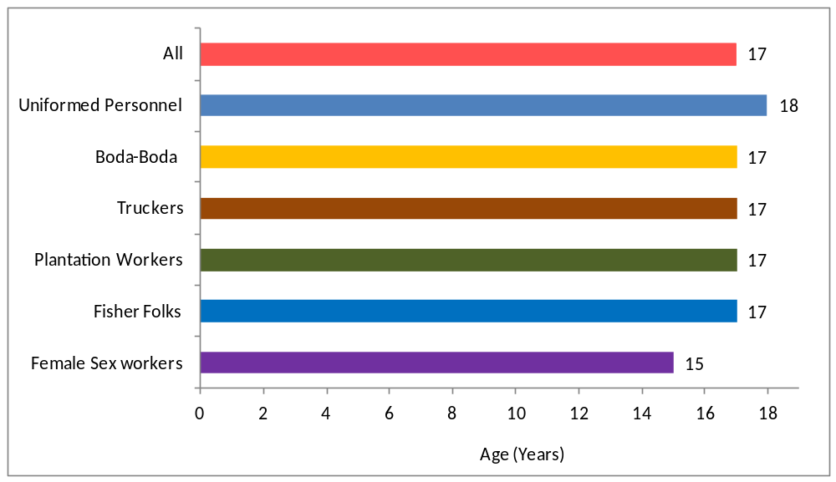

Figure 5.2 Proportions of Respondents Reporting Having Sex by Age 15 Years

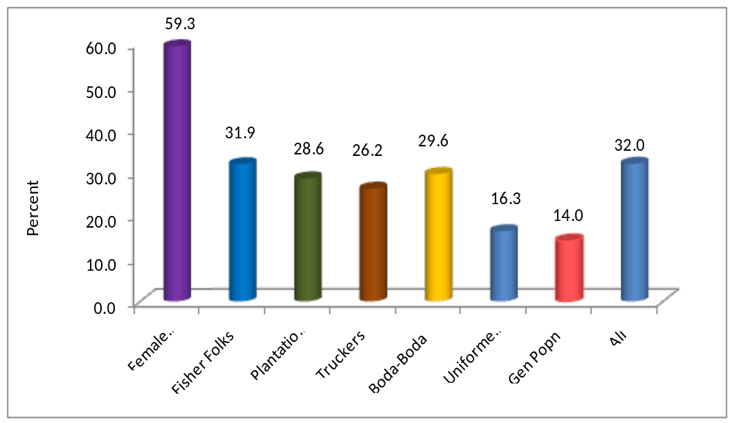

5.3 Primary Abstinence
The most effective means of avoiding HIV infection is abstinence which is applicable especially for young people. Primary abstinence refers to a state where a person has never had sex at all. It was noted that among three of the populations namely FSW, “Boda-boda” motor cyclists and uniformed personnel all the respondents were sexually experienced. A small proportion of truckers (1%), plantation workers (4.9%) and fisher folks (1%) reported not to have had sex . Only 1.2% of the entire study population had never had sexual intercourse whereas among those aged 15-24 years it was 4.3% of this category. This is shown in the Table 5.1 and 5.2 below:

Table 5.1: Respondents That Have Ever Played Sex

 | Type of MARP |  | Percent Never Had Sexual Intercourse |  | Percent Ever Had Sexual Intercourse |  | Number
 | Female Sex Workers |  | 0 |  | 100 |  | 199
 | Fisher Folks |  | 1.0 |  | 99.0 |  | 191
 | Plantation Workers |  | 4.9 |  | 95.1 |  | 203
 | Truckers |  | 1.0 |  | 99.0 |  | 191
 | “Boda-Boda “motor cyclists |  | 0 |  | 100 |  | 203
 | Uniformed Personnel |  | 0 |  | 100 |  | 202
 | All |  | 1.2 |  | 98.8 |  | 1,189

Figure 5.3: Proportion of 15-24 Year Old Respondents Reporting Having never Had Sex In Lifetime (Primary Abstinence)
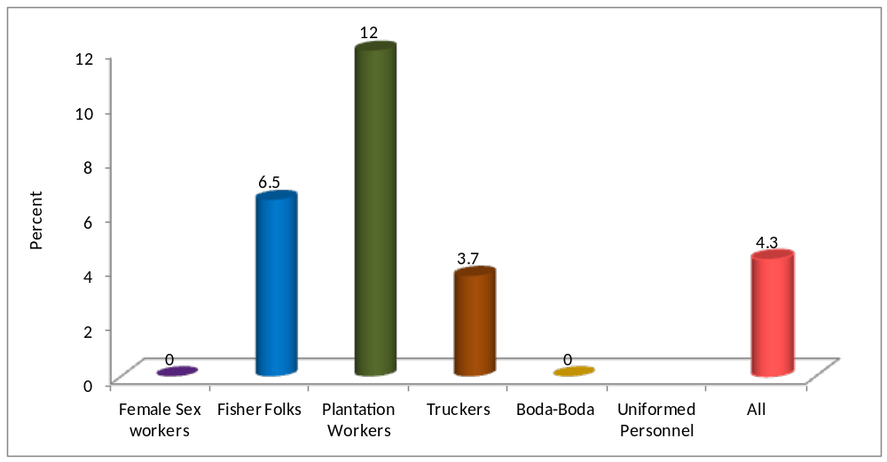The numbers for uniformed personnel were too small to provide estimates.
Table 5.2: Primary Abstinence Among Youths; Respondents Aged 15-24 Years, That Have
Never Played Sex
 | Type of MARP |  | Percent Never Had Sexual Intercourse |  | Percent Ever Had Sexual Intercourse |  | Number
 | Female Sex Workers |  | 0 |  | 100 |  | 92
 | Fisher Folks |  | 6.5 |  | 93.5 |  | 31
 | Plantation Workers |  | 12.0 |  | 88.0 |  | 75
 | Truckers |  | 3.7 |  | 96.3 |  | 27
 | “Boda-boda”motor cyclists |  | (0) |  | (100) |  | 42
 | Uniformed Personnel |  | * |  | * |  | 11
 | All |  | 4.3 |  | 95.7 |  | 278
 | Note: Figures in parentheses are based on 20-29 cases while an asterisk indicates that a figure is based on less than 20 cases and has been suppressed.

5.4 Secondary Abstinence among Youth
Secondary abstinence refers to the state of a person not having sexual intercourse in the last 12 months despite having had it before. This was for those aged between the ages 15-24 years. The majority of study population was sexually active in the last 12 months. Some form of secondary abstinence was observed among the plantation workers where about 15.2% reported to have abstained in the last 12 months. It was also reported among the fisher folks (3.4%) and truckers (7.7%).Overall, secondary abstinence was rare among the study population as only 4.9% of the population 15-24 had abstained in the last 12 months. This is shown in the figure 5.4 below and table 5.3 below:

Figure 5.4: Secondary Abstinence; Proportion of 15-24 Year Old Sexually
Experienced Respondents Reporting Having Had No Sex In 12 Months Prior To Survey Time

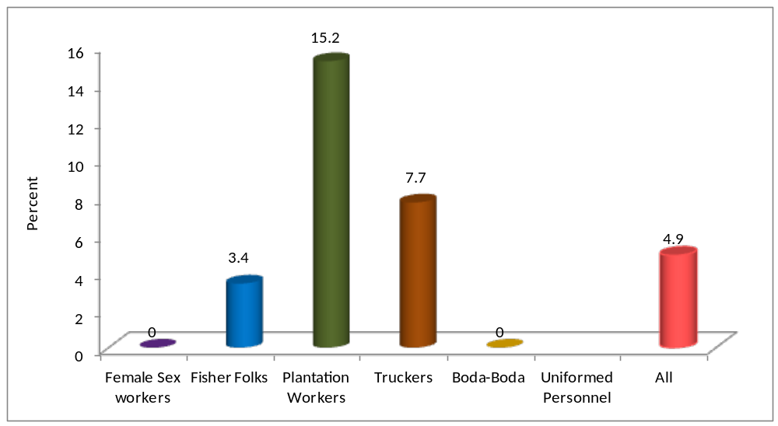
The numbers for uniformed personnel were too low to generate any meaningful information therefore not presented above.

Table 5.3: Secondary Abstinence;
Sexually experienced respondents aged 15-24 years, that did not have sex in the
past 12 months prior to the survey date

 | Type of MARP |  | Percent had no sex in 12 months prior survey |  | Percent had sex in 12 months |  | Number
 | Female Sex Workers |  | 0 |  | 100 |  | 92
 | Fisher Folks |  | (3.4) |  | (96.6) |  | 29
 | Plantation Workers |  | 15.2 |  | 84.8 |  | 66
 | Truckers |  | (7.7) |  | (92.3) |  | 26
 | “Boda-boda “motor cyclists |  | 0 |  | 100 |  | 42
 | Uniformed Personnel |  | * |  | * |  | 11
 | All |  | 4.9 |  | 95.1 |  | 266
 | Note: Figures in parentheses are based on 20-29 cases while an asterisk indicates that a figure is based on less than 20 cases and has been suppressed.

5.5 Multiple Concurrent Sexual Relationships and Life Time Partnerships
Multiple concurrent sexual partnerships are one of the risk factors related to HIV transmission in Uganda. The national prevention strategy seeks to reduce the number of sexual partnerships in the country. The study sought to establish the multiple partnerships among other MARPs rather than the FSWs. This covers the proportion of respondents who had sex with more than one sexual partner in the last 12 months. The mean and median number of sexual partners is also established among the different MARPs.
Multiple sexual partnerships are common in the study population and it was highest among the “boda-boda” motor cyclists (64.8%) and truckers (59.8%).It is equally common among the fisher folks (45.6%), uniformed personnel (35.8%) and the plantation workers (31.5%). The mean lifetime partners were highest among the truckers (27.1) and fisher folk (14.7). FSWs are excluded in this because by virtue of their occupation they are engaged in multiple sexual relationships daily. For the entire study population 47.8% were engaged in multiple sexual partnerships in the last 12 months. The reported concurrent multiple partnerships is more prevalent in the study population compared to the general population at 39 %(UHSBS 2004-04) in the same East Central region. Specifically the proportion of plantation workers engaged in concurrent multiple sexual partnerships at 31.4% compares 40.8% observed among the workers in Tilda Rice Plantation(HIV Sero-Behavioural Survey in Four Agricultural Plantations of Lake Victoria Basin in Uganda -2010) and 78% of “Boda-Boda” motor cyclists ever bought sex from two or more female sexual partners(Crane Study Report :High risk groups Surveys conducted in 2008-9 in Kampala, Uganda).Multiple sexual partnerships in the study population is shown in figure 5.5 and table 5.4 below:

Figure 5.5: Multiple Partnerships in 12 Months Prior to Survey Period Among 15-49 Year Old Sexually Experienced Respondents

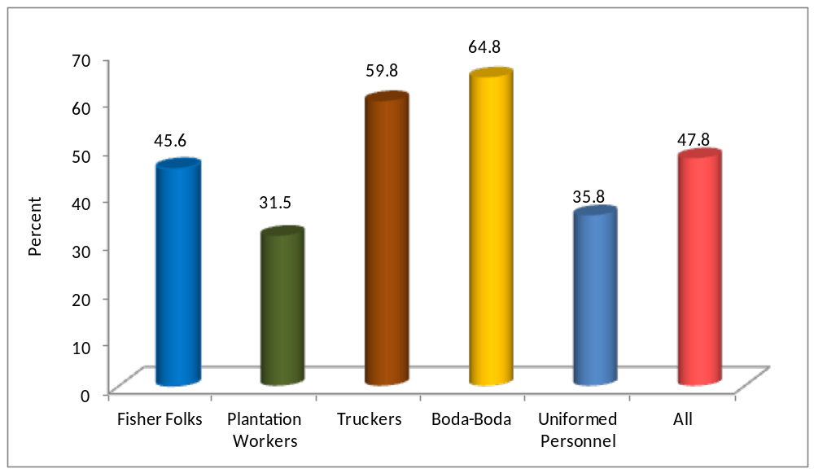

Table 5.4: Multiple Sexual Partnerships
Percentage of sexually active respondents aged 15-49 who had sexual intercourse in the last 12 months, and among them, the percentage who have had intercourse with more than one partner in the last 12 months, and mean number of lifetime sexual partners among those who have had intercourse
 | Type of MARP |  | Percentage who had sex in last 12 months |  | Percentage who had 2+ partners in the last 12 months¹ |  | Mean number of lifetime sexual partners |  | Median number of lifetime sexual partners |  | Number aged 15-49 yrs who ever  had sex
 | Fisher Folks |  | 97.2 |  | 45.6 |  | 14.7 |  | 6 |  | 180
 | Plantation Workers |  | 79.3 |  | 31.5 |  | 9.6 |  | 3 |  | 184
 | Truckers |  | 95.4 |  | 59.8 |  | 27.1 |  | 9.5 |  | 174
 | “Boda-boda” motor cyclists |  | 96.5 |  | 64.8 |  | 13.9 |  | 5 |  | 199
 | Uniformed Personnel |  | 89.0 |  | 35.8 |  | 12.3 |  | 5 |  | 173
 | All |  | 91.5 |  | 47.8 |  | 15.4 |  | 5 |  | 910
 | ¹ Corresponds to Emergency Plan Core Prevention Indicator 4 "Percent of respondents aged 15-49 who had sex with more than one partner in the last 12 months"

Figure 5.6: Reported Median Number of Lifetime Sexual Partners
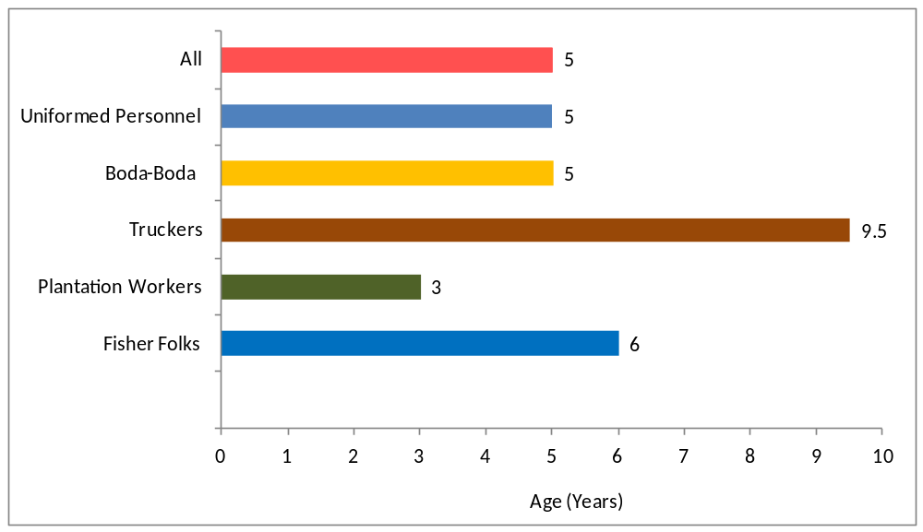

5.6 Higher Risk Sex
Higher risk sex is regarded as having sex with a partner who is not your spouse or whom you are not living with. In addition to higher risk sex the study established whether condoms were used in the last higher risk sex.
Having higher risk sex was especially common among the “Boda-boda” motor cyclists (47.8%) and truckers (46.1%). In addition 34.6% of the fisher folks, 36.5 % of the plantation workers and 21.3% of the uniformed personnel had higher risk sex. Among these groups truckers (84.1%) and uniformed personnel (74%) reported use of condoms in the last higher risk sex compared to 51.5% among the uniformed personnel, 59.1% among fisher folks and 55.4% among the plantation workers. Among all respondents 37.2% engaged in higher risk sex and 64% used condoms in their most recent sexual encounter.
Comparison with similar studies show 42.2% of Tilda plantation workers (HIV Sero Behavioural Survey in Four Agricultural Plantations- 2010) and 17.4% of youth aged 15-24 years (STAR –EC LQAs 2011) engaged in higher risk sex in the last 12 months. Condom use in the last higher risk for the youth was 72.4% while reported consistent condom use among Tilda plantation workers was 28.4%. The summary on higher risk sex are shown in the Table 5.5 and figures 5.7 and 5.8 below:

Figure 5.7: Percentage who Had Higher Risk Sex Among Respondents Reporting Sexual Activity in the Last 12 Months and Condom Use in Such Sex.



 | Table 5.5: Higher Risk Sex in last year and condom use is such sex
 | Percentage of respondents reporting high risk sex (with boyfriend/girlfriend, not living-in partner, casual acquaintance, commercial sex worker etc) in the last 12 months and, among those reporting such sex in the last 12 months, percentage reporting condom use the last time they had sex with such a partner by MARP category
 | MARP category | Percentage respondents reporting higher risk sex in the last 12 months | Number of respondents | Percentage reporting condom use at last higher risk sex | Number of respondents reporting higher risk sex in the last 12 months
 | Fisher Folks | 34.6 | 191 | 59.1 | 66
 | Plantation Workers | 36.5 | 203 | 55.4 | 74
 | Truckers | 46.1 | 191 | 84.1 | 88
 | “Boda-boda “motor cyclists | 47.8 | 203 | 51.5 | 97
 | Uniformed Personnel | 21.3 | 202 | 74.4 | 43
 | All | 37.2 | 990 | 64.1 | 368

5.7 Commercial Sex Work Male Respondents
The sexual intercourse with a commercial sex worker puts an individual in the direct contact with the entire sexual network established by the sex-worker. Therefore this study focused on the percentage of men who report having sex with a commercial sex worker in the last 12 months and whether condoms were used in the last sexual encounter. It was established that among the men respondents engagement in commercial sex was more common among truckers (29.3%), “boda-boda” motor cyclist (16.3%) and fisher folks (12.9%) .The prevalence of commercial sex among the male respondents was 14.7% and 52.7% used condoms in the last sexual encounter. This is shown in the figure 5.8 below:

Figure 5.8: Percent of Men Reporting Paid Sex in 12 Months Prior Survey and Condom Use in Last Paid Sex

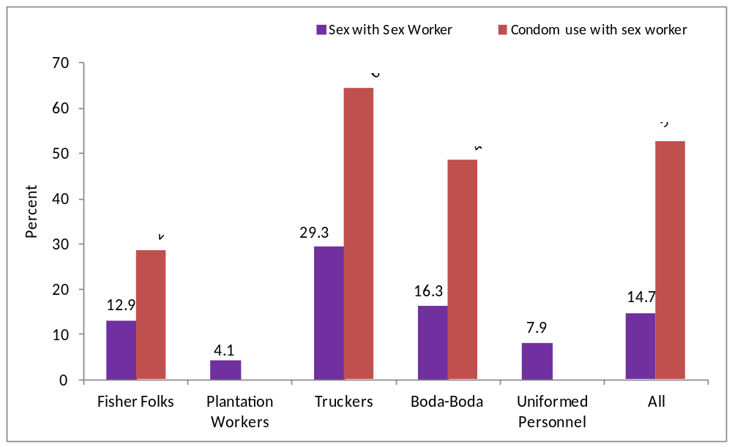

 | Table 5.6: Paid sex in last year and condom use at last paid sex
 | Percentage of men reporting sex with a commercial sex worker in the last 12 months
 | and, among men reporting sex with a commercial sex worker in the last 12 months,
 | percentage reporting condom use the last time they had sex with a commercial sex worker,
 | by MARP category
 | MARP category | Percentage reporting sex with a commercial sex worker in the last 12 months¹ | Number of men | Percentage reporting condom use at last sex with a commercial sex worker² | Number of men reporting sex with a commercial sex worker in the last 12 months
 | Fisher Folks | 12.9 | 163 | (28.6) | 21
 | Plantation Workers | 4.1 | 170 | * | 7
 | Truckers | 29.3 | 191 | 64.3 | 56
 | “Boda-boda “motor cyclists | 16.3 | 203 | 48.5 | 33
 | Uniformed Personnel | 7.9 | 151 | * | 12
 | All | 14.7 | 878 | 52.7
 |  |  |  |  | 129
 | ¹ Corresponds to UNAIDS Sexual Behavior Indicator 3 "Commercial sex in the last year"
² Corresponds to Emergency Plan Core Prevention Indicator 6 "Percent of men reporting sex with a sex worker in the last 12 months who used a condom during last paid intercourse" and to UNAIDS Sexual Behavior Indicator 4 "Condom use at last commercial sex, client report".
Note: Figures in parentheses are based on 20-29 cases while an asterisk indicates that a figure is based on less than 20 cases and has been suppressed.

5.8 Female Sex Workers Sexual Behaviours

5.8.1Mean and Median Number of Sexual Partners for FSWs

The study established that the mean number of clients FSWs had per day was 1.5 ,while the median was 1. The mean number of clients FSWs had in a week was 4.9 while the median was 3.
    - Condom Use among Female Sex workers

About 80% of the FSWs reported condom use in their last sexual encounter and among these encounters 71.8% condom use was suggested by the FSWs and only 43.9% reported to use condoms every time they had sex. Thirty two percent of the FSWs expressed willingness to have unprotected sex if given reasonable money.

5.8.3 Reasons for non condom use
The common reason raised for non condom use were partner objection (29.3%), dislike by customers (36.6%) and partner trust (12.2%).

CHAPTER SIX

Sexually Transmitted Infections Prevalence

Key findings related to STIs.

- Self reported STI prevalence was high among the MARPs it was highest among FSWs (37%) and “ Boda- boda” motor cyclists(25.6%) which is evidence of unprotected sex among these groups.
- The population with the least reported STI prevalence were plantation workers (16.6%) and uniformed personnel (17.8%).
- STD prevalence was higher among those who reported not to have used condoms 19.6%) compared to those who used condoms in the last sexual encounter (25.6%) validating the role provided by condoms in STI control.
- About 80% of the infected FSWs sought for treatment or sought advice.
- STI Health seeking was poor among some groups like truckers and plantation workers where 40% of those who had an STI reported that they did not seek treatment.

6.1 Introduction

Sexually Transmitted Infections (STIs) have been documented as one of the risk factors related to HIV. The presence of STIs increases the risk of HIV infection two-fold. Therefore the national response has developed interventions to strengthen STI management in the country especially among the MARPs. This study captures the self reported prevalence of STIs by focussing on reported abnormal genital discharge and genital sores/ulcers in the last 12 months.
STI infections were more common in the FSWs (35.7%), “boda-boda” motor cyclists(25.6%) and fisher folks (22.8%) in addition the infections were not absent in other MARPs but with a lower prevalence of 17.8% among uniformed personnel, 16.6% among plantation workers and 19.6% among truckers. Overall, 23% of the respondents reported to have had an STI the last 12 months and among these 68% sought for advice or treatment. This is presented below figure 6.1 and table 6.1 below:

Figure 6.1 Prevalence of Self Reported STIs in 12 months and Health Seeking
Behaviour
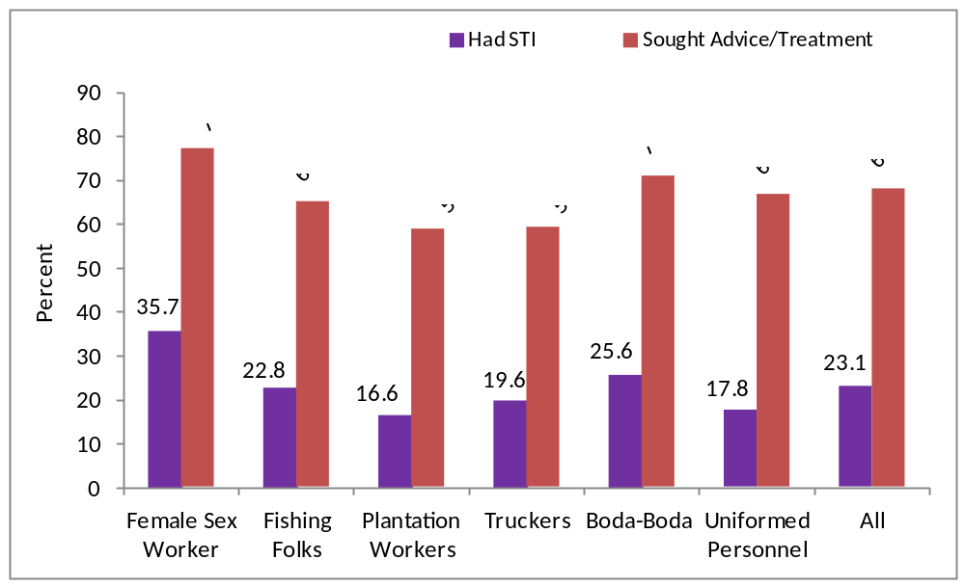

Table 6.1: Prevalence of Self-Reported Sexually-Transmitted Infection (STI)

Among respondents who ever had sex, percentage self-reporting an STI in the 12 last months, by MARP category
 | Type of MARP |  | Percentage reporting an STI |  | Number ever had sex |  | Percentage who sought advice/  treatment |  | Number who had STI
 | Female Sex Workers |  | 35.7 |  | 199 |  | 77.5 |  | 71
 | Fisher Folks |  | 22.8 |  | 189 |  | 65.1 |  | 43
 | Plantation Workers |  | 16.6 |  | 193 |  | 59.4 |  | 32
 | Truckers |  | 19.6 |  | 189 |  | 59.5 |  | 37
 | “Boda-boda " motor cyclists |  | 25.6 |  | 203 |  | 71.2 |  | 52
 | Uniformed Personnel |  | 17.8 |  | 202 |  | 66.7 |  | 36
 | All |  | 23.1 |  | 1,175 |  | 68.3 |  | 271

CHAPTER SEVEN

HIV Counselling and Testing and Male Circumcision

- About 90% of uniformed personnel and about 80% of FSWs had ever taken an HIV test in life while 76.1% had ever taken a test.
- Overall, 53.7% of the study population and about 70% of the FSWs had had an HIV test in the last 12 months. This is a lot higher than the general population at 46.9 %(LQAs 2011).
- Only 35% of plantation workers and 46.8% of “Boda-boda” motor cyclists had taken an HIV test in the last 12 months.
- The proportion of respondents who had circumcised was highest among the truckers (79.6%) followed by the “Boda- boda” motor cyclists (67.5%) and fisher folks (62%).
- About 60% of the male study population was circumcised.
- Among all the groups, it is only among the fisher folks (15.8%) where a reasonable percentage that indicated that they got circumcised less than a year ago.
- The main reason stated for circumcision was to reduce the chance of getting HIV infection yet the majority of the respondents were circumcised before the SMC intervention.
- Self reported HIV prevalence was 10% and it was highest among FSWs at 20%

7.1 Introduction
The national response recognizes the role HCT plays as an entry point to HIV care and behaviour change. Currently the uptake for HIV counselling and Testing is about 40% in the general population and higher among groups at higher risk of HIV infection.

This study established whether the respondents had ever had an HIV test in their entire life and also whether they had a test in the last 12 months. The recent uptake for HCT Services was highest among the FSWs as 69.3% of the FSW respondents had ever had an HIV test in the last 12 months. The lowest recent HCT uptake was among the plantation workers (35%) followed by ‘boda-boda’ motorcyclists (46.8%) and truckers (48.7%).
On whether the respondents had ever taken an HIV test in life it was established that the highest uptake was among the uniformed personnel (89.6%) and the FSWs (83.4%). It was within the range of 60% and 74% for the rest of the MARPs. The finding shows that the uptake for HCT among some of these groups is a lot higher compared to the general population which is about 46.9% in the study region (STAR –EC LQAs 2011).

Figure 7.1: Percentage Ever Tested and Tested in 12 months for HIV by MARP



7.2 Male Circumcision
The national HIV response has taken on Safe Male Circumcision (SMC) as new biomedical prevention intervention based on the evidence that it provides 60% protection among the males who are not yet infected. A policy, operational guidelines and communication strategy were launched and the intervention is currently under implementation nationally and in the study region.

Among the MARPs studied in the region the percentage of males who had circumcised was relatively high. It was highest among the truckers (79.6%) followed by the “boda- boda”motor cyclists (67.5%) and fishing community/folk (62%). Among all the groups, it is only among the fisher folks where it was observed that 15.8% got circumcised less than a year ago while for others it was either since childhood or five and more years ago. This shows that the current initiatives have had root only among the fisher folks. The reasons given for circumcising included: being a religious requirement; for reducing chances of HIV and other STI infections. This reason presented by respondents that they were circumcised to reduce the risk of infection doesn’t seem logical since the majority were circumcised before the initiation of the SMC programme. The prevalence of male circumcision is illustrated below:

Figure 7.2; Male Circumcision in Different MARPs
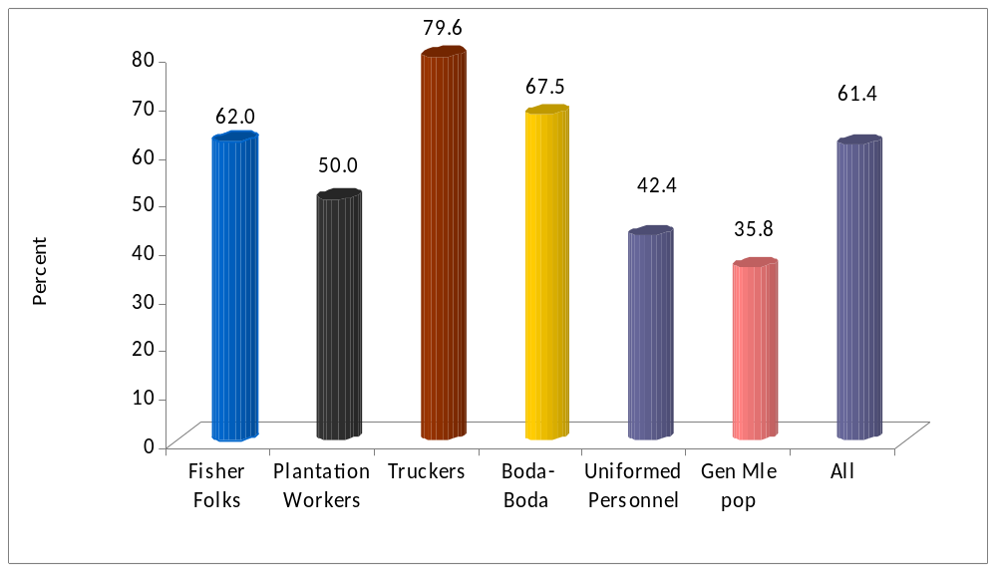

Table 7.1: Percentage of men who have been circumcised, by MARP category and Period
 | Male circumcision
 | Percentage of men who have been circumcised, by MARP category
 |  |  |  | Period when circumcision was done:
 | MARP Category | Percent Circumcised | Number of Men | Less than 1 yr | 1 year ago | 2 years ago | 3-4 years ago | 5 + years ago | Since Child-hood | Number Circumcised
 | Fisher Folks | 62.0 | 163 | 15.8 | 4.0 | 2.0 | 5.0 | 28.7 | 44.6 | 101
 | Plantation Workers | 50.0 | 170 | 2.4 | 6.0 | 1.2 | 8.3 | 46.4 | 35.7 | 85
 | Truckers | 79.6 | 191 | 0 | 3.3 | 6.6 | 4.6 | 28.3 | 57.2 | 152
 | “Boda-boda"motor cyclists | 67.5 | 203 | 4.4 | 1.5 | 2.2 | 6.6 | 20.4 | 65.0 | 137
 | Uniformed Personnel | 42.4 | 151 | 4.5 | 3.2 | 4.8 | 6.3 | 47.6 | 33.3 | 64
 | All | 61.4 | 878 | 5.0 | 3.4 | 3.5 | 6.0 | 31.5 | 50.7 | 537

Table 7.2: Reasons for Circumcision

 | Reasons why respondents got circumcised
 | Reason |  | Number of respondents citing the reason |  | Percent
 | Religion requires to do so |  | 46 |  | 27.1
 | Reduce chances of catching HIV |  | 68 |  | 40.0
 | Reduce chances of catching STIs |  | 9 |  | 5.3
 | Hygiene reasons |  | 19 |  | 11.2
 | Others |  | 28 |  | 16.5
 | Total |  | 170 |  | 100

7.3 Self Reporting HIV prevalence
The respondents who reported to have ever tested where asked to state the HIV status and in response it was noted that most of them were willing to share their HIV results. Through this sharing the HIV prevalence was highest among the FSWs (20.9%) and fisher folks(13.3%).It was lowest among the truckers (0%)and plantation workers(1.4%).However, the 0% among truckers is likely not to be accurate given their vulnerabilities and risky behaviours reported amongst these groups.

 | Table 7.3. Self Reported HIV prevalence, Care and Treatment by MARP Category
 | MARP Category |  | Percentage Willing to Share Results | Number Received results | Percentage HIV positive | Number sharing results | Percentage taking Septrin or Cotrimoxazole daily | Percentage taking ARVs daily | Number HIV positive
 | Female Sex Workers |  | 97.1 | 138 | 20.9 | 134 | (89.3) | (25.0) | 28
 | Fisher Folks |  | 97.4 | 116 | 13.3 | 113 | * | * | 15
 | Plantation Workers |  | 97.2 | 71 | 1.4 | 69 | * | * | 1
 | Truckers |  | 98.9 | 93 | 0 | 92 | * | * | 0
 | 'Boda-boda' Motorcyclists |  | 96.8 | 95 | 8.7 | 92 | * | * | 8
 | Uniformed Personnel |  | 100 | 126 | 10.3 | 126 | * | * | 13
 | All |  | 98.0 | 639 | 10.4 | 626 | 87.1 | 27.7 | 65
 | Note: Figures in parentheses are based on 20-29 cases while an asterisk indicates that a figure is based on less than 20 cases and has been suppressed.

CHAPTER EIGHT

Population Estimates, Vulnerability, Mapping of MARPs and HIV Service Status

8.1.0 Introduction
This section presents the findings mainly from qualitative arm of the study but aligned according to the key thematic areas of the study as defined by the research questions. The presentation is according to the key study MARPs. It focuses on the size estimation and mapping of hotspots and health facilities
Overall, the estimated number of Most At Risk Populations were 84,941.These were distributed throughout the study region a summary of which is presented below and the majority of whom were the fisher folks. The detailed distribution by gender and districts is attached in annex 6.

MARP Category | Estimated Population in East Central Uganda region
Female Sex Workers | 1,497
Boda -Boda Cyclists | 12,680
Plantation workers | 2,201
Uniformed Personnel | 2000
Fisher folk | 63,640
Truckers | 321 per night
Total | 82,339

8.1.2 Key Findings on sex workers
- The FSWs were mainly located in urban areas and fishing landing sites in the study region.
- The study identified three main categories of FSWs by work profile namely: bar based, lodge based and disguisedly employed sex workers.
- It was estimated that there were approximately 489 lodge based sex-workers amongst whom 66% were operating in fishing communities and overall 1497 FSWs in the study region.
- Approximately 232 sex-workers were bar based and not employed by the social facility they operated from while 776 were disguised as bar or lodge attendants.
- The street based sex-workers were limited in the region apart from those stationed at parking yards and where truckers congregate.
- Unprotected sex was reported to be more common among the bar and street based categories compared to the lodge based sex-workers.
- The sex workers reported that they charge a fee of about 5,000/= ($2.1)Uganda shillings for a sexual intercourse lasting for a short period of less than five minutes while between 15,000/= ($6.3) to 50,000 ($20.1)depending on whether it is for a longer period or overnight.
- The reported categories of clients were truckers, “boda-boda”motor cyclists and businessmen in main land hotspots and townships while fishermen were the common clients at landing sites.
- The majority of sex workers were relatively young between 15 and 40 years of age.
- The reported factors leading to sex work were poverty, lack of employment, sexual dissatisfaction among the married and a means of supplementing income.
- The majority of sex workers reported to be mobile and the main reason for the frequent mobility was to maintain market for their services where there is a drive or demand for the new girls in the sites.

8.1.3 Characteristics of MARPs, Size Estimation and Vulnerability
The study presents the characteristics of the six MARPs namely: FSWs, “boda-boda” motor-cyclists, truckers, fisher folks, plantation workers and uniformed personnel. MARPs have been taken as a target group because of the more than average risk they have for HIV infection.

8.1.4 Characteristics of female sex workers

Geographical Location and Size Estimation
Through the key informant and FGDs interviews it was established that the Female sex workers were mainly operating in the key urban areas and hot spots in the East-Central Region. In addition these operated in fish landing sites.

They are mainly found in the town centers along the Mombasa –Jinja high way and here in Bugiri around Naluwerere, Bugiri town, Muwayo, Buwuni, Busowa and Namayemba. They are also located in the inland town centers that make up the major town centers in a given sub-county e.g. Nankoma town board.They can also be found in the landing sites such as Lwenge/Maziriga and Waka waka (KI Bugiri)

Through enumeration and comparison with the means of the different reported groups of sex-workers it was established that there were approximately 1497 commercial sex workers as distributed below:

Table 8.1: Estimates of FSWs by district and category.

Districts | Lodge Based | Bar Based | Bar and Lodge attendants | Totals
Bugiri | 20 | 62 | 140 | 231
Buyende | 0 | 0 | 25 | 25
Iganga | 22 | 100 | 199 | 321
Kaliro | 0 | 0 | 58 | 58
Kamuli | 0 | 0 | 133 | 133
Luuka | 0 | 0 | 35 | 35
Namayingo | 263 | 0 | 186 | 449
Namutumba | 16 | 19 | 0 | 35
Mayuge | 159 | 50 | 0 | 210
Regional | 489 | 232 | 776 | 1497

Table 8.2 :Estimated Number of Female sex workers for Selected hotspots estimates

Name of hotspot | Indiv. Structured qu.estimates | Bar/lodge survey | Mean
Naluwerere | 129 | 122 | 126
Busowa | 38 | 71 | 55
Iganga | 86 | 189 | 138
Idudi | 82 | 93 | 89

8.1.4 Estimated Number of Female sex workers by KIs and FGDs
As a means of enhancing validity estimates were sought from KIs and FGDs.Through these discussions the following was noted.
On average there are over 25 sex workers per trading center with some places like Naluwerere having slightly higher number of about 40(KI District Health office Bugiri)
We are over 100 ba miss’ here in Naluwerere alone but we could even be more because there are those who don’t want to be known as sex workers(FSW leader KI).
We could be about 30 sex workers operating here in Busowa town (FSW FGD Busowa)

Kaliro has very few women in sex business because its not a busy town so most of them relocate to Iganga and only visit here once in a while (SAIL Plantation workers FGD).

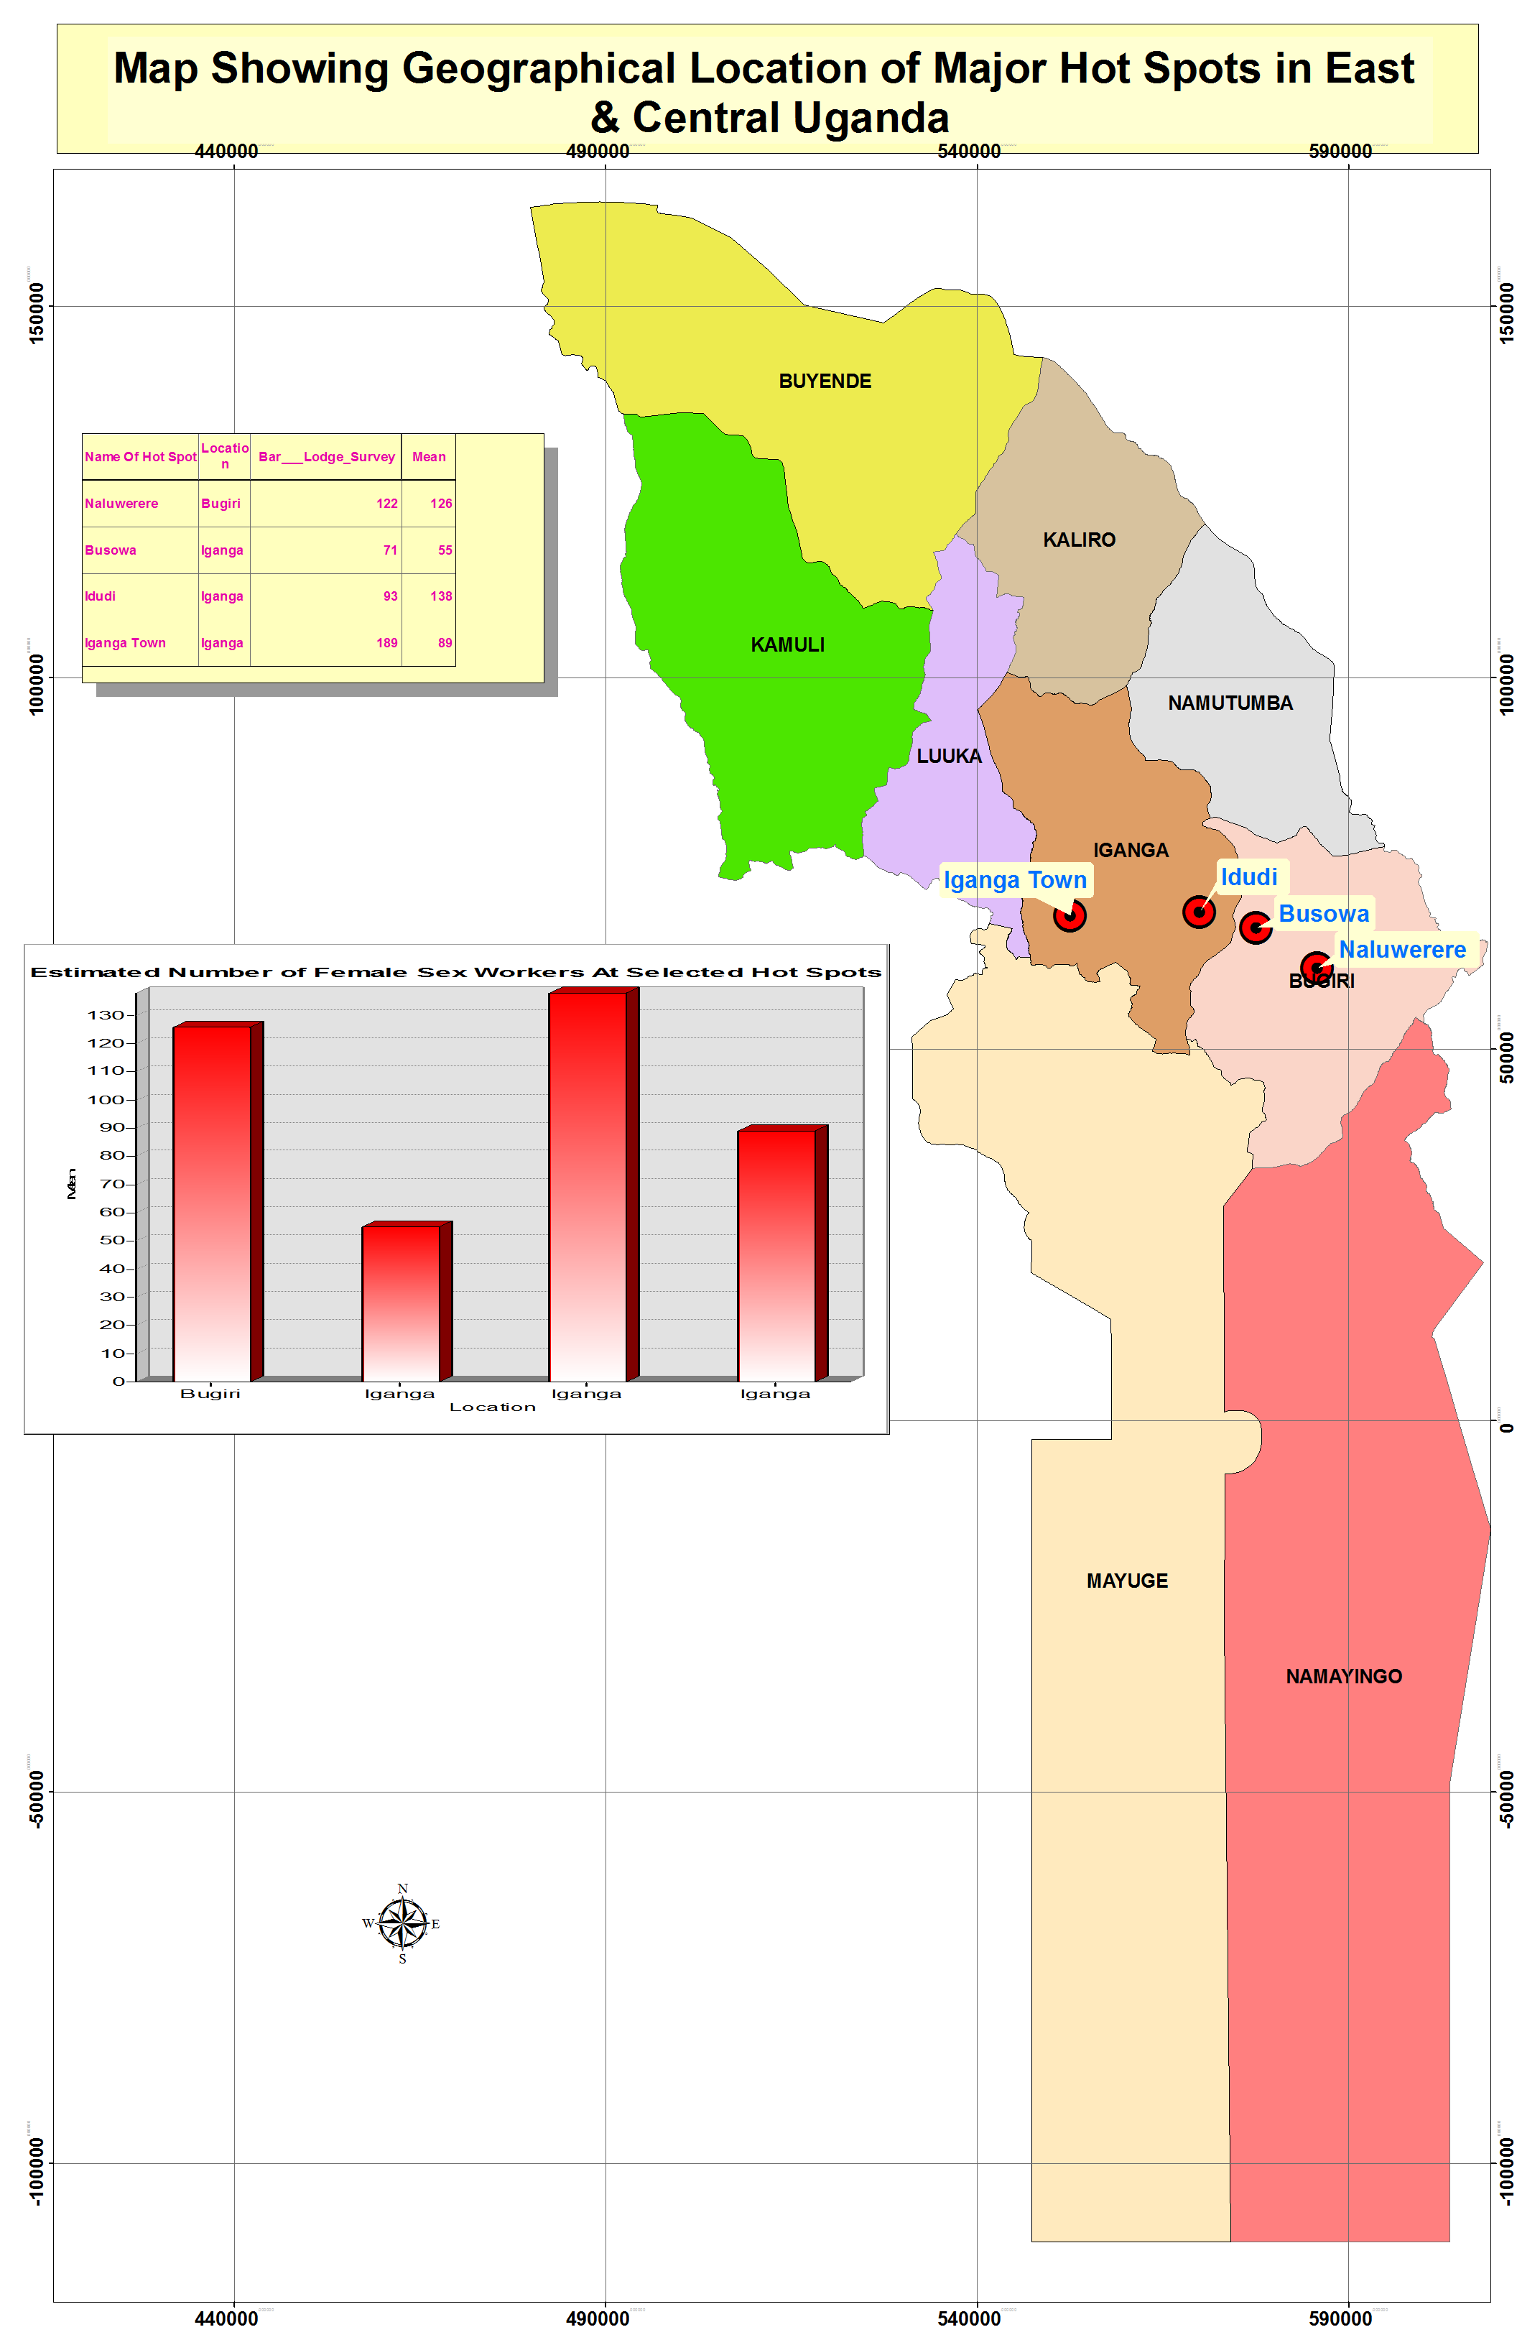

8.1.5 Current Age of Sex workers
By the nature of the business most of the female sex workers were reported to range between the ages of 15 years to 40 years. This is consistent with the age distribution figure 3.5 which shows that most of the FSWs were within the age range of 15-39 years. This is reflected in the statements below

The age varies between 15-40 years however the majority lie between 20-30 year s(KI Bugiri).
The ages tend to vary the young girls are usually between 14-20 years and the older ones are between 21-40 years (FSW FGD Bugiri).
Some of us start this business young from about 14 years and stay in the business for a long time (FSW KI Bugiri).

Also as you have seen the majority of women in the business are young girls and some of them don’t usually stay here for long because they believe the truckers and the other customers tend to look out for young energetic girls, so the women of 28 years and above are usually out competed in the business (FSW FGD Busowa hotpot).

8.1.6 Nationality and Ethnicity
Most of the FSWs were Ugandans with a mixture of different ethnic groups namely: Basoga, Baganda, Basamia, Bagishu and Itesots but this was dependent of the location of operation.
They are mostly Ugandans over 95% and a few from Kenya, Tanzania and Rwanda (KI Bugiri).
We the Ugandans are the majority though there are some Rwandese but who don’t want to be identified as sex workers. There are people of all tribes here the Basoga, Baganda, Basamia, Bagishu, Itesots, Nyarwandas(FSW FGD Bugiri).

The sex business here is typically ours the women of different ages and types, most of us are from Uganda, others are from Congo, Tanzania, Rwanda and even others are mixture of parents from different countries like Congolese father and Ugandan mother so we are both (FSW FGD Busowa).

8.1.7 Clients
The clients commonly reported were long distance drivers/assistants, bar customers and businessmen. The truckers were of different nationalities like Congolese, Sudanese, Somalis, Rwandese and Burundians while the others were mainly Ugandans. This is asserted in the statements below:
The customers are usually long distance truck drivers, businessmen, civil servants and landing sites fishermen who usually have disposable income from fishing (KI Bugiri).
Customers range from the truck drivers and their tonne boys, the natives of the area, businessmen “ boda- boda” motor cyclists and bar customers (FSW KI Bugiri.).
The customers we get are from Uganda, Kenya, Congo, Sudan, Somalia, Rwanda and Burundi most of them are truck drivers and others are businessmen (FSW FGD Busowa).

8.1.8 Dressing Code and Identity and Time of Work
In the hotspots along the high way most of the sex workers worked during the night however the established based category worked throughout the 24 hours depending on when the customers came. On the other hand business was mainly during the day for the sex workers based at fishing sites. The dressing code varied from FSW type, the establishment based type in bars and lodges overall dressed normally however those on the streets or parking yards tried to expose their bodies and figures to attract customers more. The above scenarios are illustrated in statements below:

The activity takes place usually at anytime as long as it is conducive for instance in the landing sites most sex work is during the day since that’s when majority of the fisherman are around .In other town centers like Busowa , Naluwerere its both during the day and night e.g. in the bars, drinking joints and lodge (KI Bugiri).

We don’t have a particular way of dressing each one dresses the way she feels will attract customers for her, some of us will put on very short skirts and revealing tops and others will put very tight trousers like jeans to bring out their curves(FSW FGD Bugiri) .
Here in Naluwerere almost every barmaid is taken as a FSW because most barmaids here also participate in the sex business. Usually we are on the streets at night and we sometimes approach the parked truck drivers .We also go to the bars and while waiting for customers we pickup conversations with men in the bars and that’s when they will eventually know that you’re a sex worker(FSW FGD Bugiri).

We refer to ourselves as “Ba misse”. The girls and women involved in this type of work also work as barmaids. Ba misse usually live in a group of 4-5 women in a room normally rented behind a bar and share the expense of renting the room (FSW KI Naluwerere).
Amongst ourselves, we do know each other because most of us are not married so we work and stay in lodges and this is how we meet and know each other (FSW FGD Busowa hotspot).

Since most of us work in the bars the dress code doesn’t usually matter, when the customers come, it’s the sex they want and not the way we are dressed that they want, besides that at work, we don’t get the time to put on makeup (FSW FGD Busowa).

The business here is usually a night business because that is when most of the truckers come and also during the day most of us are resting. Most of us especially the young girls fear to be identified during the day and prefer to work only in the night (FSW FGD Busowa Hotspot).

8.1.9 Amount Paid for Services
The amount paid for sexual encounter was dependent of the duration of sex or at times whether protection was used or not. The short encounters normally lasting an ejaculation or less than five minutes would cost between three thousand shillings and five thousand shillings while the long encounters which would take a maximum of an overnight which would cost between 15,000/= ($6.3) to 50,000/= ($20.1) depending on the localities. The price sentiments are presented below:

The charges range from between UGX. 5000 - UGX 20,000 but it can be lower depending on whether the person offering the sex has had a meal or not and usually if it is not then the person can settle down for as low as UGX 3000(KI Bugiri).

The prices of a sexual encounter vary, a short encounter ranges between Ugx. 3000 – Ugx. 5000 and full or all night long also varies between Ugx. 10,000 – Ugx. 20,000(FSW FGD Bugiri).
The charges for a short time is Ugx.5000 and long time is between Ugx.15000- Ugx.25000 though this is negotiable sometimes we are so desperate and like you have not made any money in the last two days and once a customer offers you Ugx. 10,000 you give in to his demands(FSW FGD Busowa hot spot).

8.1.10 Operational Sites and Vulnerability Levels
Most of the FSWs operated in lodges, bars or on the streets .The FSWs usually work in the night and are at times sexually abused. Their experiences exposed them to risk of HIV since they indicated that some customers deliberately refused to use condoms and even enforced anal sex outside their negotiations. There was also exploitation of young groups by some proprietors who would use them as sex tools and receive the benefits in return.
We usually operate from the streets around the areas where the trucks park, in the bars and lodges because these are places where our customers are found and its usually in the night because that’s when the bars have many people and also that’s when most of the trucks have parked(FSW FGD Bugiri).

Their inability to constantly use the condoms because of higher pay or deliberate refusal by client is actually a violation of their right to life. This exposes them to STIs and HIV. The sex business usually booms in the lodges, bars and around the truck parking areas both during day and night depending on the place however it’s very hard to ascertain or guarantee the security of the sex workers and also they know that it is illegal so they never report cases of assault or abuse by their customers to the police (KI Bugiri).

Our bad experiences are endless; most of our male customers don’t want to use condoms. Some of the customers steal the very money they paid you for sex without our knowledge; they notice where you keep the money and secretly take it without you noticing and you cannot accuse them because they will deny and become violent. Other customers you negotiate with them very well for vaginal sex and they instead forcefully demand for anal sex. The differences in penis sizes cause the condoms to burst and some men don’t want to change the condoms when they are already in the act of sex play. The male customers also convince you to travel with them and when they feel they are done with you, they kill you or drug you up and fix bottles in your private parts (FSW KI Bugiri).

Some people here operate and recruit young girls to engage in the business for instance there’s a joint called Bebes wa Barbara everybody here knows that she has young girls who both work in her bar and also sell sex and she receives the money on their behalf. Amongst ourselves, we do know each other because most of us are not married so we work and stay in lodges and this is how we meet and know each other (FSW FGD Busowa hotspot).

Some of our customers don’t want to use condoms or they deliberately break the condoms and infect us with HIV and STDs. Sometimes the men turn violent after using you and don’t want to pay; they beat you up especially the Somalis who chew marijuana. The police here don’t allow us to operate freely, they sometimes arrest us in the night and harass us and demand for sexual favours (FSW FGD Busowa hotspot).

Not knowing the health status of our clients and yet they may be having all sorts of diseases and infection – But we just go/risk because we need money. Some of these guys/youth are forceful/soldier like and we are sort of helpless/powerless. If you are not sharp you are at a high risk of all sorts of problems including HIV/AIDS/STDS e.t.c(FSW FGD Iganga).

8.1.11 Factors leading to Engagement in Commercial sex work
These factors were economic and non-economic in nature. Sexual dissatisfaction and inadequate support from the male counterparts were contributing factors to joining sex work. The widows and young girls were reported to be influenced by lack of basic needs. The other factors included peer pressure, lack of gainful employment, a desire for luxurious lifestyles
These are reflected in statements below:
There is sexual dissatisfaction among married women due to the fact that many of their husbands are alcoholics and drunkards and therefore have rough sex without foreplay before the actual penetration sex.
The financial inability of husbands to address the material needs of their spouses and homes in particular forces women to seek other ways of making ends meet. Lack of financial ability of widows and young girls to address their day today needs such food, rent and school fees. The orphaned girls don’t have anyone to provide them with resources to address their needs such as school fees. Most of the widows leave in poverty after they have lost all property that formerly belonged to their deceased husbands to their in-laws. Long distance relationships where husbands keep out of touch for a long time, gives the women the opportunity to engage in the sex business (KI Bugiri).

There are very many divorced and separated women here who struggle to survive and sex work is the only way of survival. There is peer influence especially when young girls see others earning a lot of money out of the business; they are attracted to join just for the money.There are also many school dropout girls here who are mainly orphans and the easiest job for them to do is sex business since they don’t have any experience to do any other jobs (FSW KI Bugiri).

Most of us are not educated and therefore we don’t have jobs and sources of income so sex work helps us realize money. Even with the jobs some of us do, the income is not usually enough to care for our basic needs and take care of our families so sex work is an alternative source of money to supplement the little we get. There is also peer influence especially among the young girls here they see this as the easiest way of earning money (FSW FGD Busowa hotspot).

Large families, here in Busoga people produce a lot and yet they are too poor to provide for their families so, many of the children provide cheap labour in bars from where they also engage in sex business(SAIL Plantation workers FGD).

8.1.12 Suggestions
The different groups were asked to provide some suggestions for improvement of the operations of FSWs and the response was varied. While others suggested alternative engagement others proposed harm reduction interventions. Those proposing alternative sources of income proposed a seed fund and skills development among sex workers. The other suggestions included health education, peer education and legal aid in case of abuse, condom promotion, redeveloping the female condom and targeting of clients among others.
Health education on safer sex options like safe and continuous use of condoms
There’s need to support them come up with income generating activities as alternative for instance we could make them have access to soft loans as women in general and not FSW.School going age girls could be given government loans so that they return to school and these loans bond them to pay back after school
(KI Bugiri).

‘Entandikwa’ for each FSW to start up alternative business for alternative income even if its as little as Ugx. 500,000($208).Extend skill training and development services in the areas of tailoring, catering, computer services and saloon among others to sex workers groups. Need for establishment of the female knowledge room since the existing one is predominantly male oriented and so women can’t access it easily and we are even sent away by the men. The continued supply of condoms especially life guard because this is what the customers prefer. Need to redevelop the female condom further because the available ones are difficult to use and the customers don’t even like them; if the female condom could be made like a panty or knickers that we just wear may be it could help us .Free condoms from the knowledge room,STI treatment from URHB and free ART (FSW KI Bugiri).

There should be programs targeting the truck drivers and not only us, because we are labeled as the bad ones always, but the men and the truckers in particular don’t like to hear the word condom or even use them, so let programs target them. These young girls should be encouraged to return to school and government should provide them with the basic requirements to enable them stay longer at school. Introduce programs that will train us and later give us some income to start up alternative money generating activities (FSW FGD Busowa hotspot).
Legal Aid for FSWs especially if they are arrested. But we should also be disciplined and decent. When authorities are handling us it should also be in a decent way not in a dehumanizing way like it is now being done. We need special HCT outreach services

since we fear to go to the main stream health units because of fear, stigma, isolation and Rumors or the small town syndrome (FSW FGD Iganga).
Get us other alternative jobs because we have different skills but we are discriminated against while seeking employment. For example. jobs of tailoring, teaching, shop keeping, hair dressing e.t.c. where we have experience but have no job opportunities. “For example I have a diploma in Business Administration but I am here selling sex” (FSW FGD Iganga).

8.2 Key findings related to plantation workers
- Three operational plantations were identified in the study region namely: Tilda Rice Plantation, Sugar and Allied Industries limited (SAIL) and Mayuge Sugar Plantation.
- Through interface with their administrators it was established that the total plantation staff was 2,201 where Tilda had 1, 140,SAIL had 61 and Mayuge SP had 1,000.
- Most of the staffs in Tilda were indigenous Basoga while for the others migrant labour was common.
- The age range for the majority was between 20-50 years.
- The majority of the labour staffs were males in the plantations.
- Risky behaviours not outstanding and relatively similar with the general population.
- Alcohol consumption and staying away from spouses influenced extra marital sex among the plantation staffs who were staying away from their spouses.
- No written HIV work-policies were found at the three plantations however it was observed that there were more organized HIV interventions in Tilda Rice Plantation with a health centre II.

8.2.1 Introduction

The study identified initially four plantations in the study region these included: Tilda Rice plantation and Kirinya Forest Reserve located in Bugiri district, Sugar and Allied Industries Limited (SAIL) in Kaliro district, Mayuge Sugar factory in Mayuge district. However, it was noted that Kirinya forest reserve plantation was not operational during the study time and the staffs were not available as it only operates seasononally. SAIL in Kaliro had a total of 61 staff among whom 60 were males and only one female.

8.2.2 Size Estimation and Characteristics of Plantation workers

Size Estimation
The main approach used was review of institutional records and interface with the staff in charge of human resources. It was noted that Tilda Rice Scheme had a total of 1,140 workers who included 90 permanent staff, 50 short contract staff and 1000 staff employed through contractors to the institution. There were about 100 workers at Mayuge Sugar plantation.

Table 8.3 Plantation workers estimates by plantation

District | Name of Plantation | Estimated population
Bugiri | Tilda Rice Scheme | 1,140 people
Kaliro | SAIL | 61
Mayuge | Mayuge Sugar Plantation | 1,000
Bugiri | Kirinya Forest Plantation | No staff during study period.
Source of information: Institutional records and Human resource officers

8.2.3 Geographical Location
Plantation workers operate mainly in three plantations in the East central region Tilda Rice plantation in Bugiri district,Mayuge Sugar Plantation in Mayuge district and SAIL in Kaliro district.The locations of the four plantations and the neighboring health facilities visited are displayed on the following map(Figure 8.3).

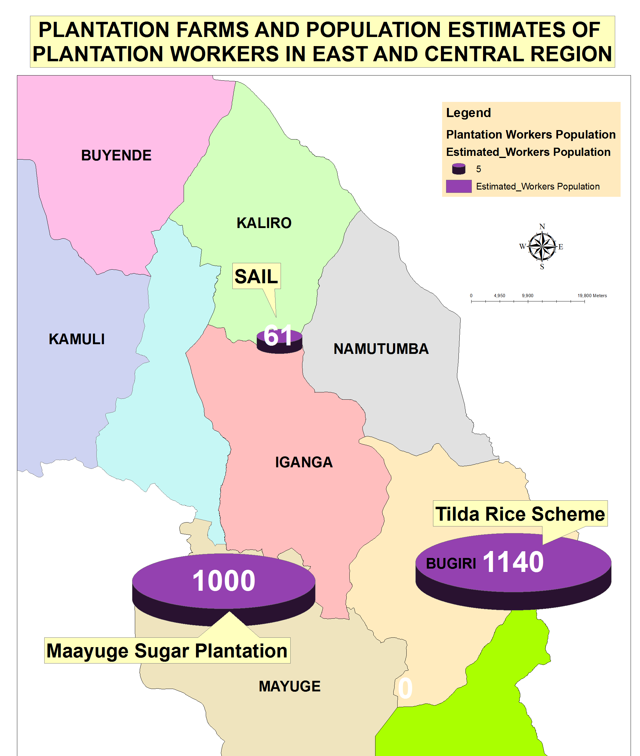

8.2.4 Nationality and Ethnicity

The majority of the population were Ugandans and from the study region. These included the indigenous Basoga and ethnic groups from the neighboring districts like Basamia, Bagisu, Bateso and the Adhola. In addition, some of the permanent staff were foreigners of Indian origin especially in top management. Some of the staffs engaged by contractors came from neighboring Kenya.

8.2.5 Vulnerability
Amongst the plantation workers, there were limited reports of increased vulnerability associated with their occupations. However, at SAIL there were reported long spells of staffs staying away from their spouses yet they remained regularly interfacing with fellow staffs hence some increased risk. Multiple partnerships were common coupled with non-use of condoms were taken as factors increasing vulnerability of the plantation workers and the host communities. These issues are reflected in the statements below:

When you work with some body for a long period of time at times you develop some trust even if you don’t know his HIV status (Workers FGD Tilda Rice Scheme).

Multiple sexual partners make many people in Busoga to be vulnerable.
Poor condom use also increases the levels of infection in the region. This happens when you stay away from your spouse for a long time (SAIL Plantation workers FGD).

8.2.6 Age and Sex
The majority of the workers were male in most of the plantations given that the nature of work is labour intensive however the number of female workers was approximately 25% of the entire workforce. Most of the workforce range from 20 to 50 years.

These were mainly within the energetic age bracket of between 20 and 50 years and most of whom were male workers (SAIL Plantation workers FGD).

Most of our staffs are males by the nature of work I could estimate that the females are about 25% and the males 75% of the staff population which we have (Mayuge Sugar Plantation FGD).

8.2.7 Risky Behaviors and the Influencing factors
Multiple sexual relations were common in addition to limited condom use. The factors aggravating this were reported to alcohol consumption and long durations of workers away from their spouses.
Being away from home for long periods, some of us have not been to our homes for over two months and here you can’t be sure of what your wife is doing at home and she also can’t be sure of what you’re doing while away. There is too much consumption of alcohol among the locals, local brew i.e. kaliga from sugar modulus is made around the areas of Kakira and Mayuge and it is distributed in large amounts in the region and its very certain the production will also start here once we commence sugar production by 2014
(SAIL FGD).

8.2.8 HIV Response
It was only Tilda Rice Scheme which had an HIV program and un -written workplace HIV policy. The services were being offered through a health center II initiated by government but supported by Tilda Rice Scheme. In addition some staff would be supported to get treatment outside the health facility as need arises. Peer education initiatives had been started with external support.
We have a health facility just outside our main gate with a staff from government and we provide the drugs and facilitate some referrals which are made .We also have peer educators who educate and interact with fellow staff on issues of HIV & AIDS. (KI Tilda)
We have care and support services from TASO,PMTCT in our health units, couple counseling, condom distribution, nutritional support for PLHIVs and safe male circumcision(Mayuge Plantation workers FGD) .

8.2.9 HIV Response Gaps
Apart from Tilda and Mayuge Sugar Factory/Plantation other plantations did not have good access to HIV prevention and care services for instance HCT was far making it difficult to access. Whereas condoms were quite available there was limited use because of limited knowledge and skills.
The prevention services are limited to mainly the urban areas like here and the village people won’t bother to ride a bicycle for 30 km just to come for HCT or to pickup condoms. Condoms may be readily available but knowledge and access to condom use is very scarce because people fear to ask for them and the distributors never demonstrate because they assume we know (SAIL Workers FGD).

8.2.10 Suggestions
The study participants proposed an improvement of the available services like PMTCT, SMC targeting an age group lower than 15 years and compulsory HCT. This is expressed in the statements below:
There is need to promote PMTCT education in the rural parts of Busoga .Also the massive circumcision program of STAR-EC needs to be for all males and not limited to 15 years and above. Frequent sensitization and regular HCT programs to the community (KI Mayuge).

We need improvement in nutritional support, counseling, HIV sensitization and introduction of compulsory HIV testing (Mayuge Plantation workers FGD).

8.3 Key findings related to Uniformed Personnel
- The police, army and prison staffs were identified as a key population at risk of HIV infection.
- Through regional police and prisons structures it was established that there were 1075 police and 274 prisons staff in the study area most of whom were males.
- There was one army barracks in Maga-maga with a community population of about 1,000 people and 35% were non-combatants.
- Overall, there were 2,000 uniformed personnel in the study region.
- The uniformed personnel were not leaving in isolation as they were customers of social outlets in the region.
- Risky behaviours like multiple sexual relations, rescuing accident victims without protective gear and unprotected sex were reported among the uniformed personnel.
- The risk was influenced by sharing of accommodation, alcohol abuse, enticement and attraction by suspects, supplementing income for females and closeness especially during night deployments.
- The common sources of health information were radio, workshops and parade meetings.

8.3.1 Introduction
The study targeted three categories of uniformed personnel namely the police, Prison staff and the army. The most reliable source of data on the population sizes was interface with the district and regional leaders against the background of the sensitivity of the uniformed personnel. Information is presented at district level for both police and army.
Data on number of uniformed personnel were collected from regional offices. The team was not directly availed data on numbers in Magamaga Army Barracks hence this section presents only an estimate from a key informant for the army numbers for uniformed personnel from the police and the prisons from official records. For security reasons data were provided on district basis with no specific reference to which station has which numbers. In total the study region had a total of 1075 police, 274 prisons staff and about 650 army combatants in Magamaga. About 805 of the uniformed personnel were males.
These are broken down in the table below:

Table 8.4 showing the number of police staff per district.

District name | Males | Females | Totals
Namayingo | 69 | 5 | 74
Buyende | 57 | 16 | 73
Mayuge | 131 | 32 | 163
Kamuli | 94 | 46 | 140
Luuka | 52 | 9 | 61
Bugiri | 147 | 34 | 181
Iganga | 147 | 71 | 218
Kaliro | 67 | 20 | 87
Namutumba | 61 | 17 | 78
Total | 825 | 250 | 1075
Source Regional Police Commander Jinja

Table 8.5 showing prisons staff by district

District name | Males | Females | Totals
Namayingo | 4 | 3 | 7
Buyende | 13 | 4 | 17
Mayuge | 69 | 13 | 82
Kamuli | 32 | 13 | 45
Luuka | 7 | 3 | 10
Bugiri | 9 | 8 | 17
Iganga | 52 | 20 | 72
Kaliro | 15 | 3 | 18
Namutumba | 5 | 2 | 7
Total | 206 | 69 | 275
Source Regional Prisons Commander Jinja

8.3.2 Age
The age range for uniformed personnel was consistent with the rest of the public services structure but fell within the range of 25-50 years in the study area.

8.3.3 Vulnerability of Uniformed Personnel
The increased risk was noted in the interface especially with suspects or by nature of deployment and also in event of managing accident victims where the officers are exposed to blood especially when protective gear and infection control procedures are not adhered to. This is noted in the statements below:
We are mostly vulnerable to sexual activities especially during investigation of cases of female suspects. Also a lot of transfers which can’t allow us to concentrate on our families, this makes some of us susceptible to extra martial sex. There are also some “stupid” police officers who rape female suspects in the cells
The night patrols in which victims are arrested, some officers negotiate sex with suspects in exchange for their release (Police Officers FGD).

8.3.4 Factors Influencing Risk Behaviours
The study participants were asked about the factors influencing risky behaviours among the uniformed personnel and alcohol consumption, the nature of accommodation facilities, inadequate pay especially among female uniformed personnel and limited HIV knowledge were mentioned as the factors influencing risky behaviours as indicated in the assertions below:
The excessive use of alcohol and drugs which affects most people’s sense of judgment. Lack of proper and decent accommodation for police officers, when you look at our uni-pots, they are so close to each other and we do share houses so your neighbor can easily poach on your wife when you are away on night duty.

In East Central, there are high poverty levels here, even when you are employed like us, the payments are so poor and can barely provide for the basics, so people engage in other dubious work like women in sex work or soliciting for bribes. We also don’t get enough sensitization on certain things like condom use and neither do we get exposed to HCT services at our facility, because most people fear to associate with guns and that’s all they think and know about the police (Police FGD).

8.4 Key Findings related to “Boda-boda”motor Cyclists
- The “boda –boda” population operated in mainly urban and semi urban areas in the study area.
- It is estimated that there are about 12,680 “boda-boda” motor cyclists among whom 28% were stationed at the district headquarters while the rest were in the other outlets.
- The “boda-boda”motor cyclists are a young energetic population mainly aged between 15 and 35 years.
- They had leadership structures built on stages.
- They are idle especially during the day and it is a norm to discuss their sexual experiences and exploitations.
- They engaged in sexual relationships with their clients especially school girls, FSWs and married women who tend to take advantage of free lifts.
- Most of them reported to be single and engaged in multiple sexual relations most of which were unprotected.
- Alcohol abuse, enticement by clients, idleness, negative- peer influence availability of extra daily cash and high libido were reported as some of the factors leading to risky behaviours.
- They were knowledgeable on HIV prevention and care but with misconceptions of young girls being free of HIV and assuming that concordance (same HIV results) of couples always.
- “Boda –boda” motor cyclists had access to HIV services like condoms, HCT and treatment however they reported stock-outs of HCT kits in some facilities.

8.4.1 Introduction
There was a general consensus among the study participants that the “boda- boda” motor-cyclists were a MARP in the study area. These had a bigger concentration in urban centers compared to the rural settings. They operated at “boda- stages” where there was some form of bonding and leadership for each of these units of operation. The majority of these ‘boda- boda’ motorcyclists were young men aged 15 years to 35 years.

“Boda -boda” motor Cyclists Characteristics

8.4.2 Geographical Location
“Boda-boda” motor cyclists operate normally in urban centers in the region and position themselves in strategic positions called “stages’’ to easily access clients in need for lifts on their motorcycles

8.4.3 Size Estimation
The size estimation for boda- boda’ motorcyclists took a mixture of methods and one of the key approaches were a review of the records held by the leaders at the district , township and stage levels. This was done while working closely with the chairpersons. “Boda-boda” associations were found to be more active in Mayuge, Bugiri and Namayingo districts and these helped to establish the numbers in their respective districts. Through this review and interaction with “boda-boda” leaders the following were established.

Table 8.6: Showing the Number of ‘Boda- boda’ Motor Cyclists per District
 | Estimates for the urban areas hosting district headquarters |  | Estimates for other areas |  | Total District Estimate
District | Total number of “Boda-boda motor cyclists (Local records) | Adjusted for under reporting +5%  A | Total number of “Boda-boda” motor cyclists from other areas  (Local Records) | Adjusted for under reporting +5%  B | Size estimate  A+B
Iganga | 800 | 840 | 2,190 | 2,300 | 3,140
Mayuge | 333 | 350 | 1,763 | 1,851 | 2,201
Bugiri | 601 | 631 | 1,453 | 1,526 | 2,157
Kaliro | 423 | 444 | 429 | 450 | 895
Namayingo | 145 | 152 | 537 | 564 | 716
Namutumba | 268 | 281 | 269 | 282 | 564
Kamuli | 140 | 147 | 770 | 809 | 956
Luuka | 82 | 86 | 473 | 497 | 583
Buyende | 144 | 151 | 1254 | 1317 | 1,468
Regional | 2,936 | 3,082 | 9,138 | 9,596 | 12,680

8.4.4 Organization and Leadership
Throughout the region, the “Boda-boda “motor cyclists had some leadership structures built on the “stage” concept. The stages had some membership ranging from 5-15 “boda-boda” motor cyclists and depending on the location most of them had a chairperson. In some districts like Bugiri , Mayuge and Namayingo the group had district level leadership.

8.4.5 Vulnerabilities of “boda-boda” motor-cyclists
An assessment of the vulnerability of “boda-boda” motor cyclists was made from the discussions showing biological and environmental issues increasing the risk of exposure. Biologically against the background that most of the cyclists were young and energetic, tendencies of excitement were reported on sighting young girls and this was exploited by some of the girls for free lifts. The cyclists also take advantage especially of the young girls. Cases were reported of girls especially those working in social outlets who work late and they often offer to pay in kind especially in the night which finds them unprepared and as such having unprotected sex.
As “boda-bodas”, we are very vulnerable because most of these boys you see here are very young and still growing up so they get excited by women and most of these women exploit them because they want to always get free lifts from them.
Also in the night, some of the clients especially the women don’t want to pay for the fare, some negotiate sex in exchange especially those working in bars and night clubs and others because they have failed to pay, have been raped by the “ boda- bodas”, so the danger here is that these are not planned sexual encounters and therefore there is no condom use and the encounter could be in a bush, dark place or abandoned building(Boda Boda Leader KI Namutumba).
The girls we befriend besides our normal spouses don’t want to use condoms. They want/prefer live sex (Boda Boda Cyclists FGD Mayuge).

8.4.6 Factors Influencing Risk Behaviours among “Boda- boda” Motor Cyclists
Deliberate effort was made to secure information on the factors that promote risky behaviours among “boda –boda” motor cyclists. It was reported that these groups had high libido which was promoted by discussions at work whenever they sighted any girls during their free time. The peer influence, availability of daily disposable cash and abuse of alcohol and drugs was also reported to be influencing them into risky sexual practices.
Generally we as men, we have big appetites for sex, we discuss sex all the time and we also want to have it all the time for instance, in our “ boda- boda stages” here, these young men are only discussing each passing by woman, the women they have had sex with.Most of our colleagues are very young below 25 years, they are still single, so most of them are excited by issues like having many sexual partners at different times(Boda- Boda KI Namutumba).

There is a lot of peer influence especially from older ones especially among us the “boda- bodas”. The money fact, many of these people have money and they engage in a lot of risky behavior. Some of our colleagues here take too much alcohol and others even take drugs like marijuana (Boda Boda KI Namutumba).
Redundancy – Our youth are mostly unemployed. The few who are say in Boda Boda business are too many compared to the customer base which leads to disguised under employment. Look at those boys settled under that tree, they are totally redundant (Health workers KI Kamuli).
“Boda Bodas” follow the FSW. They have access to those women and girls who are the customers from whom they get sex sometimes they go in without condoms. Last Monday (4 days ago) a boda boda who had a habit of raping passengers (beautiful) was arrested in the process of demanding for sex from a customer ( Health workers KI Kamuli).
We see a lot of customers including women. secondly, we transport them on our bikes while they are holding us in the waist, touching our bodies or pressing their breasts against our backs with the accompanying warmth and when you break they press against you sometimes deliberately---- All this leads to arousal for the biker and the passenger herself. Thirdly , they expect us to have some money to give them. So they agree easily when we propose love/sex (Boda Boda FGD Mayuge).

8.4.7 Knowledge and Perceptions among “Boda- Boda” Motor cyclists
HIV Knowledge among target audiences is expected to promote positive behavioral change therefore the study sought to assess the level of HIV knowledge. Amongst the “boda-boda” motor cyclists there was evidence that they could accurately state the modes of HIV transmission and available services. However, some misconceptions and wrong beliefs were reported like: taking young girls to be free of HIV infection and automatic conclusion that if one spouse is infected with HIV then the partner was also infected. This is illustrated in the assertions below:

Among people here they very well know that HIV is transmitted through live sexual intercourse with an infected person. They also know that a pregnant woman infected with HIV can transmit to her baby during birth if she doesn’t deliver from a health facility. There’s a belief among people here that the young girls are usually free from HIV infection. We also know and belief that when a man is infected, then even his partner is infected. We know that there is now treatment for HIV which is septrin and ARVs which are available in the health centers (Boda Boda Leader KI).
Fear and discrimination – most people still don’t want to test. Support services are not available. Those who test are not supported psycho – socially. Our experience is that those who test +ve deteriorate very fast and die. So we fear to test (Boda Boda FGD Mayuge).

8.4.8 HIV Service Accessibility and Current Prevention Needs
An assessment was made of the available HIV services and the gaps amongst the target population. It was noted that some HIV prevention and care were available for “boda –boda” motor cyclists among which were condoms and HCT especially by NGOs like Uganda Reproductive Health Bureau. However, they noted gaps in the availability of some of the drugs and at times HIV test kits. This is reflected in the statements below:
We access the prevention service but they are still very limited, things like condoms are not easy to get even when you visit the hospitals .The drugs some times are out of supply in the hospitals when we go to pick them. There are sensitizations and free HCT programs that are carried out by URHB(Boda Boda Leader KI).
Our unique prevention needs are encouraging every pregnant woman to deliver from hospitals, provision of condoms and safe male circumcision programs(Boda Boda Leader KI Namutumba).

8.5 Key findings related to fisher folks
- This population is located at landing sites on Lake Victoria, Lake Kyoga and River Nile distributed in five districts namely: Bugiri, Kamuli, Buyende, Mayuge and Namayingo districts.
- Its estimated that the total fishing community in the survey region is 63,639.
- The fishing population is highly mobile some of whom are with spouses at different landing sites.
- There were more males compared to females among the fisher folks.
- They are characterized with risky behaviours like sharing of women, multiple sexual partnerships and non-use of condoms.
- They had accurate knowledge on modes of HIV transmission, signs and symptoms yet they had negative attitude about taking any protection measures like using condoms.
- The influencing factors to high risk sex include: availability of extra daily disposable cash, high consumption of alcohol, redundancy during the day, a high concentration of social outlets operating all the time, negative attitudes and low risk perception.
- There is limited coverage of HIV service outlets and health workers in fishing communities.
- Insufficient health products like HIV test kits in some health facilities.

8.5.1 Introduction
The fisher folks were taken as those communities benefiting from the fishing industry in the respective communities. These include fishermen or barrias, boat owners, fish processors, fish mongers, traders, boat makers/repairers and transporters. Some of the fishing communities or fisher folks are on the islands while others are on the main land. The fisher folks are found on six out of the nine study districts namely: Namayingo with the highest population, followed by Mayuge then Kamuli, Bugiri and Kaliro with smallest populations. This section covers the estimations, the characteristics including behaviors, HIV response, program gaps and suggestions for improvement.

8.5.2 Estimated Number and their Characteristics
The size estimation was mainly on the basis of triangulation information from BMU registers, KI interviews, FGDs and individual questionnaire information. The estimates are presented in this section. Overall it was noted that the fishing folk were generally mobile communities with large spectrum of age categories but doing different things. They were both men and women depending on particular site assignments for example the category of boat makers and fishermen were men while fishmongers or dealers were a mixed category. Some of these groups were not permanent residents who would come and spend on average five days at a site. Through the different methods, it was estimated that the fisher folks population was 63,639.

We have about 1,254 fisher folk registered with our BMU with most of them engrained in different activities ranging from fish mongering, boat making, fish dealers, the transporters to the fishermen. The fishermen, the transporters and boat makers are predominantly men and then the fisher mongers and fish dealers are usually both men and women. Most of the fish mongers, dealers and transporters are people who just come in to buy and transport the fish but are not permanent residents here though usually the transporters can stay around for 5 days to one week buying and loading fish into their cooling cars since there is scarcity of fish now days(KI Waka Waka Landing Site ).

Its about 500 people of whom the majority involved in the fishing business are men however women who own boats and deal in fish are also taken as part of the fishing folk here (KI Waka-Waka).

Table showing the estimates of fisher folk by category by districts:

Fisher folk category | District | Bugiri | Buyende | Kamuli | Kaliro | Mayuge | Namayingo | Regional Total
Barias | Male | 501 | 1,397 | 545 | 1,582 | 9,382 | 12,725 | 26,131
Barias | Female | 2 | 1 | - | 6 | 2 | 18 | 29
Processors Smokers | Male | 1 | 81 | 48 | 69 | 278 | 828 | 1,304
Processors Smokers | Female | 13 | 108 | 113 | 75 | 1,001 | 1,709 | 3,019
Traders | Male | 25 | 857 | 1,007 | 1,710 | 1,776 | 1,467 | 6,842
Traders | Female | 11 | 977 | 822 | 1,053 | 563 | 957 | 4,383
Fish Mongers | Male | 47 | 376 | 98 | 105 | 383 | 2,019 | 3,028
Fish Mongers | Female | 46 | 452 | 73 | 87 | 323 | 866 | 1,846
Transporters | Male | 1 | 63 | 52 | 132 | 299 | 190 | 738
Transporters | Female | - | 43 | 24 | 48 | 33 | 36 | 184
Boat Owners | Male | 108 | 318 | 204 | 266 | 1,669 | 1,852 | 4,417
Boat Owners | Female | 7 | 110 | 23 | 125 | 332 | 244 | 841
Boat Makers | Male | 6 | 71 | 30 | 6 | 407 | 153 | 673
Boat Makers | Female | - | 4 | - | - | - | 21 | 25
Net Repairers | Male | - | 28 | 36 | 21 | 152 | 244 | 480
Net Repairers | Female | - | 5 | 7 | 9 | 4 | 21 | 46
Sex workers | Females | 38 | 27 | 70 | 14 | 289 | 261 | 699
Boda Boda | Males | 107 | 35 | 434 | 131 | 35 | 97 | 839
Others | Male | 74 | 543 | 627 | 473 | 2,197 | 207 | 4,120
Others | Female | - | 698 | 703 | 125 | 2,329 | 140 | 3,995
District Estimate |  | 988 | 6,194 | 4,912 | 6,037 | 21,454 | 24,055 | 63,639

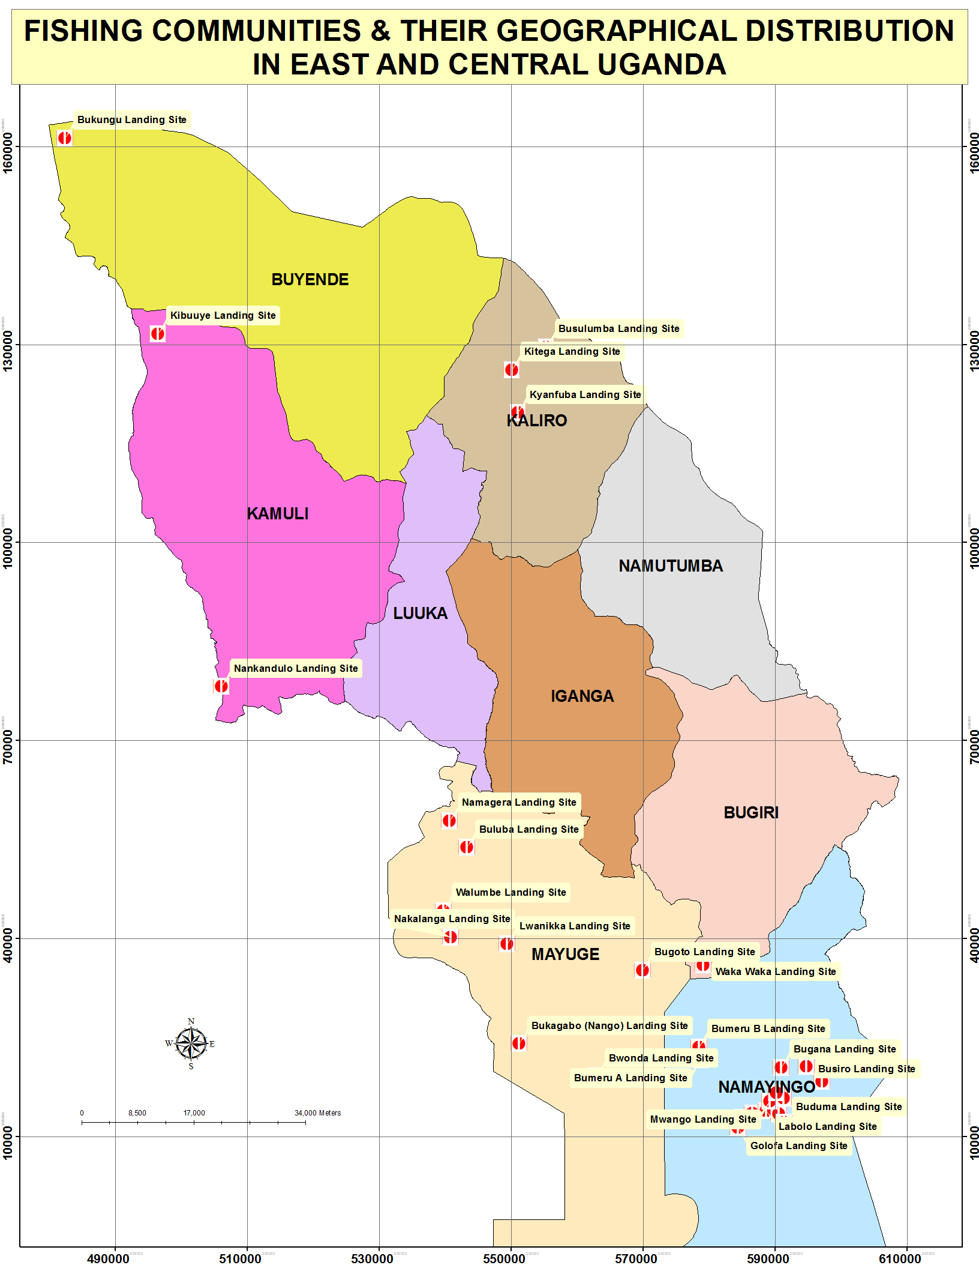

8.5.3 Age
There is no age limit for the fishing business because even children as early as 10 years have already learnt how to fish and this being the predominant activity here, people of all age are involved in the fish business(KI Waka Waka Landing Site).
Fishing usually has no age because even children of 8-10 years go fishing and even the elderly do go fishing (KI-Bwondha Landing sites).

8.5.4 Vulnerabilities
The study solicited insights among the different groups that expose them to the risk of HIV infection and this is with a view of mitigating some of these factors in the interventions. The common factor stated to increase their risk of HIV infection was the high level of mobility without their spouses. In addition the risk perception among the study participants in the fishing communities were that HIV kills over a longer time as opposed to the daily risks of drowning and hippos which kill them instantly.

Our population here is also a highly mobile one not only the fishermen but even the other people in this business, they move from one landing site to another and this is influenced by market days in different landing sites and this makes them very vulnerable to HIV&AIDS and STD infections because they are always away from home (KI Waka Waka Landing Site).

Here we are so vulnerable to water animals like crocodiles and hippos, we are more afraid of the hippos than contracting the HIV because they kill you instantly unlike HIV (FGD Waka Waka landing site).
The other groups like the police, “boda- boda motor cyclists”, plantation, FSW and truckers are also very mobile people like us, so they equally spread the HIV&AIDS to different other parts (FGD Waka Waka landing site).

8.5.5 Emerging MARPs and the Prevention Needs

A deliberate effort was made to establish existence of any other groups which seem to have more than average HIV risk and their prevention needs. In response, the study participants identified the mobile business men who came to transact business on market days and stay overnight. The common prevention needs cited were HIV education and availing them with condoms. This situation is reflected in the statements below:

Yes, the mobile business people who come here once every week for the Sunday- Monday overnight market. This booming weekly overnight market puts the business people and community here at a high risk of HIV infection since there is a lot of immorality that takes place especially during the night (Fisher Folk FGD Waka Waka).

There is need for constant condom distribution during the market days. The peer educators should sensitize people on the importance of condom use to counter their negative attitudes condom use; In general we as fishermen don’t usually use condoms (Fisher Folk FGD Buyende).
The married people are at risk of infection because they don’t seek services such as condoms, HTC, safe male circumcision e.t.c. There is no disclosure among the HIV+ couples in most cases, even among those couples on ARVs, and there is secrecy within couples and at community level (KI Mayuge District).

8.5.6 Factors Influencing Risk Behaviours among Fisher folks
The study established the risk factors and the drivers of the HIV epidemic in the study area and in specific MARPs. It was noted that in fishing communities there are fewer women compared to men and as such the women are shared. In addition whenever a new woman joins the communities most of the men strive to have sex with her first before the rest of the members. The availability of extra money which is earned daily enables the men to use it to buy sex and enjoy alcohol. There were also wrong beliefs and assumptions to the effect that they were already infected and therefore no need for protection. The availability of free time coupled with social amenities provided a conducive environment for alcohol consumption and sexual engagements. These scenarios are presented in the statements below:
Speculations that most of them are HIV+ make them reckless and not want to use condoms. The hear- say that most of the sex workers who visit the area also HIV+ makes them not care and they assume they will die anyway. The ratio of men to women here in the landing site is about 1:5 and once there a new woman in the area everyman with money tries so hard see to it that he’s the first to have sex with her and sometimes the men will even place a bet on it (KI BMU Waka Waka).

Here there is a lot of money in circulation that exchanges hands not only among the fishermen but among the fisher folk so this rises the desire for money among the sex workers who make themselves readily available in the area. There is a belief here that some of us died a long time after contracting HIV and its just a matter of time and the ARVs never reach places like Waka Waka so the people don’t care how they carry on with their lives(KI BMU Waka Waka).

The fisher folks can be rated to be the highest among those with high Risks. This is because of the nature of their work where they stay away from their families for long hours on water or at another landing site(s). They usually have multiple partners. They operate at landing sites and oscillate among the several landing sites even across the lake to Lango, Teso and Bugwere among others (Health workers KI, Buyende District).

The presence of many bars in the area which are usually open throughout the day and night means that we can access alcohol at anytime. There are also many discos in the area with nice and enticing women who are seductively dress so we get carried away and given in to their demands. There is presence of lots of money, here we believe that you can’t buy a bone yet you can afford the real meat so the many mobile good looking women that come here are usually sex workers who also know that we always have money from the fishing business(Fisher Folk FGD Waka Waka BMU).

Most of us care about today and tomorrow will take care of itself, we are not educated and even the other groups like boda bodas, plantation workers, so the basic information on protection that we have is limited and even the little we don’t put it into use (Fisher Folk FGD Waka Waka BMU).

Fishermen (most of the time) work at night and rest during the day. They have disposable income to spend during their rest time out of fish sales .On the Islands there are fewer women than men so they end up sharing the women. And they have money which they spend – “ozilya kivubi” meaning “you eat it the Fisherman’s style”.
There is this issue of “I don’t care” attitude. AIDS is not regarded seriously but just another human affliction like malaria and the service delivery system has not prioritized those MARPS and targeted them for service delivery like HIV&AIDS clinics, HCT outreaches, condom distribution and IEC materials(Health worker KI Buyende).

8.5.7 Knowledge and Perceptions among Fisher folks
HIV preventive and care knowledge is expected to facilitate behavioral change among individuals. The study established the knowledge levels among perceptions among specific target populations. It was common knowledge that HIV is mainly transmitted through having unprotected sex with an HIV infected persons and the signs and symptoms of HIV like loss of weight, having opportunistic infections like TB and Herpes-Zoster were mentioned. Despite this knowledge condom use was reported to be minimal. The statements below show their insights:

Surely the fisher folk here know that HIV is transmitted through unsafe sex but their attitudes towards condom use is still poor, we receive condom supplies in plenty but they never pick them. There is also a belief that HIV is a curse for the fishing community since they are gifted with money, they perceive that if you survive dying in the waters than you certainly cannot survive contracting the HIV virus (KI BMU Waka Waka).

HIV is transmitted through sexual contact with an infected person. We also know that HIV makes you grow very thin and small and some people even develop TB and signs like herpes ‘kisepi’. HIV+ pregnant women, if they don’t deliver from hospital, then they will give birth to HIV+ children (Fisher Folk FGD Waka Waka).

8.5.8 HIV Response in among fisher folks
Some of the fisher folks reported the availability of services which they could use and they included: SMC, distribution of condoms and septrin. The main partner noted among the fishing communities was STAR EC. It was also noted that some of the services were quite far as such affecting utilization.

The services as far as HIV prevention are still limited, the existing health center here only distributes septrin and refers people to Nankoma or Bugiri and given the long distances most people don’t bother going or if they go this month the following month they won’t go. The safe male circumcision program by STAR E-C has received overwhelming support from the locals as many men are getting circumcised. There has been condom distribution by STAR E-C through its trained peer educators. The trained model couples have been equipped to train other on sensitive issues like being faithful and condom use. The presence of STAR- EC circumcision program has reinforced some people’s attitudes and behavior however, the fact that the program targets 15 years and above still denies many the chance to circumcision (KI Waka Waka).

The prevention techniques we have here are condoms but of course not everybody is using condoms or when people pick you can’t ascertain whether they are actually using them. We have the male circumcision program at the health center III and this is run by Star EC (Fisher Folk FGD Waka Waka).

We don’t actually see many prevention services here except for the male circumcision which you have found on going right now at the health center.
Pregnant women here are encouraged to go for antenatal and to make sure they test and deliver from the health center III. We get free condoms from different organizations like Uganda Reproductive Health Bureau(URHB) and STAR E-C but they keep them in the BMU office until when they expire and because people here don’t believe in using condoms because it’s like eating a sweet in “ kaveera”(Fisher Folk FGD Waka Waka).

8.5.9 HIV Response Gaps and Needs
Despite the availability of services some service gaps were reported. These included limited education on condoms, SMC and HCT. Supplies like HIV test kits were noted to be irregular at some of the sites. In addition there were limited condom distribution outlets leading to expiry of condoms in the BMU offices.

The challenge with the circumcision program is that people have not been completely sensitized that it reduces the risk of infection and not eradication the infection completely. There is also need to sensitize the people on the prevention services available like safe condom use always. There is need to encourage people here to attend HCT and to make the service more frequently and readily available (KI Waka Waka).

The health center III has programs like HCT but they are not well equipped sometimes when you ask to be tested, they tell you they don’t have testing materials. The fishing folk in islands like Libya, Ssiringina among others never get items like condoms or HCT or even sensitization campaigns because the people who are supposed to do it assume that the world ends at the landing sites and there is nothing of importance beyond the inland. Therefore as much as more and more condoms are supplied here, people need to be educated and sensitized about condom use. The organizations that supply condoms should train and get people who can effectively distribute these condoms because when they bring them to the BMU office, they just expire from there. Organizations that are helping people deal with HIV/AIDS related issues should be able to setup offices in most of the big landing sites where they can keep in constant touch with the people and know the issues that affect them rather than just coming to visit these areas once in a while(Fisher folk FGD Waka Waka Bugiri).

Figure 8:Namayingo district landing sites and location of health facilities

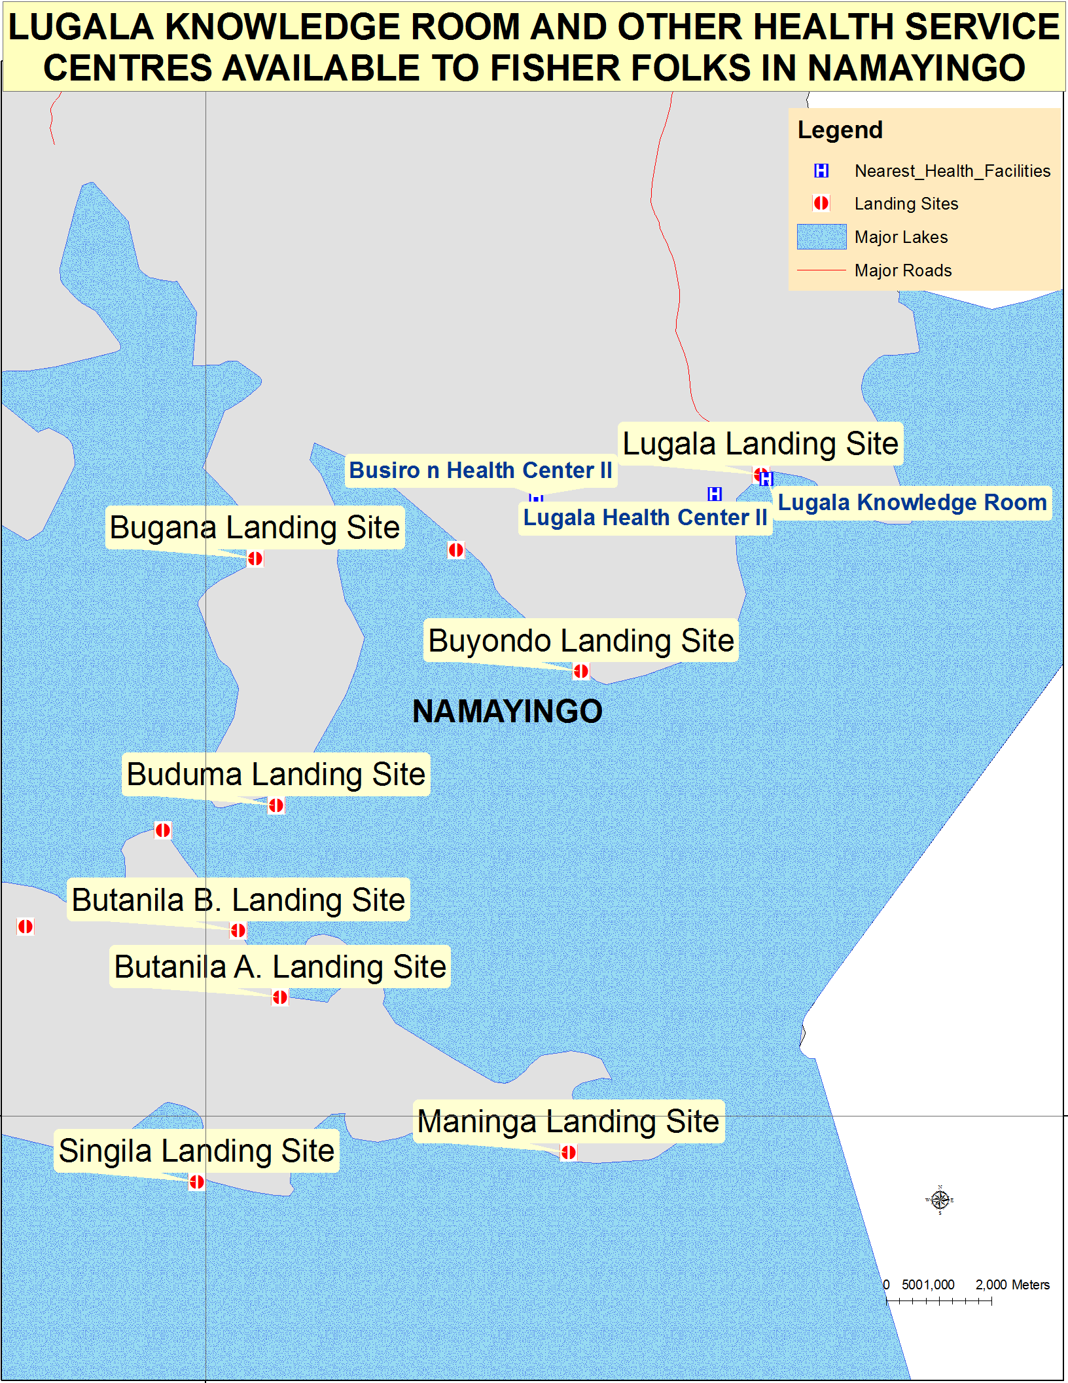

8.6 Key findings Truckers and Their Assistants

- The truckers and their assistants were identified as a key population at risk of HIV infection in the study region.
- It was estimated that on a daily basis there were about 321 truckers and their assistants staying overnight at 4 hotspots in the study region namely Naluwerere, Busowa, Idudi and Bulanga.
- The truckers and their assistants were a mobile group by nature of their occupations.
- They formed the key customers of FSW at the hotspots.
- The truckers were of different nationalities in the region (Somalis, Kenyans, Burundians and Ugandans).
- Risky behaviours were common like multiple concurrent sexual relationships and limited condom use.
- The influencing factors for risky behaviours include: Peer pressure, the alcohol and drug abuse.
- The current source of information on health was the radio while the preferred was the radio and local public address systems.
- Proposals were made to scale-up HCT and care for orphans and widows.

8.6.1 Introduction
Globally and regionally the truck drivers and their assistants have been regarded as groups with a higher risk of HIV infection. The study sought to establish the hotspots where the truckers usually park over night along the Busia/Malaba Kampala routes within the Busoga region. It was established that within this area there were 4 main stop overs; Naluwerere (Bugiri District), Busoowa (Bugiri District) , Idudi (Iganga District) and Bulanga (Mayuge/Luuka District). They are called “stopovers” because almost no truck has either of these towns as their final destination. They stop over for many reasons but the main one is resting and getting refreshments and food before they embark on their long journeys.

8.6.2 Size Estimation among Truckers and their Assistants
The study sought to establish the number of truckers and their assistants who stay in the region per day. The system used enumeration of trucks parking in the four key “stop-overs” within the parking time that is between 8.30pm and 11.30pm.Through this the average number of truckers was multiplied by 2.5 because every truck is expected to have three people yet in reality some are two while the others are three and 2.5 would be the middle level position. Data were collected by enumeration of trucks that parked for a period of four days in Naluwerere and Idudi and three days for Busoowa and Bulanga. The enumeration team captured the 'head'/in-front number plate of all parked trucks. Data were cross checked on a daily basis to avoid capturing the same truck twice between the different stopovers in the same day.

Figure 8: Map showing hotspots and estimates of truckers

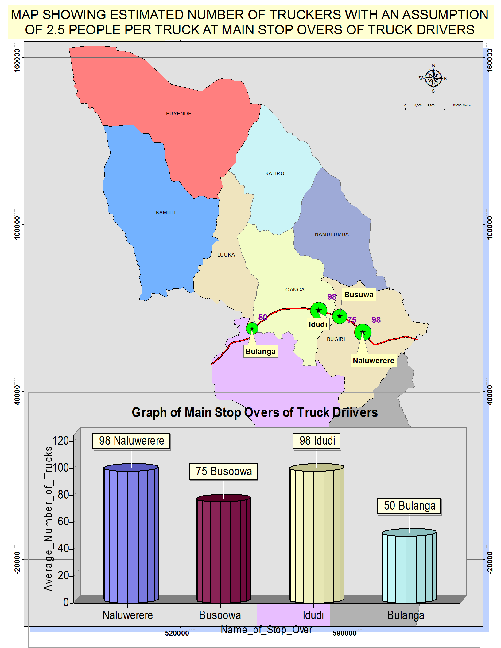

Through the above system the following averages and estimates were established.

Table showing the estimated number of Truckers/Assistants

Name of stopover/Hotspot | Mean Number of trucks | Estimated number of truckers with an assumption of 2.5 people per truck
Naluwerere | 39 | 98
Idudi | 39 | 98
Busowa | 30 | 75
Bulanga | 20 | 50
Total | 128 | 321

8.6.3 Geographical Location
By virtue of their occupations the truckers and their assistants are mobile populations who move from township to township along the highway from Mombasa and have “stop-overs” just to refresh. In the context of this study their locations would be areas where they frequently park over night before proceeding with their journeys.

8.6.4 Nationality
The truckers and their assistants originate from different counties. Some are Kenyans while others are Rwandese, Burundians, Ugandans and Somalis.

It is difficult to get the details of the nationalities of the truckers however we note that some of them are Ugandans others Kenyans, Somalis, Rwandese and Burundians(Local Leader KI Bugiri).

8.6.5 Risk Behaviors and influencing Factors
The truck drivers and their assistants who operated at the different sites at on the highway indicated that they would be engaged in high risk sex with mainly commercial sex workers and their “highway wives”. This was influenced by alcohol consumption/drug abuse, peer influence, availability of extra cash and the long period away from their spouses. This is illustrated in the assertions below:

Truck drivers are a high risk group because of the multiple partners they frequently engage with. They operate from Bars and Lodges. Being away from Home for long, alcohol consumption, opium smoking/mairungi or Khatt eating which arouse their sex libido. Some truckers get involved in risky behaviours because of peer influence and a poor nurturing background (Leaders KI Iganga).

The truckers stop over to eat and sleep or for recreation and sex. This is because the girls and married women have sex due to poverty and need for money. It is actually a cycle. The young girls go to truckers and married men because of their need for money yet some of them might be HIV+ve. The wives go to truckers and may bring the disease to the husbands (Truckers FGD IDUDI).

The Truck drivers engage in sex with us because they take long to go back to their homes. Yet they are the ones who have some good/reasonable money. Without much ado they give out money and entertain well. They usually operate in lodges and Bars in the several stops (FSW Iganga).

8.6.6 HIV Response
The available services involved provision of education and HCT through outreaches and provision of condoms. These services are provided in the night since they are not available during the day.
We get HIV counseling and testing services in the night and Some condoms are supplied, some are free but others are sold. It could be better if these are given to people who own lodges, Bars, and Restaurants, freely. The lodge owners should be the network for condom distribution and promotion (Truckers FGD).

Once in a while there are outreaches say once in three months for HCT, awareness or mobilization or condom distribution (Truckers KI).

8.6.7 HIV Response Gaps
The national response aims at promoting access to both HIV prevention and care services. In the context of truckers and their assistants the distance to health facilities is quite long so they rely mainly on local pharmacies and drug-shops for self medication .There is also limited access to condoms and as well education as there is still some fear and stigma related to condom use.
We do not have any health unit except small local pharmacies. The nearest is Busesa HC IV which is 10 km away (Truckers FGD IDUDI).
Some don’t use condoms because women don’t buy them and yet want money. Some don’t want to use condoms (Truckers). If a woman insists on the condom the trucker tell them to buy them for themselves if they want to use them. So help us with condoms especially in lodges and Bar outlets (Truckers FGD IDUDI).

Some men just fear condoms. They close/cover their eyes and ask you put on the condoms for him. They prefer live sex (FSW FGD Iganga Town).

8.6.8 Current Source of Health Information among Truckers
The radio was the common source of information while others reported getting
information from local leaders. This is consistent with the information presented in other
studies where the radio is stated as the main source of information.
The Radio is the common source and meetings with local leaders were the common source of information on health (Truckers FGD Idudi).

8.6.9 Preferred Source of Health Information
The study participants were asked their preferred sources of information on health and in response they said they prefer getting information on health from radios and local public address systems which were noted to be cheaper.

Could be the radio because using other messengers may not be effective since they may not pass on the message. The public address system (PAS) which we have in the locality is also effective and it is cheaper. 10,000/= can be used for a week to pass on information (Truckers FGD).

8.6.10 Suggestions
The proposals made for improvement included establishment of units for treatment, sensitization especially on the need for HCT and provision of basic necessities for orphans and children.
Establish a health unit to treat and sensitize HIV/AIDS patients who are hiding or are poor. They can also do sensitization .We should also have care and support for orphans like they do in Mbale, as we hear. They help orphans by giving blankets and other necessities. More frequent outreaches be made to the area for HCT, awareness, condom distribution etc. People should be open about their status. They should be sensitized to stop fearing and come out to seek care since ARVs help one to live better and avoid opportunistic infections (Truckers FGD).

8.7 General Key Findings

- The study population noted other challenges like high prevalence of malaria, jiggers, lack of toilets and health especially the fishing communities.
- The HIV burden in the study area was noted to be big with morbidity, mortality , increasing number of orphans and widows leading to low productivity.
- Emerging populations at high risk were market vendors, businessmen, taxi –drivers and young people in the region.
- Multiple sexual partnerships were common in the study region.
- Risky behaviours have been influenced by alcohol consumption and cultural influences like widow inheritance.
- STAR EC and key partners like The AIDS Support Organisation (TASO).AIDS Information Centre (AIC), Programme for Accessible Health Communication and Education (PACE) and Uganda Reproductive Health Bureau (URHB) are supporting the implementation of HIV interventions.
- SMC, female condoms consequences of teenage pregnancies, occupational dangers of sex work, and alternatives to Commercial sex work, discordance and succession planning were identified as areas with critical knowledge gaps.
- The Radio, peer-to-peer education, health workers and community initiatives like Village Heath Teams( VHTs) were the preferred source of information on health.
- There is need to develop of new district HIV strategic plan where they don’t exist.

8.7.1 Other Problems in the Community
On top of HIV&AIDS an effort was made to establish other factors that interact with the health of the study population. The conditions mentioned included prevalence of malaria, STIs, intestinal worms and diarrhoea. This is worsened by lack of clean water. Unique challenges were noted among “boda –boda” motor cyclists who reported the lack of protective gear for their work like rain coats, heavy jackets and gumboots especially during the rainy seasons affected their healthy.
Malaria is 1st on the list if you look at our Work plan it’s the 1st
Then HIV/AIDS, STI’s TB, Intestinal worms especially along the lake shores
(KI Mayuge).
Malaria is problem mostly due to lack of mosquito nets. I estimate that only 30% of the population use mosquito nets yet the area is bushy with lots of swamps, stagnant water and lake Kyoga. Diarrhea diseases due to poor sanitation and inadequate latrine coverage in homes. Access to safe clean water is too low. Distance to clean water in far and people share shallow wells with animals. Respiratory infection – I could relate this to the poor hygiene and lack of information on preventive measures. TB is also part of this (KI Buyende).
All these problems are compounded by poverty. Formerly we have been suffering from jiggers which we fought very hard with our speaker (Hon. Rebecca Kadaga)– we bought medicine treated and did a lot of sensitization and education in our community(Health workers KI Kamuli District).
Lack of facilities during our work e.g. rain which cause various ailments or air entering the chest, asthma, TB, Body swelling, General body ailments .Poor toilet coverage, sanitation and water. Water is a problem and we don’t have enough facilities like bore holes or safe drinking water (Boda Boda FGD Mayuge).

8.7.2 HIV Magnitude and Manifestation
The HIV problem in the study community was regarded as a big problem and this was manifested in the loss of people including parents leading to orphans. It has also led to the separation of spouses especially if the results turn to be positive for one individual.
It has scared away many potential clients because they “say “eh …. so and so used to go there (Bar, lodge) and died”.It has caused death and orphans – “I am myself a product of losing a guardian (auntie) who used to look after me but died and I ended up doing CSW. It leads to family breakdown directly through denial /stigma, isolation or discrimination. Indirectly through us ending up in CSW and being rejected by our families. Some cases are of widows of HIV&AIDS victims who join prostitution to look after their families and hence put others and herself at risk. Discordance leads to separation and breakage of marriages and families (FSW FGD Iganga).
AIDS has caused many of us to lose our loved ones. It has broken many of our families leaving behind orphans, widows and widowers (Police FGD).
HIV has had a big impact on us here we lose about five “ boda bodas” every year to AIDS We also lose our jobs, some of our bosses when they discover that we are infected, they find a way of taking the motor bike away from you and some of our colleagues who have fallen victims have actually died much earlier than expected.
The ability of some of the “boda boda” motor cyclists to live with the disease is very difficult due to stigma from community and mostly colleagues, so they live in fear and some of them have even abandoned their jobs and relocated elsewhere(Boda Boda cyclists).

HIV has affected many families here, over 100 fishermen die here every year due to AIDS and once most of them realize that they are infected, they relocate to places where they are not known and others even live in isolation. We have very many orphaned children here, you can, most of the children you see here learning how to fish don’t go to school and have no relatives here because their parents died because of AIDS(Fisher Folk FGD Waka Waka).
Losing productive members including civil servants farmers and young people.HIV/AIDS still has an element of stigma- As a result so many people end up not testing. Some members feel shy/fear to access HIV/AIDS services like HCT, ARVs, etc. It’s contributing to domestic violence and separation, fights because of the disagreements and coping with the results given. Orphans are a burden to the community after their parents die( Fisher Folk FGD Waka Waka).
It has reduced on the productivity of the population since some would- be- producers of income are either infected or affected. Secondly there is a high number on new infections per day that is., new case enrolled in the Aids clinic per day -about 2-3 new cases per day yet this is at level HCT III. So I think that at level HC IV it is around ten new cases enrolled per day. It is serious in this place. This is partly due to the high mobility of the population while on business and fishermen.
Still on the HIV, we are losing many new borns in the villages whose mothers did not seek ANC /PMTCT. Around 40% of mother do not attend/ seek ANC.HIV&AIDS according to me has been on the rise. Infections are increasing-looking at sites like where TASO operates offering ARVs such as Namwenda HC IV, it now has 600-700 clients on ARVs. In 2007- 2009 they were like 400 clients on ARVs in the same health unit.
It has also caused divorce and breaking of marriages. This is due to discordance or even upon disclosure. They opt not to stay together even when both are +ve(Health workers FGD Kamuli district).

8.7.3 Factors Influencing Risky Behaviours
Alcohol consumption was noted as a source of impairment to logical thinking, negative cultural influences like widow inheritance, poverty leading girls into commercial sex-work and malicious infection tendencies among some HIV infected individuals. The availability of ARVs has led to complacency among the population since the death is not immediate this is coupled by fear and stigma related to accessing condoms. These factors are captured in the statements below:
Drinking alcohol and promiscuity .When you drink you lose sense of judgment and can even forget to use the condom and risk or you become reckless and go live. You become averse to risk and just see your partner just as another human being and you go live saying after all I will die anyway. (FSW FGD Iganga).
Cultural aspects still persist such as widow/widower inheritance in the villages. Further ARVs availability has brought a certain level of complacence since some folks feel there is medicine to help you live a full life. Experience here shows that condoms are not consistently used. It may be used in the initial stages and not the consequent ones. There is also a fear and stigma attached to buying the condoms from shops or other outlets (Health Worker KI Mayuge).
Poverty is another cause/problem for prevention and mitigation efforts. People give in to sex (girls) for a little financial incentive. The Boda boda do this a lot to school girls. They give them small “chapattis”(gifts) and they give in to sex(Health workers KI Kamuli).
The indecent dressing and provocative behavior of girls and women lure men and tempt them into sex and consequently HIV spread (Local Leader KI Iganga).
Deliberate spreading by those who discover that they are HIV +ve.This is because of lack of sensitization in Mayuge we involve ourselves a lot in extra marital/casual sex. One of us infected over 10 people according to self confession before he died
(Boda Boda FGD Mayuge)

8.7.4 Emerging High Risk Groups
One of the objectives of the study was to identify any emerging groups at high risk of HIV infection so individuals were asked to mention any groups which they felt were at higher risk of HIV infection and why. The key groups mentioned as emerging MARPs were the businessmen/shopkeepers because of their interactions with people, the students who feel they are free of HIV infections especially the young girls who seek favours and extra money.
Students think they are still young and are not at risk because they think their sex partners are not HIV +ve and yet the older sick men and women go with these young partners of theirs. i.e. sugar daddy/mummy syndrome or cross generational sex. The need for essentials and admiring things/ goodies also put them at risk since it tempts them to go with older partners (FSW FGD Iganga).
School girls – Because of their need for subsistence money for example to eat, they are easy ‘Prey’ for us . Generally whoever has money is at an advantage over one who doesn’t have and may exploit such a situation whichever and whenever he/she likes(Boda Boda FGD Mayuge).
Businessmen and shopkeepers interact with customers some of whom they woo and give favours or price cuts on goods. They operate in their shops, bars, lodges and anywhere else (FSW FGD Iganga).

The Business Community are people who come in to transact business which may not be accomplished in a day or two and so they station in guest houses and lodges or at concubines in the townships, suburbs, local communities and landing sites. Note that we have the biggest cattle market in the Busoga region notably Buyende cattle market and Igwaya market in Kagulu Sub- county which alternate every Thursday (Health worker KI Kamuli).
Polygamy/Polygamous families- It is a common phenomenon in the Busoga region. These are more at risk of HIV than the monogamous families. This is because the wives are not faithful to each other. Faithfulness is not observed as a concept here. Taxi drivers and the conductors are also a high risk group. They have women on every stage. They think they know and are enlightened and they have a bit of disposable income. They also use drugs such as Mairungi/ Khatt. They are very stubborn and are habitual womanizers(Health workers KI Kamuli District Health office).
Opium smokers are also at a high risk group because of the effects of opium on behavior and risk perception of the youth (Disco dancers) of between 12 to 18 years. Some are students, orphans and street kids. They operate at the discotheque. Generally, Youth are at risk because of the group influence leading to habits such as smoking. Ignorance or lack of what to do /idleness exposes them to bad vices
(Local Leader KI Iganga District)

8.7.5 Critical areas with Require Additional Knowledge Dissemination.
The study sought to establish the areas with critical knowledge gaps and the areas mentioned included information on female condoms, SMC, consequences of teenage pregnancies, occupational dangers of sex-work, and alternatives to Commercial sex work, discordance and succession planning. These knowledge gaps are reflected in the statements below:
We need more education on female condoms, consequences of engaging in sex work and alternative Income generating activities (FSW FGD Iganga).
In my opinion there is need to intensify and update on new information/ Recent concepts such as safe male circumcision- sensitization around this e.g. a misconception that after circumcision you don’t need a condom. Similarly ARVs and the context under which it applies, promotion of couples counseling and Life planning skills session not only for youth but adults as well (KI Mayuge).
People need additional information on HIV/AIDS testing outcomes (+ve and-ve living), enhanced PMTCT and Psycho social family support for the affected and infected (Health worker KI Buyende).
Address the problem of teenage pregnancies .Parents to take more responsibility over their children especially girls – some parents do not care for their children (Health workers KI Kamuli).
In my opinion people need more information on Fear/self stigmatization if you get infected, the occupational dangers of Commercial sex work, alternative employment and Routine HIV testing in the community (Local Leaders KI Iganga district).
Topics or themes that require more information are: Discordance, Disclosure, Circumcision and Succession planning, e.g. will writing (NGO representative KI Kamuli).

8.7.6 Current and Preferred Source of Health information
The common sources of information on health were radios, TV, peers and VHTs. On the
other hand preferred sources varied whereas the majority had preference for radio while
others preferred peer to peer education, health workers with accurate information and
community initiatives like VHTs. These are presented in the statements below:

We normally get health information from TV esp. NTV, Phone Radios and from peers and prefer face-to-face communication with health workers or peers (FSW FGD Iganga).
The source of health information are VHTs – Yet the coverage is still low i.e., 130/600 villages. The other sources of information are radio and health workers. The radio is the most preferred followed by Village Health teams (KI Mayuge).
The mobile van – It can reach all the community in a glance and it captures attention more. Radio – Because people tend to listen preferably to one radio more than others station i.e. Kamuli Broadcasting services(Health workers KI Buyende District).
The current sources of health information are Health workers, radios and film shows. The Radio is preferred because it reaches a wider range and health workers because they give accurate information as patients seek services. Even health facilities are good because all those who go to get services can be given knowledge /information (Health workers KI Kamuli District).
Health information through community initiatives that is community based organisations(CBOs) /Faith Based Organisations(FBOs) are preferred because these are accessible to the lowest grass-root people(NGO representative KI Iganga)

HIV Response
With the support from mainly STAR-EC condoms have been made available, radio program implemented, a spectrum of HIV services including ART are provided and district coordination structures strengthened. However, the accessibility in some areas is difficult since the clients require to move over 30kms to access a service. In addition to STAR EC support, other organizations were also providing services in the region these include PACE for Home Based Care, STRIDES in the area for VHT training and TASO in social support.

Condoms may be readily available but knowledge and access to condom use is very scarce because people fear to ask and the distributors never demonstrate because they assume we know (SAIL Plantation workers FGD).
The prevention services are limited to mainly the urban areas like here and the village people won’t bother to ride a bicycle for 30 km just to come for HCT or to pickup condoms (SAIL Plantation workers FGD).

STAR-EC has done IEC, BCC Radio talk-shows, a lot of sensitization meetings, community dialogues, engaging local councils especially @ district level. STAR_EC has done a lot .They have supported co-ordination within districts like financing DACC and DATT quarterly and Bi-annual meetings; and helped in the formation of SAC and SAT. Training of VHTs by STAR-EC.STAR-EC and STRIDES has helped train a total of 130 VHT with a total of 650 members (KI Mayuge District).

HCT with STAR –EC support and apparently we have 8 static HCT sites which also do outreaches at least 3 times or 4 times a month if facilitated in terms of personnel and logistics.ARV’s services are going on – at the moment we have 5 accredited sites – Buluba Hospital, Kiganda HC IV, Kityerera HC IV , Mayuge HC III and Wabulungu HC III (KI Mayuge District).

PMTCT program supported by STAR-EC. Condom promotion – Condoms are given to health facilities to distribute but recently with support of GF we supported three (3) NGO’s to sensitize people and also distribute condoms for one month. PACE has helped the District to support PLHIV in Buloba Hospital with Best care package .TASO has been in the area of social support and treatment especially a mobile clinic at Mayuge HCIII and they are extending to the Health facilities where ART has been extended to. STAR –EC supports other organizations like AIC, FLEP, UDHA, the Busoga Diocese, NACWOLA in related, prevention, care and support activities (KI Mayuge).
HIV/AIDS HCT outreaches have been conducted, SMC, IEC and PMTCT/ EID (Early Infant Diagnosis) been carried by MoH at facility with STAR-EC support (Health workers KI Buyende District).
ARV therapy/ART is being offered in almost all health levels
from HCIII upwards(Health workers KI Kamuli).

8.7.7 HIV response Gap
Despite the response some gaps were noted these included the need to: accredit more facilities in the region for ART; address the insufficient supply of HIV test kits , train more VHTs and MARPs specific peer educators.

We still need to train 470 VHTs to cover all the 600 villages in the whole district. Intensify HCT in MARPS and Hard- to- reach areas .Resources allowing, establish and accredit more ART sites e.g. to the remaining three Health centers III. Intensify condom promotion esp. by involving CBO’s & NGO’s Peers training – This should not cover only the youth but extend to peers of MARPS, the aged, Disabled and all categories of the population.
Sensitize on the importance of adherence and taking on ART generally when need be.
Testing kits are at times insufficient. Some health workers are not properly trained to offer HIV/AIDS related services hence the need to train more health workers esp. in (HIV/AIDS) HCT(Health workers KI Kamuli)

8.7.8 Suggestions
Regular reviews of the HIV response by stakeholders, development of district level HIV Strategic Plans and monitoring and evaluation were proposed for action. In addition proposals were made to initiate youth friendly services; Scale-up nutritional support, translate IEC/BCC materials and support adherence for PLHIV. This is summed up in the statements below:
After the mapping and survey, we need to do an integrated comprehensive work plan which should bring together all of us stakeholders such as the NGO’s CBOs, FBOs , Districts other departments like community development etc. This will lead to one team of stakeholders in implementation and M&E. The District five-year strategic plan expired. Now we feel we should develop another HIV/AIDS strategic plan but we need support to do so (KI Mayuge).
Youth friendly services should be rolled out to attract and cater for the youth because they shy away from general health centers(Health Workers KI Kamuli).
Fight stagnation and Discrimination of H.I.V/AIDS patients and instead promote care and support to them. Encourage couple counseling because it is not treated or taken seriously by the community.I propose translation of IEC materials into local languages,building capacities of local NGOs / CBOs and community initiatives and more involvement of beneficiaries in planning(NGO representative KI Iganga).
We propose nutritional supplements, basic support, mosquito nets distribution and safe water provision(Boda Boda FGD Mayuge) .

CHAPTER NINE

Conclusions and Recommendations

9.1 Introduction
This section provides a description of the findings according to the research questions and in comparison with national level population level studies and MARP specific studies. It also presents recommendations according to the specific MARPs.

9.2 Overview of the conclusions
Four of the six MARPs under this study were located in urban areas in the six districts under study. The study confirmed that the groups were Most At Risk Populations as demonstrated by their sexual behaviors. The study was able provide estimates for the different MARPs an attempt which had never been made before in nine districts in East and Central Uganda. There were HIV service delivery gaps especially for the fishing communities and these need to be addressed.

9.3 MARPs Population Estimation, Location, Vulnerability and other characteristics.
The selected Most At Risk Populations described include: the female sex workers, uniformed personnel, plantation workers, fisher folks, “boda-boda” motor cyclists and truckers .Each of the groups are discussed.

9.4 Female Sex Workers
In the nine study districts the sex workers were found to provide their services in urban areas and fishing communities. The highest concentration of Female Sex Workers (FSWs) was mainly located at the trans-Saharan high way. The majority were based at bars and lodges while the others would .It was estimated that the region had a total of 1497 sex workers yet about 50% were disguised and this has implication for interventions since it would be difficult to target them.
The sex workers were highly mobile and were influenced by poverty, peer influence and lack of employment. They had limited negotiation competencies for safer sexual practices because of temptations for a higher pay for un- protected sex. They also reported not to be in control of their clients who often force them into unprotected sex and even kill them. By the nature of the work most of the sex workers were young .The reported clients were truckers, “boda -boda” motor cyclists, fishermen at landing sites and business men.
Overall Female Sex Workers in the study region were vulnerable to risk of HIV infection as HIV protection was not their priority.

9.5 Plantation workers
During the study period there were three plantations functional namely: Tilda Rice Plantation, Sugar and Allied Industries Limited (SAIL) and Mayuge Sugar Plantation. A total of 2201 workers were identified to be working in the three plantations most of whom were in Tilda Rice Plantation and Mayuge Sugar Plantation most of whom were males aged between 20-50 years. The risky behaviours were reported but comparable to the general population the risky behaviours included were extra marital sex among workers living away from their spouses and alcohol consumption. Most of the workers in the plantations were indigenous. In terms of availability of HIV interventions it was noted that Tilda Rice Plantation is the only entity which had a fairly organized HIV programme hosted by the personnel officer with a Health Centre II linking up with other referral outlets.
The plantations were located in three districts namely: Mayuge Sugar Plantation in Mayuge districts, Tilda Rice Plantation in Bugiri District,SAIL in Kamuli district.
On the basis of the reported behaviours , this group does not wholly qualify the nortion that they are Most At Risk Population.

9.6 Uniformed Personnel
The study established population and characteristics of the police, army and prisons staffs. It was established that prisons and army were located in all the study districts while the army were only in Mayuge district. According the regional offices there were a total of 1075 police staffs and about 274 prisons staff. The army population was estimated to be 650 and located in “Maga-Maga” barracks in Mayuge district. The uniformed personnel were not living in isolation and interfaced closely with non-combatants. The factors enhancing their vulnerability included the consumption of alcohol, the families sharing of residences , transfers without spouses ,enticement of some female suspects and night deployments. Specifically , accident scenes were also reported the be a source of risk of HIV infection. The common source of information for this group were the radios ,workshops and parade meetings. The uniformed groups present unique characteristics which put them at higher risk of HIV infection and therefore need special considerations for interventions.

9.7 “Boda-Boda” motor cyclists
The “boda -boda” motor -cyclists formed a major section of the transport sector in the study region. These were mainly in urban and pre-urban areas. It was estimated that there were 12,680 “boda -boda” motor –cyclists. They are a young energetic population aged between 15-35 years with some form of leadership structures compared to other populations like sex workers who don’t have any organized leadership. They reported engagement in risky behaviours like multiple sexual relationships and higher risk sex. These engagements were mainly with school girls, female sex workers and married women who seek free lifts and provide sex in exchange. These behaviours were influenced by alcohol abuse, idleness, negative peer pressure, extra daily cash and high libido. The group also expressed knowledge of the modes HIV transmission however assumed that young girls were free of HIV infection. The “boda -boda” motor -cyclists reported to be single.
The group had access to HIV preventive services like condoms and HCT .The gap expressed was lack of HIV test kits at some of the health facilities as such affecting uptake.
The “boda -boda” motor –cyclists demonstrated risky HIV behaviours compared to the general population a confirmation that they contribute to fuelling the HIV epidemic in the study region.

9.8 Fisher Folks
The fisher folks are located at landing sites on Lake Victoria, Lake Kyoga and River Nile distributed in six districts namely: Bugiri, Kamuli, Kaliro Buyende, Mayuge and Namayingo districts. It was estimated that this population is about 63,639 in the entire survey region. The fisher folks are a mobile population dominated by more males compared to females. They tend to share the few males, have multiple sexual partnerships and in un-protected sex. They had fair knowledge of HIV prevention methods, signs and symptoms of HIV/AIDS and yet they had negative attitudes to condom use.
The influencing factors to the risky behaviours were high consumption of alcohol, extra disposable income, redundancy and low risky perceptions.
Despite this, there are limited service outlets and health workers especially at the islands. The lack of HIV test kits in some facilities affected HIV service delivery.
The fisher folk were engaged in behaviours which put them at higher risk of HIV infection compared to the general population and therefore desire tailored HIV interventions.

9.9 Truckers and their assistants
It was estimated that there were 321 truckers and their assistants staying overnight at the four hot-spots along the highway namely at in the study region namely Naluwerere, Busowa, Idudi and Bulanga.They were of different nationalities that is Somali, Kenyans, Burundians and Ugandans. They were engaged in risky behaviours like multiple sexual relations and unprotected sex. These behaviours were influenced by peer pressure, alcohol and drug abuse. The friendly services were limited apart from Naluwerere where there is moon-light services at the knowledge room. The truckers got their information from radio and preferred the same radio and local public address system.
The behaviours of this group and their characteristics make them vulnerable to HIV infection and would therefore require targeted interventions.

9.10 Emerging Most At Risk Populations and Prevention Needs
The emerging groups mentioned included Mobile business men and Women : who came to transact business on market days and stay overnight. Young School girls: Exchange sex for favours like rides. The others mentioned included: the taxi drivers/conductors and the polygamous men.

9.11 Prevention Needs
The common prevention needs cited were HIV education, availing them with condoms at strategic sites and HIV counseling and testing services.

9.12 Knowledge Attitudes and Beliefs among the Selected MARPs
Comprehensive knowledge was generally low among most of the MARPs as among all the groups the comprehensive knowledge was less than 50%.The uniformed personnel had the highest comprehensive knowledge while the fisher folks had the lowest comprehensive knowledge at 27.7%.Overall HIV prevention knowledge was high amongst the MARPs yet the misconceptions were still common as about 30% of the survey population still had misconceptions related to HIV and AIDS. The accepting attitudes for people living with HIV were generally low and these were higher among the uniformed personnel and lowest among the Female Sex Workers. Tuberculosis Knowledge was not universal as about 80% of the study population was aware that TB curable while about 60% were aware that it can be transmitted through air.
Overall, the Most At Risk Populations were quite knowledgeable about HIV prevention methods while the comprehensive knowledge was quite low for most of the groups.

9.13 HIV and AIDs related Sexual Behaviour
Against the background that HIV transmission in Uganda is mainly hetero sexual understanding the sexual behaviours are crucial in forming HIV interventions.
In this study the age of sexual debut was lowest among the female sex workers and highest among the uniformed personnel. Both primary and secondary abstinence were rare among the study populations. Higher risk sex and multiple partnerships were common among the MARPs. Among “boda- boda” motor cyclists and truckers about 60% had sex with one more sexual partners in the last 12months.

9.14 Service Accessibility
Among the six MARPs service accessibility was assessed for mainly HIV Counseling and Testing, Safe Male Circumcision and Sexually Transmitted Infections. About 40% of the sex workers had an STI in the last 12 months and 80% sought for treatment. In addition uptake for HIV Counseling and Testing was relatively high for the selected MARPs. The HCT uptake was higher among the uniformed personnel and the female sex workers was 70%.The male circumcision was higher among the truckers(79.6%), “boda-boda” motor cyclists(67.5%) and the fisher folks(67.5%)
Whereas the uptake for some services was high the health and human health infrastructure was lower especially among the islands hosting the fishing communities. Generally there was need to address the service gaps among the MARPs.

9.15 Recommendations
Scale –up Safe Male Circumcision for the Male MARPs Categories
Safe Male Circumcision policy and Communication strategy have been developed to provide a framework for increasing access and use of safe and sustainable services as an integral part of HIV prevention strategy. This was based on evidence that SMC provides about 60% protection from HIV infection. In this policy MARPs were identified as one of the target groups.Specifically, in this study the reported uptake for SMC was high especially among truckers (79.9%) , “boda –boda” motor cyclists and fishing folk(62%) compared to 25% in the general population. However, on this uptake only limited percentages were taken within the last two years. The majority was either since childhood and about five years ago. The implication being the SMC programme has not taken root apart from the fisher folk where 15.8% reported to have circumcised within a period less than one year.
Against this background we need to introduce MARPs friendly SMC operating at a time which is convenient like at night for truckers and outreaches or surgical camps among the fisher folk.

9.16 Establish MARPs Led HIV Community Education Services
Amongst the MARPs there were some established leadership structures like BMU leaders in fishing communities and the “ boda-boda” motor cyclists committees. These routinely interface with their respective MARPs and they need to be guided to develop sustainable MARPs HIV interventions. In addition these structures need support to work closely with established knowledge rooms. Therefore it is proposed that the existing knowledge room at Naluwerere be strengthened and similar centres established in all the major towns and hotspots in the region.
9.17 Income Generation Activities
The key factors influencing sex workers to join this work included poverty, lack of employment and need to complement existing sources of income. To address this problem, some of the MARPs like FSWs need to be provided with skills like tailoring, baking and a start-up fund locally referred to as “Entandikwa” to start up alternative income generation projects.
  - Develop and Implement a Behavioural Change Communication strategy
for MARPs
On the basis of the factors influencing risk behaviors in the study region a comprehensive BCC strategy for the MARPs needs to be developed addressing priority behavioural concerns. This strategy will need to use a mix of channels but with radio as the lead channel and using entertainment education approaches. In addition to other concerns stigma and discrimination needs to be strategically addressed.
9.19 Promotion of Life Skills among MARPs
It was noted that some MARPs lacked basic life skills like negotiation of safe sex and assertiveness. This made them more vulnerable to HIV infection .There is therefore need to develop MARPs tailored life skills tools to help MARPs promote key life skills among the respective populations.
9.20 Scale-Up Peer Education Program
The key sources of influence for many MARPs are peers. During their free-time, discussions are held on issues which may not impact positively to sexual behaviours .More MARPs specific Peer Educators need to be trained, equipped and deployed to provide basic HIV information as well as make effective referrals.
9.21 Improvement of Accommodation
Especially among the uniformed personnel the sharing of residential units by uniformed staff made them more vulnerable to HIV infection as they at times led to sharing of spouses. It is critical that STAR EC strives to either modify existing residences or even develop new ones to reduce the associated risks.
9.22 Support the development of HIV workplace policies for plantations.
Among the three key plantations in the region none was noted to have any workplace HIV policy guiding the interventions at each of the establishments. The plantations need to be supported both technically and financially to establish sustainable HIV programs with collaboration with the human resource managers.
9.23 Scale-Up HIV services delivery through innovative service models
Given the uniqueness of MARPs the time when the services are provided in most of the health facilities may not be convenient to them. This and other factors need to be addressed to promote HIV service accessibilities through models like moonlight services.
9.24 Parent Child Communication Initiatives
In the region early initiation of sex and cross generational sex were reported to be common. The sexual debut was low especially among the female sex workers. Young girls were also engaged in sex for favours like free lifts to school and petty gifts. As means of reducing this challenge a proposal is made to support the introduction of a strong Parent to Child Communication initiative.

Annexes

Annex 1 References

- Clare Chandler (2009) Consortium Manual for Qualitative Analyis.

- Dr Alex Opio,Michael Muyonga and Noordin Mulumba (2010) HIV/AIDS Sero Behavioral Survey among fishing communities in Lake Victoria Basin.

- Dr Alex Opio, Noordin Mulumba and Michael Muyonga (2010) HIV/AIDS Sero Behavioral Survey among Plantations.
- Macro/Ministry of Health (2004-5) Uganda HIV Sero Behavioral Survey.

- Ministry of Health (2003) HIV Sero and Knowledge Attitudes Behaviours and Practices (KABP) for Surveys among Commercial sex workers in Kampala

- Ministry of Health (2011) HIV Sero Behavioural Survey among Fishing communities in Wakiso and Mukono Districts.

- Ministry of Health (2003) Knowledge Attitudes Behaviors and Practices (KABP) Survey among fishing communities in Mukono District.

- Ministry of Health (2003) Knowledge Attitudes Behaviors and Practices (KABP) Survey among fishing communities in Wakiso District.

- Ministry of Health (2010) Rapid Behavioral Assessment at Hot Spots (Naluwerere, Katuna and Mbuya).

- Nations High Commission for Refugees (2006) Behavioral Surveillance Survey (June 2006).
- USAID (2009): Distribution of most-at-risk population groups and their Perceptions towards HIV/AIDS: A baseline survey in Amhara region-Ethiopia for the Implementation of mobile HIV counseling And testing.

Annex 2: Tables of Comprehensive HIV knowledge by MARPs Categories
Comprehensive Knowledge about HIV/AIDS – Female Sex Workers
 | Background characteristic |  |  | Comprehensive Knowledge¹ |  | Number of respondents
 | Age
 | 15-19 |  |  | (29.6) |  | 27
 | 20-24 |  |  | 33.8 |  | 65
 | 25-29 |  |  | 32.2 |  | 59
 | 30-34 |  |  | (36.0) |  | 25
 | 35-39 |  |  | * |  | 14
 | 40-59 |  |  | * |  | 9
 | Marital status
 | Never married |  |  | 33.9 |  | 59
 | Married/ Living together |  |  | 33.3 |  | 42
 | Others like Divorced |  |  | 33.7 |  | 98
 | Education
 | Primary/Post Primary |  |  | 31.5 |  | 108
 | Secondary |  |  | 40.3 |  | 72
 | College/University |  |  | * |  | 2
 | Others |  |  | * |  | 17
 | Religion
 | Roman Catholic |  |  | 25.9 |  | 54
 | Protestant |  |  | 41.0 |  | 61
 | Born Again |  |  | * |  | 7
 | Muslim |  |  | 34.2 |  | 76
 | Others |  |  | * |  | 1
 | Distance to former place of residence
 | Born in that area |  |  | 30.3 |  | 33
 | Less than 29 Km |  |  | 44.7 |  | 38
 | 30 - 100 Km |  |  | 31.3 |  | 64
 | 100 Km and above |  |  | 33.9 |  | 59
 | Not Stated |  |  | * |  | 5
 | Frequency of travel in last 12 months
 | Never slept away |  |  | 30.0 |  | 80
 | 1 - 5 trips |  |  | 38.0 |  | 79
 | Above 5 trips |  |  | 32.4 |  | 37
 | Not Stated |  |  | * |  | 3
 | Total |  |  | 33.7 |  | 199
 | ¹ Percentage who say that people can reduce the risk of getting the AIDS virus by using a condom every time they have sex and by having sex with just one partner who is not infected and who has no other partners, who say that people cannot get the AIDS virus from mosquito bites or from sharing food with a person who has AIDS, and who say that a healthy-looking person can have the AIDS virus. Note: Figures in parentheses are based on 20-29 cases while an asterisk indicates that a figure is based on less than 20 cases and has been suppressed.

:Comprehensive Knowledge about HIV/AIDS – Fisher Folks
 | Background characteristic |  |  | Comprehensive Knowledge¹ |  | Number of respondents
 | Age
 | 15-19 |  |  | * |  | 7
 | 20-24 |  |  | (37.5) |  | 24
 | 25-29 |  |  | 19.3 |  | 57
 | 30-34 |  |  | 25.0 |  | 32
 | 35-39 |  |  | (17.8) |  | 28
 | 40-59 |  |  | 41.9 |  | 43
 | Marital status
 | Never married |  |  | * |  | 16
 | Married/ Living together |  |  | 28.8 |  | 156
 | Others like Divorced |  |  | * |  | 19
 | Education
 | Primary/Post Primary |  |  | 29.9 |  | 127
 | Secondary |  |  | 34.2 |  | 38
 | College/University |  |  | * |  | 2
 | Others |  |  | (8.3) |  | 24
 | Religion
 | Roman Catholic |  |  | 28.8 |  | 59
 | Protestant |  |  | 30.0 |  | 60
 | Born Again |  |  | (33.3) |  | 21
 | Muslim |  |  | 22.9 |  | 48
 | Others |  |  | * |  | 3
 | Distance to former place of residence
 | Born in that area |  |  | 31.9 |  | 47
 | Less than 29 Km |  |  | (7.1) |  | 28
 | 30 - 100 Km |  |  | 29.3 |  | 58
 | 100 Km and above |  |  | 32.7 |  | 52
 | Not Stated |  |  | * |  | 6
 | Frequency of travel in last 12 months
 | Never slept away |  |  | 34.2 |  | 73
 | 1 - 5 trips |  |  | 20.5 |  | 73
 | Above 5 trips |  |  | 28.9 |  | 45
 | Not Stated |  |  | * |  | 0
 | Total |  |  | 27.7 |  | 191
 | ¹ Percentage who say that people can reduce the risk of getting the AIDS virus by using a condom every time they have sex and by having sex with just one partner who is not infected and who has no other partners, who say that people cannot get the AIDS virus from mosquito bites or from sharing food with a person who has AIDS, and who say that a healthy-looking person can have the AIDS virus. Note: Figures in parentheses are based on 20-29 cases while an asterisk indicates that a figure is based on less than 20 cases and has been suppressed.

Comprehensive Knowledge about HIV/AIDS – Plantation Workers
 | Background characteristic |  |  | Comprehensive Knowledge¹ |  | Number of respondents
 | Age
 | 15-19 |  |  | * |  | 19
 | 20-24 |  |  | 33.9 |  | 56
 | 25-29 |  |  | 48.6 |  | 37
 | 30-34 |  |  | (57.1) |  | 21
 | 35-39 |  |  | (50.0) |  | 24
 | 40-59 |  |  | 37.0 |  | 46
 | Marital status
 | Never married |  |  | 41.7 |  | 60
 | Married/ Living together |  |  | 47.1 |  | 121
 | Others like Divorced |  |  | (18.2) |  | 22
 | Education
 | Primary/Post Primary |  |  | 36.3 |  | 80
 | Secondary |  |  | 49.5 |  | 91
 | College/University |  |  | * |  | 18
 | Others |  |  | * |  | 14
 | Religion
 | Roman Catholic |  |  | 53.4 |  | 58
 | Protestant |  |  | 42.6 |  | 61
 | Born Again |  |  | 29.4 |  | 34
 | Muslim |  |  | 37.8 |  | 45
 | Others |  |  | * |  | 5
 | Distance to former place of residence
 | Born in that area |  |  | 39.1 |  | 64
 | Less than 29 Km |  |  | 36.6 |  | 41
 | 30 - 100 Km |  |  | 52.2 |  | 67
 | 100 Km and above |  |  | (34.6) |  | 26
 | Not Stated |  |  | * |  | 5
 | Frequency of travel in last 12 months
 | Never slept away |  |  | 37.9 |  | 87
 | 1 - 5 trips |  |  | 41.8 |  | 55
 | Above 5 trips |  |  | 48.5 |  | 33
 | Not Stated |  |  | (50.0) |  | 28
 | Total |  |  | 42.4 |  | 203
¹ Percentage who say that people can reduce the risk of getting the AIDS virus by using a condom every time they have sex and by having sex with just one partner who is not infected and who has no other partners, who say that people cannot get the AIDS virus from mosquito bites or from sharing food with a person who has AIDS, and who say that a healthy-looking person can have the AIDS virus.
Note: Figures in parentheses are based on 20-29 cases while an asterisk indicates that a figure is based on less than 20 cases and has been suppressed.

Comprehensive Knowledge about HIV/AIDS – Truckers
 | Background characteristic |  |  | Comprehensive Knowledge¹ |  | Number of respondents
 | Age
 | 15-19 |  |  | * |  | 6
 | 20-24 |  |  | (38.1) |  | 21
 | 25-29 |  |  | 34.8 |  | 46
 | 30-34 |  |  | 66.7 |  | 33
 | 35-39 |  |  | 47.4 |  | 38
 | 40-59 |  |  | 40.4 |  | 47
 | Marital status
 | Never married |  |  | 39.3 |  | 28
 | Married/ Living together |  |  | 45.7 |  | 151
 | Others |  |  | * |  | 12
 | Education
 | Primary/Post Primary |  |  | 37.0 |  | 81
 | Secondary |  |  | 48.9 |  | 90
 | College/University |  |  | * |  | 15
 | Others |  |  | * |  | 5
 | Religion
 | Roman Catholic |  |  | 52.9 |  | 51
 | Protestant |  |  | 43.9 |  | 57
 | Born Again |  |  | * |  | 8
 | Muslim |  |  | 38.2 |  | 68
 | Others |  |  | * |  | 7
 | Distance to former place of residence
 | Born in that area |  |  | 43.3 |  | 60
 | Less than 29 Km |  |  | * |  | 14
 | 30 - 100 Km |  |  | 44.1 |  | 34
 | 100 Km and above |  |  | 46.4 |  | 69
 | Not Stated |  |  | * |  | 14
 | Frequency of travel in last 12 months
 | Never slept away |  |  | 42.1 |  | 38
 | 1 - 5 trips |  |  | 40.0 |  | 30
 | Above 5 trips |  |  | 44.4 |  | 117
 | Not Stated |  |  | * |  | 6
 | Total |  |  | 44.0 |  | 191
¹ Percentage who say that people can reduce the risk of getting the AIDS virus by using a condom every time they have sex and by having sex with just one partner who is not infected and who has no other partners, who say that people cannot get the AIDS virus from mosquito bites or from sharing food with a person who has AIDS, and who say that a healthy-looking person can have the AIDS virus.
Note: Figures in parentheses are based on 20-29 cases while an asterisk indicates that a figure is based on less than 20 cases and has been suppressed.

Comprehensive Knowledge about HIV/AIDS – “Boda-Boda “motor cyclists
 | Background characteristic |  |  | Comprehensive Knowledge¹ |  | Number of respondents
 | Age
 | 15-19 |  |  | * |  | 5
 | 20-24 |  |  | 24.3 |  | 37
 | 25-29 |  |  | 29.8 |  | 57
 | 30-34 |  |  | 39.2 |  | 51
 | 35-39 |  |  | 35.5 |  | 31
 | 40-59 |  |  | 22.7 |  | 22
 | Marital status
 | Never married |  |  | * |  | 15
 | Married/ Living together |  |  | 29.7 |  | 182
 | Others like Divorced |  |  | * |  | 6
 | Education
 | Primary/Post Primary |  |  | 30.9 |  | 136
 | Secondary |  |  | 33.9 |  | 56
 | College/University |  |  | * |  | 1
 | Others |  |  | * |  | 10
 | Religion
 | Roman Catholic |  |  | 30.3 |  | 33
 | Protestant |  |  | 37.5 |  | 48
 | Born Again |  |  | * |  | 11
 | Muslim |  |  | 30.6 |  | 108
 | Others |  |  | * |  | 3
 | Distance to former place of residence
 | Born in that area |  |  | 31.1 |  | 90
 | Less than 29 Km |  |  | 29.7 |  | 74
 | 30 - 100 Km |  |  | (30.8) |  | 26
 | 100 Km and above |  |  | * |  | 12
 | Not Stated |  |  | * |  | 1
 | Frequency of travel in last 12 months
 | Never slept away |  |  | 32.3 |  | 93
 | 1 - 5 trips |  |  | 32.8 |  | 64
 | Above 5 trips |  |  | 26.2 |  | 42
 | Not Stated |  |  | * |  | 4
 | Total |  |  | 30.5 |  | 203
¹ Percentage who say that people can reduce the risk of getting the AIDS virus by using a condom every time they have sex and by having sex with just one partner who is not infected and who has no other partners, who say that people cannot get the AIDS virus from mosquito bites or from sharing food with a person who has AIDS, and who say that a healthy-looking person can have the AIDS virus.
Note: Figures in parentheses are based on 20-29 cases while an asterisk indicates that a figure is based on less than 20 cases and has been suppressed.

 | Comprehensive Knowledge about HIV/AIDS – Uniformed Personnel
 |  | Background characteristic |  |  |  |  |  |  |  | Comprehensive Knowledge¹ |  |  |  |  |  | Number of respondents
 |  | Age
 |  | 15-19 |  |  |  |  |  |  |  | * |  |  |  |  |  | 0
 |  | 20-24 |  |  |  |  |  |  |  | * |  |  |  |  |  | 11
 |  | 25-29 |  |  |  |  |  |  |  | 38.7 |  |  |  |  |  | 31
 |  | 30-34 |  |  |  |  |  |  |  | 51.6 |  |  |  |  |  | 31
 |  | 35-39 |  |  |  |  |  |  |  | (62.5) |  |  |  |  |  | 24
 |  | 40-59 |  |  |  |  |  |  |  | 46.7 |  |  |  |  |  | 105
 |  | Marital status
 |  | Never married |  |  |  |  |  |  |  | * |  |  |  |  |  | 9
 |  | Married/ Living together |  |  |  |  |  |  |  | 47.2 |  |  |  |  |  | 176
 |  | Others |  |  |  |  |  |  |  | * |  |  |  |  |  | 17
 |  | Education
 |  | Primary/Post Primary |  |  |  |  |  |  |  | 48.6 |  |  |  |  |  | 35
 |  | Secondary |  |  |  |  |  |  |  | 43.6 |  |  |  |  |  | 140
 |  | College/University |  |  |  |  |  |  |  | (61.5) |  |  |  |  |  | 26
 |  | Others |  |  |  |  |  |  |  | * |  |  |  |  |  | 1
 |  | Religion
 |  | Roman Catholic |  |  |  |  |  |  |  | 48.5 |  |  |  |  |  | 68
 |  | Protestant |  |  |  |  |  |  |  | 47.7 |  |  |  |  |  | 88
 |  | Born Again |  |  |  |  |  |  |  | * |  |  |  |  |  | 16
 |  | Muslim |  |  |  |  |  |  |  | 32.0 |  |  |  |  |  | 25
 |  | Others |  |  |  |  |  |  |  | * |  |  |  |  |  | 5
 |  | Distance to former place of residence
 |  | Born in that area |  |  |  |  |  |  |  | * |  |  |  |  |  | 13
 |  | Less than 29 Km |  |  |  |  |  |  |  | 44.4 |  |  |  |  |  | 36
 |  | 30 - 100 Km |  |  |  |  |  |  |  | 57.4 |  |  |  |  |  | 68
 |  | 100 Km and above |  |  |  |  |  |  |  | 44.2 |  |  |  |  |  | 77
 |  | Not Stated |  |  |  |  |  |  |  | * |  |  |  |  |  | 8
 |  | Frequency of travel in last 12 months
 |  | Never slept away |  |  |  |  |  |  |  | 40.0 |  |  |  |  |  | 65
 |  | 1 - 5 trips |  |  |  |  |  |  |  | 45.5 |  |  |  |  |  | 66
 |  | Above 5 trips |  |  |  |  |  |  |  | 54.5 |  |  |  |  |  | 66
 |  | Not Stated |  |  |  |  |  |  |  | * |  |  |  |  |  | 5
 |  | Total |  |  |  |  |  |  |  | 46.5 |  |  |  |  |  | 202
¹ Percentage who say that people can reduce the risk of getting the AIDS virus by using a condom every time they have sex and by having sex with just one partner who is not infected and who has no other partners, who say that people cannot get the AIDS virus from mosquito bites or from sharing food with a person who has AIDS, and who say that a healthy-looking person can have the AIDS virus.
Note: Figures in parentheses are based on 20-29 cases while an asterisk indicates that a figure is based on less than 20 cases and has been suppressed.
Annex 3 tables on Beliefs about AIDS by MARP categories: Beliefs about AIDS – Female Sex Workers
Percentage of respondents who, in response to a prompted question, correctly reject local misconceptions about AIDS transmission or prevention, and who know that a healthy-looking person can have the AIDS virus, by selected background characteristics
 |  |  |  |  |  | Percentage of respondents who know that : |  |  |  |  |  |  |  |  |  |  |  |  | Percentage who reject the two most common local misconceptions and say that a healthy-looking person can have the AIDS virus¹
Background characteristic |  |  |  |  |  | A healthy-looking person can have the AIDS virus |  |  |  |  | AIDS cannot be transmitted by mosquito bites (Country specific) |  | AIDS cannot be transmitted by supernatural means (Country specific) |  |  |  | A person cannot become infected by sharing utensils with someone who has AIDS |  |  |  |  | Number of respondents
Age
15-19 |  |  |  |  |  | (92.6) |  |  |  |  | (63.0) |  | (85.2) |  |  |  | (51.9) |  | (29.6) |  |  | 27
20-24 |  |  |  |  |  | 87.7 |  |  |  |  | 55.4 |  | 90.8 |  |  |  | 73.8 |  | 38.5 |  |  | 65
25-29 |  |  |  |  |  | 86.4 |  |  |  |  | 57.6 |  | 88.1 |  |  |  | 62.7 |  | 33.9 |  |  | 59
30-34 |  |  |  |  |  | (100) |  |  |  |  | (64.0) |  | (84.0) |  |  |  | (64.0) |  | (40.0) |  |  | 25
35-39 |  |  |  |  |  | * |  |  |  |  | * |  | * |  |  |  | * |  | * |  |  | 14
40-59 |  |  |  |  |  | * |  |  |  |  | * |  | * |  |  |  | * |  | * |  |  | 9
Marital status
Never married |  |  |  |  |  | 89.8 |  |  |  |  | 57.6 |  | 89.8 |  |  |  | 72.9 |  | 37.3 |  |  | 59
Married/ Living together |  |  |  |  |  | 95.2 |  |  |  |  | 61.9 |  | 90.5 |  |  |  | 59.5 |  | 35.7 |  |  | 42
Others like Divorced |  |  |  |  |  | 85.7 |  |  |  |  | 59.2 |  | 85.7 |  |  |  | 65.3 |  | 36.7 |  |  | 98
Education
Primary/Post Primary |  |  |  |  |  | 89.8 |  |  |  |  | 56.5 |  | 88.0 |  |  |  | 63.9 |  | 35.2 |  |  | 108
Secondary |  |  |  |  |  | 87.5 |  |  |  |  | 72.2 |  | 90.3 |  |  |  | 69.4 |  | 43.1 |  |  | 72
College/University |  |  |  |  |  | * |  |  |  |  | * |  | * |  |  |  | * |  | * |  |  | 2
Others |  |  |  |  |  | * |  |  |  |  | * |  | * |  |  |  | * |  | * |  |  | 17
Religion
Roman Catholic |  |  |  |  |  | 88.9 |  |  |  |  | 48.1 |  | 83.3 |  |  |  | 68.5 |  | 29.6 |  |  | 54
Protestant |  |  |  |  |  | 90.2 |  |  |  |  | 67.2 |  | 91.8 |  |  |  | 67.2 |  | 44.3 |  |  | 61
Born Again |  |  |  |  |  | * |  |  |  |  | * |  | * |  |  |  | * |  | * |  |  | 7
Muslim |  |  |  |  |  | 86.8 |  |  |  |  | 61.8 |  | 88.2 |  |  |  | 64.5 |  | 36.8 |  |  | 76
Others |  |  |  |  |  | * |  |  |  |  | * |  | * |  |  |  | * |  | * |  |  | 1
Distance to former place of residence
Born in that area |  |  |  |  |  | 87.9 |  |  |  |  | 57.6 |  | 87.9 |  |  |  | 72.7 |  | 33.3 |  |  | 33
Less than 29 Km |  |  |  |  |  | 92.1 |  |  |  |  | 68.4 |  | 92.1 |  |  |  | 65.8 |  | 47.4 |  |  | 38
30 - 100 Km |  |  |  |  |  | 90.6 |  |  |  |  | 53.1 |  | 85.9 |  |  |  | 67.2 |  | 34.4 |  |  | 64
100 Km and above |  |  |  |  |  | 88.1 |  |  |  |  | 64.4 |  | 88.1 |  |  |  | 62.7 |  | 37.3 |  |  | 59
Not Stated |  |  |  |  |  | * |  |  |  |  | * |  | * |  |  |  | * |  | * |  |  | 5
Frequency of travel in last 12 months
Never slept away |  |  |  |  |  | 87.5 |  |  |  |  | 51.3 |  | 82.5 |  |  |  | 62.5 |  | 32.5 |  |  | 80
1 - 5 trips |  |  |  |  |  | 91.1 |  |  |  |  | 60.8 |  | 91.1 |  |  |  | 74.7 |  | 41.8 |  |  | 79
Above 5 trips |  |  |  |  |  | 91.9 |  |  |  |  | 70.3 |  | 91.9 |  |  |  | 56.8 |  | 35.1 |  |  | 37
Not Stated |  |  |  |  |  | * |  |  |  |  | * |  | * |  |  |  | * |  | * |  |  | 3
Total |  |  |  |  |  | 88.9 |  |  |  |  | 59.3 |  | 87.9 |  |  |  | 66.3 |  | 36.7 |  |  | 199
¹Corresponds to UNAIDS Knowledge Indicator 2 "No incorrect beliefs about AIDS". The two most common local misconceptions involve transmission by mosquito bites and sharing utensils with someone who has AIDS (both country specific).
Note: Figures in parentheses are based on 20-29 cases while an asterisk indicates that a figure is based on less than 20 cases and has been suppressed.

Beliefs about AIDS – Fisher Folks
Percentage of respondents who, in response to a prompted question, correctly reject local misconceptions about AIDS transmission or prevention, and who know that a healthy-looking person can have the AIDS virus, by selected background characteristics
 |  |  |  | Percentage of respondents who know that : |  |  |  |  |  |  |  | Percentage who reject the two most common local misconceptions and say that a healthy-looking person can have the AIDS virus¹
Background characteristic |  |  |  | A healthy-looking person can have the AIDS virus |  | AIDS cannot be transmitted by mosquito bites (Country specific) |  | AIDS cannot be transmitted by supernatural means (Country specific) |  | A person cannot become infected by sharing utensils with someone who has AIDS |  |  | Number of respondents
Age
15-19 |  |  |  | * |  | * |  | * |  | * |  | * | 7
20-24 |  |  |  | (75.0) |  | (58.3) |  | (91.7) |  | (79.2) |  | (37.5) | 24
25-29 |  |  |  | 93.0 |  | 40.4 |  | 86.0 |  | 68.4 |  | 22.8 | 57
30-34 |  |  |  | 90.6 |  | 37.5 |  | 84.4 |  | 50.0 |  | 25.0 | 32
35-39 |  |  |  | (89.3) |  | (46.4) |  | (85.7) |  | (60.7) |  | (25.0) | 28
40-59 |  |  |  | 93.0 |  | 60.5 |  | 93.0 |  | 69.8 |  | 46.5 | 43
Marital status
Never married |  |  |  | * |  | * |  | * |  | * |  | * | 16
Married/ Living together |  |  |  | 91.0 |  | 50.0 |  | 88.5 |  | 66.7 |  | 31.4 | 156
Others like Divorced |  |  |  | * |  | * |  | * |  | * |  | * | 19
Education
Primary/Post Primary |  |  |  | 93.7 |  | 48.8 |  | 87.4 |  | 67.7 |  | 34.6 | 127
Secondary |  |  |  | 84.2 |  | 57.9 |  | 86.8 |  | 63.2 |  | 34.2 | 38
College/University |  |  |  | * |  | * |  | * |  | * |  | * | 2
Others |  |  |  | (75.0) |  | (29.2) |  | (91.7) |  | (58.3) |  | (8.3) | 24
Religion
Roman Catholic |  |  |  | 84.7 |  | 50.8 |  | 86.4 |  | 64.4 |  | 32.2 | 59
Protestant |  |  |  | 86.7 |  | 48.3 |  | 88.3 |  | 70.0 |  | 31.7 | 60
Born Again |  |  |  | (100) |  | (47.6) |  | (95.2) |  | (71.4) |  | (33.3) | 21
Muslim |  |  |  | 91.7 |  | 45.8 |  | 85.4 |  | 58.3 |  | 27.1 | 48
Others |  |  |  | * |  | * |  | * |  | * |  | * | 3
Distance to former place of residence
Born in that area |  |  |  | 85.1 |  | 57.4 |  | 85.1 |  | 66.0 |  | 31.9 | 47
Less than 29 Km |  |  |  | (82.1) |  | (39.3) |  | (82.1) |  | (60.7) |  | (14.3) | 28
30 - 100 Km |  |  |  | 93.1 |  | 44.8 |  | 89.7 |  | 65.5 |  | 32.8 | 58
100 Km and above |  |  |  | 90.4 |  | 51.9 |  | 90.4 |  | 67.3 |  | 36.5 | 52
Not Stated |  |  |  | * |  | * |  | * |  | * |  | * | 6
Frequency of travel in last 12 months
Never slept away |  |  |  | 90.4 |  | 52.1 |  | 93.2 |  | 75.3 |  | 38.4 | 73
1 - 5 trips |  |  |  | 86.3 |  | 41.1 |  | 91.8 |  | 60.3 |  | 23.3 | 73
Above 5 trips |  |  |  | 91.1 |  | 55.6 |  | 73.3 |  | 57.8 |  | 31.1 | 45
Not Stated |  |  |  | * |  | * |  | * |  | * |  | * | 0
Total |  |  |  | 89.0 |  | 48.7 |  | 88.0 |  | 65.4 |  | 30.9 | 191
¹Corresponds to UNAIDS Knowledge Indicator 2 "No incorrect beliefs about AIDS". The two most common local misconceptions involve transmission by mosquito bites and sharing utensils with someone who has AIDS (both country specific).
Note: Figures in parentheses are based on 20-29 cases while an asterisk indicates that a figure is based on less than 20 cases and has been suppressed.

Beliefs about AIDS – Plantation Workers
Percentage of respondents who, in response to a prompted question, correctly reject local misconceptions about AIDS transmission or prevention, and who know that a healthy-looking person can have the AIDS virus, by selected background characteristics
 |  |  |  | Percentage of respondents who know that : |  |  |  |  |  |  |  | Percentage who reject the two most common local misconceptions and say that a healthy-looking person can have the AIDS virus¹
Background characteristic |  |  |  | A healthy-looking person can have the AIDS virus |  | AIDS cannot be transmitted by mosquito bites (Country specific) |  | AIDS cannot be transmitted by supernatural means (Country specific) |  | A person cannot become infected by sharing utensils with someone who has AIDS |  |  | Number of respondents
Age
15-19 |  |  |  | * |  | * |  | * |  | * |  | * | 19
20-24 |  |  |  | 80.4 |  | 48.2 |  | 76.8 |  | 64.3 |  | 39.3 | 56
25-29 |  |  |  | 91.9 |  | 70.3 |  | 94.6 |  | 83.8 |  | 54.1 | 37
30-34 |  |  |  | (90.5) |  | (76.2) |  | (90.5) |  | (81.0) |  | (57.1) | 21
35-39 |  |  |  | (87.5) |  | (75.0) |  | (83.3) |  | (66.7) |  | (50.0) | 24
40-59 |  |  |  | 78.3 |  | 58.7 |  | 76.1 |  | 58.7 |  | 37.0 | 46
Marital status
Never married |  |  |  | 85.0 |  | 58.3 |  | 86.7 |  | 75.0 |  | 46.7 | 60
Married/ Living together |  |  |  | 86.8 |  | 67.8 |  | 83.5 |  | 67.8 |  | 49.6 | 121
Others like Divorced |  |  |  | (77.3) |  | (40.9) |  | (72.7) |  | (54.5) |  | (18.2) | 22
Education
Primary/Post Primary |  |  |  | 80.0 |  | 57.5 |  | 82.5 |  | 63.8 |  | 37.5 | 80
Secondary |  |  |  | 92.3 |  | 68.1 |  | 86.8 |  | 72.5 |  | 54.9 | 91
College/University |  |  |  | * |  | * |  | * |  | * |  | * | 18
Others |  |  |  | * |  | * |  | * |  | * |  | * | 14
Religion
Roman Catholic |  |  |  | 87.9 |  | 72.4 |  | 86.2 |  | 75.9 |  | 56.9 | 58
Protestant |  |  |  | 90.2 |  | 59.0 |  | 78.7 |  | 67.2 |  | 44.3 | 61
Born Again |  |  |  | 73.5 |  | 50.0 |  | 73.5 |  | 58.8 |  | 32.4 | 34
Muslim |  |  |  | 86.7 |  | 60.0 |  | 93.3 |  | 66.7 |  | 42.2 | 45
Others |  |  |  | * |  | * |  | * |  | * |  | * | 5
Distance to former place of residence
Born in that area |  |  |  | 82.8 |  | 56.3 |  | 87.5 |  | 68.8 |  | 40.6 | 64
Less than 29 Km |  |  |  | 92.7 |  | 56.1 |  | 78.0 |  | 56.1 |  | 43.9 | 41
30 - 100 Km |  |  |  | 86.6 |  | 65.7 |  | 89.6 |  | 79.1 |  | 53.7 | 67
100 Km and above |  |  |  | (80.8) |  | (73.1) |  | (69.2) |  | (61.5) |  | (38.5) | 26
Not Stated |  |  |  | * |  | * |  | * |  | * |  | * | 5
Frequency of travel in last 12 months
Never slept away |  |  |  | 85.1 |  | 64.4 |  | 82.8 |  | 62.1 |  | 39.1 | 87
1 - 5 trips |  |  |  | 87.3 |  | 56.4 |  | 83.6 |  | 78.2 |  | 49.1 | 55
Above 5 trips |  |  |  | 87.9 |  | 66.7 |  | 84.8 |  | 69.7 |  | 51.5 | 33
Not Stated |  |  |  | (78.6) |  | (60.7) |  | (82.1) |  | (67.9) |  | (50.0) | 28
Total |  |  |  | 85.2 |  | 62.1 |  | 83.3 |  | 68.5 |  | 45.3 | 203
¹Corresponds to UNAIDS Knowledge Indicator 2 "No incorrect beliefs about AIDS". The two most common local misconceptions involve transmission by mosquito bites and sharing utensils with someone who has AIDS (both country specific).
Note: Figures in parentheses are based on 20-29 cases while an asterisk indicates that a figure is based on less than 20 cases and has been suppressed.

Beliefs about AIDS – Truckers
Percentage of respondents who, in response to a prompted question, correctly reject local misconceptions about AIDS transmission or prevention, and who know that a healthy-looking person can have the AIDS virus, by selected background characteristics
 |  |  |  | Percentage of respondents who know that : |  |  |  |  |  |  |  | Percentage who reject the two most common local misconceptions and say that a healthy-looking person can have the AIDS virus¹
Background characteristic |  |  |  | A healthy-looking person can have the AIDS virus |  | AIDS cannot be transmitted by mosquito bites (Country specific) |  | AIDS cannot be transmitted by supernatural means (Country specific) |  | A person cannot become infected by sharing utensils with someone who has AIDS |  |  | Number of respondents
Age
15-19 |  |  |  | * |  | * |  | * |  | * |  | * | 6
20-24 |  |  |  | (81.0) |  | (76.2) |  | (95.2) |  | (76.2) |  | (47.6) | 21
25-29 |  |  |  | 84.8 |  | 56.5 |  | 87.0 |  | 63.0 |  | 39.1 | 46
30-34 |  |  |  | 97.0 |  | 78.8 |  | 87.9 |  | 87.9 |  | 75.8 | 33
35-39 |  |  |  | 86.8 |  | 71.1 |  | 84.2 |  | 71.1 |  | 57.9 | 38
40-59 |  |  |  | 93.6 |  | 70.2 |  | 87.2 |  | 72.3 |  | 46.8 | 47
Marital status
Never married |  |  |  | (82.1) |  | (64.3) |  | (96.4) |  | (75.0) |  | (39.3) | 28
Married/ Living together |  |  |  | 90.1 |  | 70.2 |  | 86.1 |  | 73.5 |  | 53.6 | 151
Others like Divorced |  |  |  | * |  | * |  | * |  | * |  | * | 12
Education
Primary/Post Primary |  |  |  | 87.7 |  | 63.0 |  | 90.1 |  | 69.1 |  | 48.1 | 81
Secondary |  |  |  | 88.9 |  | 74.4 |  | 86.7 |  | 73.3 |  | 53.3 | 90
College/University |  |  |  | * |  | * |  | * |  | * |  | * | 15
Others |  |  |  | * |  | * |  | * |  | * |  | * | 5
Religion
Roman Catholic |  |  |  | 88.2 |  | 72.5 |  | 86.3 |  | 72.5 |  | 56.9 | 51
Protestant |  |  |  | 91.2 |  | 71.9 |  | 87.7 |  | 70.2 |  | 50.9 | 57
Born Again |  |  |  | * |  | * |  | * |  | * |  | * | 8
Muslim |  |  |  | 88.2 |  | 61.8 |  | 89.7 |  | 73.5 |  | 48.5 | 68
Others |  |  |  | * |  | * |  | * |  | * |  | * | 7
Distance to former place of residence
Born in that area |  |  |  | 85.0 |  | 71.7 |  | 86.7 |  | 75.0 |  | 53.3 | 60
Less than 29 Km |  |  |  | * |  | * |  | * |  | * |  | * | 14
30 - 100 Km |  |  |  | 91.2 |  | 55.9 |  | 82.4 |  | 73.5 |  | 47.1 | 34
100 Km and above |  |  |  | 88.4 |  | 73.9 |  | 85.5 |  | 68.1 |  | 53.6 | 69
Not Stated |  |  |  | * |  | * |  | * |  | * |  | * | 14
Frequency of travel in last 12 months
Never slept away |  |  |  | 89.5 |  | 68.4 |  | 84.2 |  | 86.8 |  | 55.3 | 38
1 - 5 trips |  |  |  | 86.7 |  | 53.3 |  | 83.3 |  | 70.0 |  | 43.3 | 30
Above 5 trips |  |  |  | 88.9 |  | 73.5 |  | 88.9 |  | 67.5 |  | 51.3 | 117
Not Stated |  |  |  | * |  | * |  | * |  | * |  | * | 6
Total |  |  |  | 88.5 |  | 69.1 |  | 86.9 |  | 72.3 |  | 51.3 | 191
¹Corresponds to UNAIDS Knowledge Indicator 2 "No incorrect beliefs about AIDS". The two most common local misconceptions involve transmission by mosquito bites and sharing utensils with someone who has AIDS (both country specific).
Note: Figures in parentheses are based on 20-29 cases while an asterisk indicates that a figure is based on less than 20 cases and has been suppressed.

Beliefs about AIDS – “Boda-Boda “motor cyclists
Percentage of respondents who, in response to a prompted question, correctly reject local misconceptions about AIDS transmission or prevention, and who know that a healthy-looking person can have the AIDS virus, by selected background characteristics
 |  |  |  | Percentage of respondents who know that : |  |  |  |  |  |  |  | Percentage who reject the two most common local misconceptions and say that a healthy-looking person can have the AIDS virus¹
Background characteristic |  |  |  | A healthy-looking person can have the AIDS virus |  | AIDS cannot be transmitted by mosquito bites (Country specific) |  | AIDS cannot be transmitted by supernatural means (Country specific) |  | A person cannot become infected by sharing utensils with someone who has AIDS |  |  | Number of respondents
Age
15-19 |  |  |  | * |  | * |  | * |  | * |  | * | 5
20-24 |  |  |  | 89.2 |  | 48.6 |  | 91.9 |  | 54.1 |  | 35.1 | 37
25-29 |  |  |  | 89.5 |  | 47.4 |  | 93.0 |  | 59.6 |  | 31.6 | 57
30-34 |  |  |  | 94.1 |  | 54.9 |  | 84.3 |  | 80.4 |  | 45.1 | 51
35-39 |  |  |  | 93.5 |  | 48.4 |  | 96.8 |  | 83.9 |  | 41.9 | 31
40-59 |  |  |  | (95.5) |  | (40.9) |  | (90.9) |  | (68.2) |  | (31.8) | 22
Marital status
Never married |  |  |  | * |  | * |  | * |  | * |  | * | 15
Married/ Living together |  |  |  | 91.8 |  | 46.7 |  | 90.7 |  | 69.8 |  | 35.7 | 182
Others like Divorced |  |  |  | * |  | * |  | * |  | * |  | * | 6
Education
Primary/Post Primary |  |  |  | 95.6 |  | 44.1 |  | 90.4 |  | 69.9 |  | 36.0 | 136
Secondary |  |  |  | 85.7 |  | 60.7 |  | 94.6 |  | 67.9 |  | 41.1 | 56
College/University |  |  |  | * |  | * |  | * |  | * |  | * | 1
Others |  |  |  | * |  | * |  | * |  | * |  | * | 10
Religion
Roman Catholic |  |  |  | 90.9 |  | 48.5 |  | 93.9 |  | 75.8 |  | 36.4 | 33
Protestant |  |  |  | 89.6 |  | 50.0 |  | 85.4 |  | 72.9 |  | 45.8 | 48
Born Again |  |  |  | * |  | * |  | * |  | * |  | * | 11
Muslim |  |  |  | 92.6 |  | 47.2 |  | 90.7 |  | 63.9 |  | 33.3 | 108
Others |  |  |  | * |  | * |  | * |  | * |  | * | 3
Distance to former place of residence
Born in that area |  |  |  | 94.4 |  | 46.7 |  | 91.1 |  | 67.8 |  | 34.4 | 90
Less than 29 Km |  |  |  | 86.5 |  | 50.0 |  | 93.2 |  | 68.9 |  | 40.5 | 74
30 - 100 Km |  |  |  | (96.2) |  | (46.2) |  | (80.8) |  | (73.1) |  | (34.6) | 26
100 Km and above |  |  |  | * |  | * |  | * |  | * |  | * | 12
Not Stated |  |  |  | * |  | * |  | * |  | * |  | * | 1
Frequency of travel in last 12 months
Never slept away |  |  |  | 91.4 |  | 48.4 |  | 89.2 |  | 68.8 |  | 40.9 | 93
1 - 5 trips |  |  |  | 90.6 |  | 48.4 |  | 92.2 |  | 68.8 |  | 35.9 | 64
Above 5 trips |  |  |  | 95.2 |  | 47.6 |  | 92.9 |  | 69.0 |  | 31.0 | 42
Not Stated |  |  |  | * |  | * |  | * |  | * |  | * | 4
Total |  |  |  | 92.1 |  | 47.8 |  | 90.6 |  | 68.0 |  | 36.5 | 203
¹Corresponds to UNAIDS Knowledge Indicator 2 "No incorrect beliefs about AIDS". The two most common local misconceptions involve transmission by mosquito bites and sharing utensils with someone who has AIDS (both country specific).
Note: Figures in parentheses are based on 20-29 cases while an asterisk indicates that a figure is based on less than 20 cases and has been suppressed.

Beliefs about AIDS – Uniformed Personnel
Percentage of respondents who, in response to a prompted question, correctly reject local misconceptions about AIDS transmission or prevention, and who know that a healthy-looking person can have the AIDS virus, by selected background characteristics
 |  |  |  | Percentage of respondents who know that : |  |  |  |  |  |  |  | Percentage who reject the two most common local misconceptions and say that a healthy-looking person can have the AIDS virus¹
Background characteristic |  |  |  | A healthy-looking person can have the AIDS virus |  | AIDS cannot be transmitted by mosquito bites (Country specific) |  | AIDS cannot be transmitted by supernatural means (Country specific) |  | A person cannot become infected by sharing utensils with someone who has AIDS |  |  | Number of respondents
Age
15-19 |  |  |  | * |  | * |  | * |  | * |  | * | 0
20-24 |  |  |  | * |  | * |  | * |  | * |  | * | 11
25-29 |  |  |  | 83.9 |  | 71.0 |  | 83.9 |  | 71.0 |  | 45.2 | 31
30-34 |  |  |  | 93.5 |  | 77.4 |  | 90.3 |  | 71.0 |  | 58.1 | 31
35-39 |  |  |  | (100) |  | (83.3) |  | (91.7) |  | (83.3) |  | (75.0) | 24
40-59 |  |  |  | 91.4 |  | 73.3 |  | 86.7 |  | 69.5 |  | 52.4 | 105
Marital status
Never married |  |  |  | * |  | * |  | * |  | * |  | * | 9
Married/ Living together |  |  |  | 90.9 |  | 75.6 |  | 86.9 |  | 71.0 |  | 54.5 | 176
Others like Divorced |  |  |  | * |  | * |  | * |  | * |  | * | 17
Education
Primary/Post Primary |  |  |  | 85.7 |  | 74.3 |  | 88.6 |  | 68.6 |  | 51.4 | 35
Secondary |  |  |  | 92.1 |  | 72.9 |  | 86.4 |  | 70.7 |  | 52.9 | 140
College/University |  |  |  | (96.2) |  | (92.3) |  | (92.3) |  | (73.1) |  | (65.4) | 26
Others |  |  |  | * |  | * |  | * |  | * |  | * | 1
Religion
Roman Catholic |  |  |  | 89.7 |  | 79.4 |  | 86.8 |  | 75.0 |  | 57.4 | 68
Protestant |  |  |  | 93.2 |  | 75.0 |  | 89.8 |  | 69.3 |  | 52.3 | 88
Born Again |  |  |  | * |  | * |  | * |  | * |  | * | 16
Muslim |  |  |  | (96.0) |  | (60.0) |  | (80.0) |  | (60.0) |  | (44.0) | 25
Others |  |  |  | * |  | * |  | * |  | * |  | * | 5
Distance to former place of residence
Born in that area |  |  |  | * |  | * |  | * |  | * |  | * | 13
Less than 29 Km |  |  |  | 94.4 |  | 75.0 |  | 94.4 |  | 80.2 |  | 58.3 | 36
30 - 100 Km |  |  |  | 91.2 |  | 85.3 |  | 89.7 |  | 72.1 |  | 61.8 | 68
100 Km and above |  |  |  | 90.9 |  | 79.2 |  | 83.1 |  | 68.8 |  | 53.2 | 77
Not Stated |  |  |  | * |  | * |  | * |  | * |  | * | 8
Frequency of travel in last 12 months
Never slept away |  |  |  | 92.3 |  | 72.3 |  | 80.0 |  | 63.1 |  | 46.2 | 65
1 - 5 trips |  |  |  | 95.5 |  | 74.2 |  | 92.4 |  | 75.8 |  | 53.0 | 66
Above 5 trips |  |  |  | 87.9 |  | 81.8 |  | 89.4 |  | 74.2 |  | 63.6 | 66
Not Stated |  |  |  | * |  | * |  | * |  | * |  | * | 5
Total |  |  |  | 91.6 |  | 75.7 |  | 87.1 |  | 70.3 |  | 54.0 | 202
¹Corresponds to UNAIDS Knowledge Indicator 2 "No incorrect beliefs about AIDS". The two most common local misconceptions involve transmission by mosquito bites and sharing utensils with someone who has AIDS (both country specific).
Note: Figures in parentheses are based on 20-29 cases while an asterisk indicates that a figure is based on less than 20 cases and has been suppressed.

Annex 4 - Consent Statements
Consent Statement for study participants

Introduction

Hello. My name is………………………. I’m working for STAR EC Programme. We’re interviewing people here in your community in order to find out about their sexual health. The information collected will help the project and government to plan for better health services. This exercise will cover nine districts and a total of about one thousand four hundred (1400) people both male and female was interviewed by the end of the exercise.
Have you been interviewed in the last two weeks? IF THE RESPONDENT HAS BEEN INTERVIEWED BEFORE, DO NOT INTERVIEW THIS PERSON AGAIN. Tell them you cannot interview them a second time, thank them, and end the interview. If they have not been interviewed before, proceed:
Confidentiality and consent: “I’m going to ask you some very personal questions that some people find difficult to answer. Your answers are completely confidential. Your name will not be written on this form. You do not have to answer any questions that you do not want to answer, and you may end this interview at any time you want to. However, your honest answers to these questions will help us better understand what people think, say and do about certain kinds of behaviours. We would greatly appreciate your help in responding to these questions. The interview will take about 45 minutes to ask the questions.
Persons to contact
If you have any additional questions after this interview you may contact Michael Muyonga, Patrick Nsamba Oshabe, Mulumba Noordin or Godfrey Kayita on phone number +256312277868.
Would you be willing to participate?”

Yes…………………………………….. No……………………………………………

__________________________________________________________

(Signature of interviewer certifying that informed consent has been given by respondent)

Consent Statement in Luganda
Enyanjula
Mbalamusiza/Nkulamusiza, amaanya gange nze …………………………………………. nkolera mu kitongole kye bayita STAR-EC nga kisangibwa Jinja. Tunonyereza ku neeyisa y’abantu b’ekitundu kino kubikwatagana ku mbeera zaabwe ez’okwegata n’ebyobulamu. Okunonyereza kuno kugenda kuyamba ku kitongole kino ne gavumenti okusobola okutekateeka enkola ennungi mu kubatuusako obujanjabi. Okunonyereza kuno kugenda mumaaso mu districts saatu (3) era abantu nga Lukuumi mu bina (1400) abaami n’abakyala be bagenda okwetaba mukunonyereza kuno.

Mu wikisi biri eziyise wali obuzidwako kubibuzo ebikwata kubyobulamu? BWABANGA YABUZIBWAKO, TODAMU KUMUBUZA. Bagambe nti tojja kubbabuza mulundi gwa kubiri era bebaze okome awo. Bwebaba tebanafuna ababuza genda mumuso nebibuzo.
Waliwo omukisa gw’okukuberebwa silimu nokujanjabwa endwadde zobukaba kubwerere eri abo bonna abatebye mukunonyereza kuno mu maka gabwe.

Ebyekyama : Waliwo ebibuuzo ebikukwatako ng’omuntu era oyinza okubisanga nga sibyangu byakudamu. Byononziramu byonna bijja kuba nga byakyama. Erinya lyo terijja kuwandiikibwa kulupapula luno. Ekibuuzo kyonoba toyagadde kudamu tokyanukula era esaawa yonna ebibuzo bukyayinza okukoma awo. Enziramu yo ennungi ey’ebibuuzo enetuyamba okumanya engeri abangu gye balowooza, gye boogera era neneyisa yabwe.
Tunasanyuka nyo bwonatuyamba okwanukula ebibuuzo ebyo. Okubuliriza kunno kugenda kumala edaakika anna mu taano (45 minutes)
Oluvanyuma lwokubuliriza kunno, bwoba olina ebibuuzo ebirala oyinza okubira Michael Muyonga, Patrick Nsamba Oshabe ,Mulumba Noordin or Godfrey Kayita ku simu eno +256312277868

Okuva mukitongole kyebyobulamu ku numba yesiimu.
Okiriza okwetaba mukunonyereza kunno?
Yee………………………………. Nedda…………………………..
(ekinkumu kyabuzidwa okukakasa nti yakiriza)

Kufunzwa na ma Swahali/Kiswahili
Mambo (Introduction)
Vippi! Jina yangu nayitwa....................................... Nafania STAR EC. Tuna uliza wattu hapa kwenyu. Twelewe mayisha ya woo kuwusu kuswagana. Taisha isha patwa, etatusaidiya na government kutuwanyidiay plan kibawo. Maneno hi, ita endereya ngambo tisa. We kwenye hi watakuwa elfu moja mia ine wana ume na wan wake.

Ome wayi kuwulizwa swali kati ka week yam wisho?Kama uliwulizwako kitambo osililudiye kuwulizwa swali. Wambiye, sikuwawuliza mala ya pili tena wishimiwe. Kama wame maaliza ku wawulizwa.
Sheliya na kweleza. Nayenda tuwawuliza maswahali kali kujibu binadamu. Swali zenyu zinatakiwa zikuwe Bambam. Jina yako Zitandikwa kwa hii karatasi. Osi jibu swahi ile ambao otaki ku jjibu tena ukanza kumaliza hiz mashali ekisha issa lakini ville kutujibu mzuri etatusaidiya kufahamisha wattu. Sema kwa tabiya. Tuna patia Baraka na ishimah kwenye awo ku pa akili nakutujibu. Mityan ya ma swali eta maliza dakika arbaine na taano.
Okiwa na mawayidi kama tumemaliza, okanza kutupigiya kwa simu +256- 312277868. Michael Muyonga, Partick Nsamba Oshabe, Mulumba Noordin or Godfrey Kayita.
Onataka ku yingiya ne j’ awoni la.

NDIYO……………………………… HAPANA………………………………..

……………………………………………………………………………..
(Signature of Interviewer certifying informed consent)

Annex 5: Selected Landing Sites

Number | District | Number of clusters selected | Selected Landing Sites | Number of selected Respondents
1 | Bugiri | 2 | Naguru | 11
 |  |  | Wakawaka | 11
2 | Buyende | 1 | Bukungu | 11
3 | Kaliro | 2 | Kitega | 10
 |  |  | Kyafuba | 11
4 | Kamuli | 2 | Naakandulo | 10
 |  |  | Kibuyi | 11
5 | Mayuge | 6 | Bugoto | 10
 |  |  | Bwonda | 11
 |  |  | Musoma | 11
 |  |  | Buluba | 11
 |  |  | Lwanika | 10
 |  |  | Nakalanga | 11
6 | Namayingo | 6 | Busiro | 10
 |  |  | Lugala | 11
 |  |  | Matolo | 11
 |  |  | Sigulu | 10
 |  |  | Bugana | 11
 |  |  | Buduma | 11
 | Total | 19 |  | 203

Annex 6: Number of FSWs Selected Per District

District | Estimates of Number of FSWs Generated During Pre-visits | Number of FSWs Selected Using PPS
1-Bugiri | 650 | 88
2-Buyende | 37 | 5
3-Iganga | 325 | 44
4-Kaliro | 22 | 3
5-Kamuli | 185 | 25
6-Luuka | 111 | 15
7-Mayuge | 59 | 8
8-Namayingo | 111 | 15
9-Namutumba | 3 | 0
Total | 1503 | 203

Annex 7: MARPs Category Estimates by Gender

 |  | FSW | Fisher folk | Boda-Boda | Plantation workers | Uniformed | Truckers | District totals
District | Sex
Bugiri | Male | 0 | 871 | 2,157 | 895 | 156 | 173 | 4,252
Bugiri | Female | 231 | 117 | 0 | 245 | 42 | 0 | 635
 |  |  |  |  |  |  |  | 4,887
Buyende | Male | 0 | 3,769 | 1468 | 0 | 70 | 0 | 4795
Buyende | Female | 25 | 2425 | 0 | 0 | 20 | 0 | 2470
 |  |  |  |  |  |  |  | 7265
Iganga | Male | 0 | 0 | 3140 | 0 | 199 | 98 | 3437
Iganga | Female | 321 | 0 | 0 | 0 | 91 | 0 | 412
 |  |  |  |  |  |  |  | 3849
Kamuli | Male | 0 | 3,079 | 956 |  | 126 | 0 | 4161
Kamuli | Female | 133 | 1,833 | 0 | 0 | 59 | 0 | 2025
 |  |  |  |  |  |  |  | 6186
Kaliro | Male | 0 | 4495 | 895 | 60 | 82 | 0 | 5532
Kaliro | Female | 58 | 1542 | 0 | 1 | 23 | 0 | 1624
 |  |  |  |  |  |  |  | 7156
Luuka | Male | 0 | 0 | 583 | 0 | 59 | 50 | 692
Luuka | Female | 35 | 0 | 0 | 0 | 12 | 0 | 47
 |  |  |  |  |  |  |  | 739
Mayuge | Male | 0 | 16578 | 2201 | 792 | 731 | 0 | 20302
Mayuge | Female | 210 | 4876 | 0 | 208 | 164 | 0 | 5458
 |  |  |  |  |  |  |  | 25760
Namayingo | Male | 0 | 19782 | 716 | 0 | 73 | 0 | 20571
Namayingo | Female | 449 | 4273 | 0 | 0 | 8 | 0 | 4730
 |  |  |  |  |  |  |  | 25301
Namutumba | Male | 0 | 0 | 564 | 0 | 66 | 0 | 630
Namutumba | Female | 35 | 0 | 0 | 0 | 19 | 0 | 54
 |  |  |  |  |  |  |  | 684
Estimate by category |  | 1497 | 63640 | 12,680 | 2201 | 2000 | 321
Overrall MARPs Total |  |  |  |  |  |  |  | 82,339

The study guides were individuals among the MARPs identified by local leaders to help the field team
Stages are locations where the cyclists strategically park to wait for customers.
These FSWs do not openly disclose that they are sex workers yet they selling sex
Start-up fund
Areas designated for cyclists to park as they await for passengers.
Local swahili name for fishermen
Local name for polyethylene bags
Sexual Partners of truckers at stop-overs where they regularly stay.and provide support.
Local name for recreational drugs
Local name for recreational drugs

